FOR IMMEDIATE RELEASE
APRIL 10TH, 2020

SKOOLY HAS “COACHELLA” COVERED

T.R.U. ARTIST REMINISCES ON NEW SINGLE
LISTEN TO “COACHELLA” HERE | WATCH VISUAL HERE

TESTED ATLANTA RAPPER TO RELEASE NEW MIXTAPE
NOBODY LIKES ME ON MAY 22ND

THE T.R.U. COLLECTIVE DEBUT COMPILATION AVAILABLE NOW
LISTEN TO NO FACE NO CASE HERE

CHECK OUT SKOOLY’S 2020 XXL FRESHMAN PITCH HERE

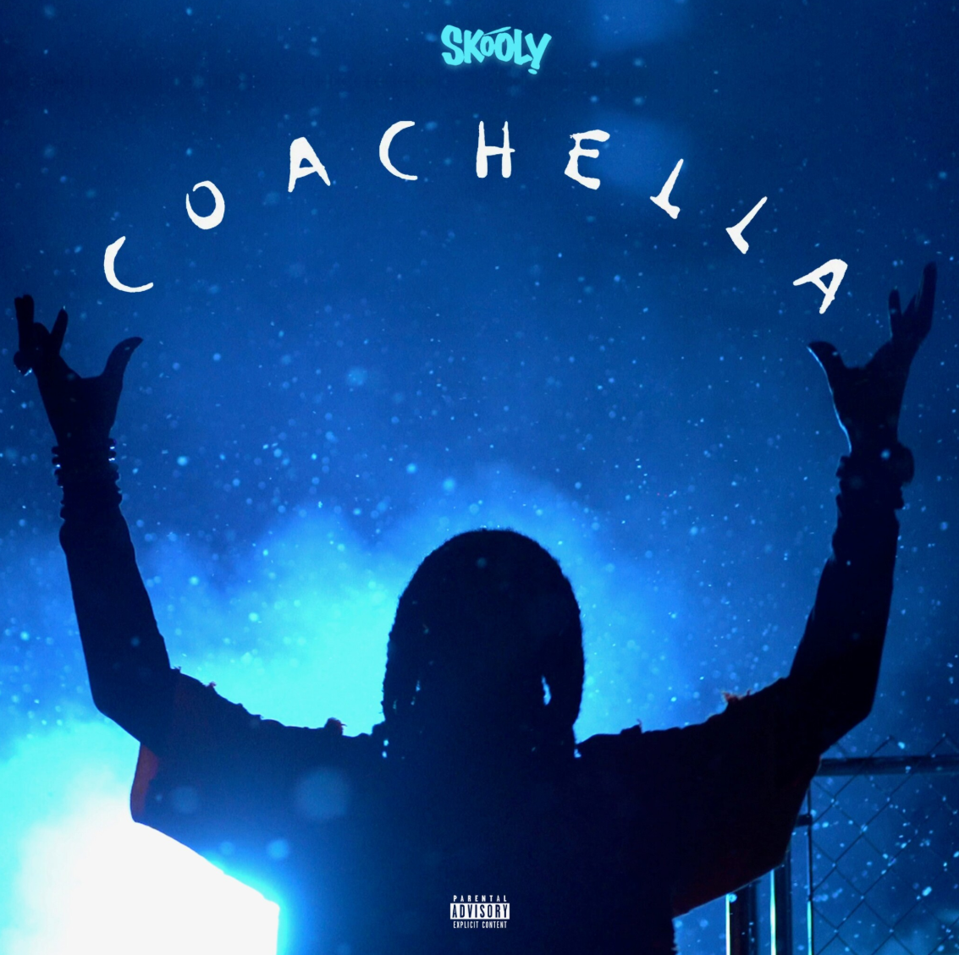
DOWNLOAD HIGH-RES SINGLE COVER ART HERE
DOWNLOAD HIGH-RES NO FACE NO CASE COVER ART HERE

T.R.U. (The Real University) recording artist Skooly takes you to “Coachella” in his latest single. “Coachella” precedes the storied rapper’s announcement of his forthcoming mixtape, Nobody Likes Me, set for May 22nd. Listen to “Coachella” HERE. Earlier this season, Skooly tapped street executive 2 Chainz for their stylish “Virgil Discount,” showcasing his quintessential delivery against a melodious flute and rattling 808s.

The multi-faceted artist has set loose a string of recent releases displaying his dexterity such as the bouncy “Pop Off” and its brilliant harp recording companion piece. Skooly enlisted Quando Rondo and NoCap for a spirited remix of “How I Feel” as the second #TRUsday release leading into the imprint’s No Face No Case album. Helmed my 2 Chainz, the 15-track compilation project showcased street-certified talent from Atlanta’s various zones, including Skooly’s Quavo-assisted “Reliable” and his frenetic feature on “Jefe Shit.”

Praised by Pitchfork for “changing the way Atlanta rapped,” the XXL Freshman hopeful has crafted a distinctive sound “that splits an imaginary line that divides swag rap and contorted R&B.” In addition to collaborations spanning Future to Young Thug, the well-connected Rich Kidz co-founder has maintained a devout following with a consistent supply of features, collaborations, and original music like his Blacc Jon Gotti mixtape and Don’t You Ever Forget Me series. Skooly was recruited in 2019 by GRAMMY® Award-winning t/rapper 2 Chainz to join his record label T.R.U. (The Real University) comprised of a vanguard of Atlanta hip-hop talent including Skooly, Sleepy Rose, Hott LockedN, and Worl. T.R.U. would announce its partnership with Atlantic Records that fall with the posse-cut “Shoot It Out” ahead of their full-length album representing “a sonic vision that highlights the Atlanta sound” (Hot New Hip Hop).

“I know Skooly is a superstar,” says 2 Chainz. “I’ve been watching him since he was about 14 in Atlanta. As a little kid, he had a Lil Wayne vibe. I’m staying down with him. He’s 25-years-old, and he’s nowhere near his peak. He really knows where to sing and where to put the bars down.”

CONNECT WITH SKOOLY
Instagram | Twitter | YouTube | SoundCloud

SKOOLY PRESS CONTACT
Brittany Bell | Brittany.Bell@atlanticrecords.com

T.R.U. PRESS CONTACT
Fairley McCaskill | Fairley.McCaskill@atlanticrecords.com

