FOR IMMEDIATE RELEASE
APRIL 24TH, 2020

SKOOLY GETS “NASTY” IN LATEST APPETIZER TRACK

T.R.U. ARTIST DROPS FRESH SINGLE ALONGSIDE NEXT FRIDAY-INSPIRED COMPANION VISUAL
LISTEN TO “NASTY” HERE | WATCH VISUAL HERE

RAPPER PAID HOMAGE TO BEAUTIFUL WOMEN LAST WEEK’S “MULATTO”
LISTEN TO “MULATTO” HERE | WATCH VISUAL HERE

RELEASED TIMELY “COACHELLA” TRACK ON WOULD-BE WEEKEND 1
LISTEN TO “COACHELLA” HERE | WATCH VISUAL HERE

TESTED ATLANTA RAPPER TO RELEASE NEW MIXTAPE
NOBODY LIKES ME ON MAY 22ND

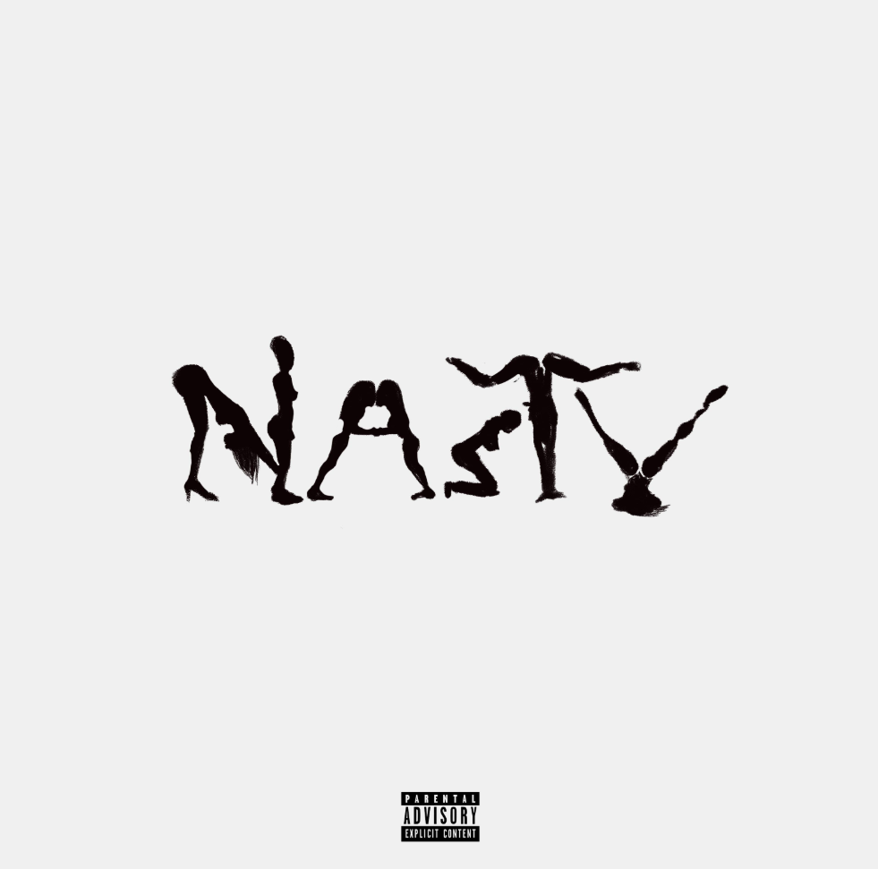
DOWNLOAD HIGH-RES SINGLE COVER ART HERE

The Atlanta artist’s voice—somewhere between nasally snarl and warped trill—splits an imaginary line that divides swag rap and contorted R&B. It was his calling card long before the rise of so-called “weirdo” rappers who wanted in on the magic of melody.
PITCHFORK

Skooly's one of Atlanta's best-kept secrets. Although he hasn't broken into a mainstream artist, he's connected with -- and possibly influenced -- many of the greatest exports out of the ATL in recent times.
HOTNEWHIPHOP

At 25, Skooly can already be considered a young OG in the rap game. Hailing from the westside of Atlanta, he helped start ATL’s buzzing rap group Rich Kidz 11 years ago as a 14-year-old rapper on the rise. Since then, his steady flow of new slaps has made him an unforgettable force in the area. Credited with influencing a few of the waves to come out of the ATL.
XXL

T.R.U. (The Real University) recording artist Skooly today dropped his latest appetizer track “Nasty” in preparation of his forthcoming mixtape. Listen to “Nasty” HERE and watch it’s Next Friday-inspired companion visual HERE. The tested Atlanta rapper stayed busy over the past few weeks releasing both “Mulatto” (watch the official video, co-directed by Skooly, HERE) and “Coachella” (watch official video HERE). These offerings set the table for his forthcoming mixtape Nobody Likes Me, due May 22nd, which features currently unreleased songs.

Earlier this season, Skooly and the T.R.U. collective released their No Face No Case album, a 15-track compilation project highlighting street-certified talent from Atlanta’s various zones. Skooly kicked off the imprint’s weekly #TRUsday releases with street executive 2 Chainz on “Virgil Discount,” showcasing his quintessential delivery against a melodious flute and rattling 808s. Other #TRUsday releases included the bouncy “Pop Off” and the spirited “How I Feel” remix with Quando Rondo and NoCap. The dexterous artist can also be heard flexing on with Quavo on “Reliable” and a frenetic feature on the T.R.U. posse cut “Jefe Shit.”

Praised by Pitchfork for “changing the way Atlanta rapped,” the XXL Freshman hopeful has crafted a distinctive sound “that splits an imaginary line that divides swag rap and contorted R&B.” In addition to collaborations spanning Future to Young Thug, the well-connected Rich Kidz co-founder has maintained a devout following with a consistent supply of features, collaborations, and original music like his Blacc Jon Gotti mixtape and Don’t You Ever Forget Me series. Skooly was recruited in 2019 by GRAMMY® Award-winning t/rapper 2 Chainz to join his record label T.R.U. (The Real University) comprised of a vanguard of Atlanta hip-hop talent including Skooly, Sleepy Rose, Hott LockedN, and Worl. T.R.U. would announce its partnership with Atlantic Records that fall with the posse-cut “Shoot It Out” ahead of their full-length album representing “a sonic vision that highlights the Atlanta sound” (Hot New Hip Hop).

“I know Skooly is a superstar,” says 2 Chainz. “I’ve been watching him since he was about 14 in Atlanta. As a little kid, he had a Lil Wayne vibe. I’m staying down with him. He’s 25-years-old, and he’s nowhere near his peak. He really knows where to sing and where to put the bars down.”

CONNECT WITH SKOOLY
Instagram | Twitter | YouTube | SoundCloud

SKOOLY PRESS CONTACT
Brittany Bell | Brittany.Bell@atlanticrecords.com

T.R.U. PRESS CONTACT
Fairley McCaskill | Fairley.McCaskill@atlanticrecords.com

