**VOCALIST ABIR GATHERS HER GIRLS FOR THE ULTIMATE “REUNION” IN NEW VIDEO**

**OFF OF HER DEBUT EP** [**“MINT”**](https://Atlantic.lnk.to/MintPR)

**AVAILABLE NOW AT ALL DSPS AND STREAMING SERVICES**

LISTEN/SHARE: <https://youtu.be/fZ2q2AvuLsI>

BUY/STREAM: <https://atlantic.lnk.to/MintPR>

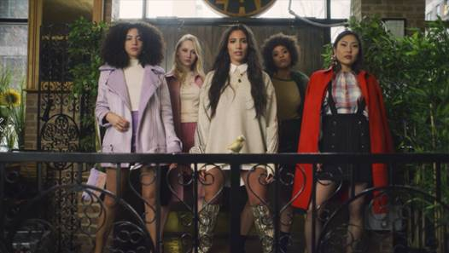

Atlantic recording artist **ABIR** gathers her girls in the gluttonous music video for EP standout **“Reunion,”** released today. [*NYLON*](https://nylon.com/abir-reunion-premiere) says, *“ABIR's crew is going to give you some serious style envy with their version of boozy brunch. If my squad doesn't roll up to the restaurant like this next weekend, I'm going to be mega-disappointed.”*“Reunion” is featured on ABIR’s debut EP ***MINT***, released last October. Watch the video [HERE!](https://youtu.be/fZ2q2AvuLsI)

On the meaning of the song ABIR says, "*Back in my hometown, there's always a 'reunion' the day before Thanksgiving where all the homies and people I grew up with link up at the same bar and catch up. It's like a high school reunion. I missed it a couple years in a row so when I finally had the chance to make it to one, it was so crazy seeing how grown up and different everyone was. It's insane how fast time flies and how much we change."*

And on filming the video she says, *"Making the video was so fun. We thought of this dope idea to do a mukbang-style brunch where a bunch of my closest friends eat the entire video, and that's it. Sometimes it's fun to pull away from the literal meaning of a song and write a treatment that fits the vibe more than the words. I imagined my girls going in on some ribs and turkey legs, and that's exactly what we did!"*

[*MINT*,](https://atlantic.lnk.to/MintPR) available at all DSPs and streaming services [HERE](https://Atlantic.lnk.to/MintPR), includes a special guest feature from rising rapper [Buddy](http://officialbuddy.com/) on the standout track, “Lose Me.” Listen [HERE.](https://atlantic.lnk.to/MintPR) The EPis highlighted by the single, “Young & Rude,” available for individual streaming and download [HERE](https://atlantic.lnk.to/YnRAY). The track, which has surpassed 3 million streams, received online applause upon its arrival, with [*Idolator*](https://www.idolator.com/7685895/abir-cuts-loose-in-cinematic-young-rude-video-premiere) raving, “ABIR is shaping up to be one of the breakout stars of 2018…The amazingly-titled ‘Young & Rude’ (is) an instantly anthemic pop song about letting your hair down and living in the moment. Those themes are conveyed perfectly in the video.” “Young & Rude” is streaming at ABIR’s official YouTube channel [HERE](https://www.youtube.com/watch?v=d8PRJu3rzyo).

Named by *Billboard* as one of the “most exciting new voices” in recent pop memory, ABIR has already made an impact on contemporary pop, earning acclaim and attention for her sultry fusion of R&B, dance grooves, and intimate lyricism. Last summer, ABIR collaborated with electronic production trio Cash Cash on the chart-topping anthem, [“Finest Hour”](https://www.youtube.com/watch?v=QUuXGUzhKfY) (Big Beat Records). ABIR also recently supported Jacob Banks and labelmates Kiiara and Jess Glynne on their US tours and has also opened for Alessia Cara, Dawn Richard, The Dream, and more. In addition to her musical success, the Morocco-born, New York, NY-based artist has also teamed with Clinique and Beats By Dre for popular brand partnerships, not to mention live performances for Fendi and Made at the always-influential New York Fashion Week.

CONNECT WITH ABIR:

[OFFICIAL](https://www.abirmusic.com/) |[INSTAGRAM](https://www.instagram.com/abir/)| [TWITTER](https://twitter.com/abir) | [FACEBOOK](https://www.facebook.com/xoabir/) l [PRESS SITE](http://press.atlanticrecords.com/abir/)

FOR ALL PRESS INQUIRIES, PLEASE CONTACT:

[Corey.Brewer@atlanticrecords.com](mailto:Corey.Brewer@atlanticrecords.com)