FOR IMMEDIATE RELEASE
MAY 1ST, 2020

ISSA RAE’S RAEDIO, ATLANTIC RECORDS AND HBO® RELEASE LATEST SINGLE OFF FORTHCOMING
INSECURE®: MUSIC FROM THE HBO ORIGINAL SERIES, SEASON 4 SOUNDTRACK

TEAMARRR’S “TEMPERATURE” TO BE ON FOURTH EPISODE OF INSECURE SEASON 4
SUNDAY, MAY 3rd ON HBO®

ETHEREAL TRACK DROPS ALONGSIDE COLORFUL ANIMATED VISUAL
AVAILABLE TO STREAM VIA YOUTUBE

BRAND NEW AND EXCLUSIVE TRACKS TO BE RELEASED WEEKLY AHEAD OF EACH EPISODE

SOUNDTRACK SET FOR A SUMMER RELEASE

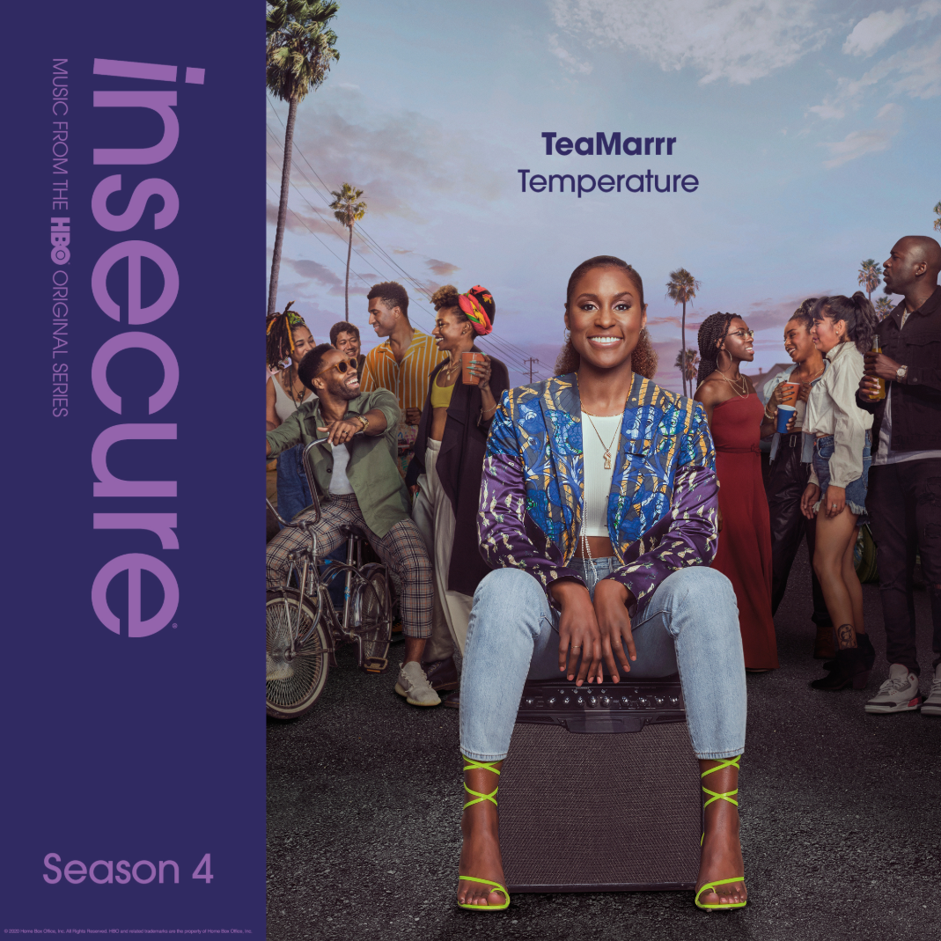
DOWNLOAD HIGH-RES COVER ART HERE

Raedio, the label founded by Issa Rae, Atlantic Records and HBO today release the latest track off the forthcoming INSECURE: Music From the HBO Original Series, Season 4 soundtrack. TeaMarrr’s “Temperature” brings the quintessential ‘really really raw’ element the Haitian songstress always delivers to this week’s episode of the award-winning HBO series, INSECURE. The track dropped today alongside a colorful companion visual, bringing the visceral, euphoric single to life – watch the animated video via YouTube. Listen during this Sunday’s episode at 10:00 p.m. (ET/PT) on HBO®. The series will also be available on HBO NOW, HBO GO, HBO On Demand and partners’ streaming platforms.

Last week’s releases included Jidenna’s “Feng Shui,” Ravyn Lenae’s “Rewind,” Poe Leos’ “Look At Me” and Yung Baby Tate’s “Do Me Like That” (ft. Buddy). Previous releases off the soundtrack include Jucee Froot’s irresistible “Eat Itself,” Cautious Clay’s “Reaching” (ft. Alex Isley), St. Panther’s “Infrastructure,” and Yung Baby Tate’s “Never Lonely” (ft. Jozzy).

“’Temperature’ is about the rollercoaster your emotions go through when dating someone,” notes TeaMarrr. “It’s all the feelings registered in a relationship – unstable, triggered or hot and bothered. If they get too close, do you get butterflies or are they on your nerves? ‘Temperature’ is about that relationship dynamic.”

INSECURE: Music From the HBO Original Series, Season 4 will feature brand new tracks from a diverse array of major artists and rising stars. The soundtrack is guaranteed to elevate the bar for music culture

ABOUT TEAMARRR
Shaking up pop, hip-hop, R&B, and more with a sharp sense of humor – and even sharper mic skills – TeaMarrr emerged in 2016 and quickly earned more than 4 million worldwide streams and high profile media attention spanning Flaunt and NPR to Ones To Watch and Consequence of Sound, to name but a few. The Boston-born and Los Angeles-based Haitian-American songstress truly broke through in 2018 with the hit single, “One Job,” scoring over 1.2 million streams and the attention of Raedio founder Issa Rae, who soon signed her. The track is joined by an official companion video, directed by James Bland (creator of Issa Rae Presents’ Daytime EMMY® Award-nominated GIANTS) and co-starring Insecure’s Jean Elie, streaming HERE.

ABOUT RAEDIO
Launched in 2019, Raedio serves artists and creators at the highest level as an “audio everywhere company,” operating as the home to a dynamic roster of talent. Most importantly, Raedio extends a platform across media to align acts with film and television projects, commercials, podcasts, and beyond. Raedio also provided music supervision services for HBO’s critically acclaimed A Black Lady Sketch Show℠.

For more information, please visit: insecuresoundtrack.com, twitter.com/theraedio and
www.instagram.com/theraedio.

ABOUT INSECURE
Returning for its ten-episode, fourth season on Sunday, April 12th (10:00-10:30 p.m. ET/PT), INSECURE follows our favorite characters as they evaluate their relationships, both new and old, in an effort to figure out who and what comes with them in this next phase of their lives. The series will also be available on HBO NOW, HBO GO, HBO On Demand and partners’ streaming platforms.

Season Four follows the main characters in the aftermath of the decisions they made in the last season. Issa pursues a passion project she actually cares about, Molly navigates a real relationship for the first time, Lawrence figures out what leveling-up means for him, and we see the effect of Tiffany’s new baby on the dynamic of the friend group. Along the way, we’ll see these characters evaluating relationships, both new and old, in an effort to figure out who and what comes with them in this next phase of their lives.

INSECURE stars Issa Rae. Other series regulars include Yvonne Orji, Jay Ellis, Natasha Rothwell, Amanda Seales, Kendrick Sampson and Alexander Hodge. Created by Issa Rae & Larry Wilmore, INSECURE is executive produced by Issa Rae, Prentice Penny, Melina Matsoukas, Michael Rotenberg, Dave Becky, Jonathan Berry, Amy Aniobi and Jim Kleverweis; co-executive producers, Laura Kittrell and Phil Augusta Jackson.

ABOUT HBO®
HBO® is one of the most respected and innovative entertainment brands in the world, serving iconic, award-winning programming to 140 million subscribers globally. A subsidiary of WarnerMedia, HBO is the world’s most successful pay TV service with an extensive array of programming that includes some of the most notable titles to be on television, including drama series Succession®, Watchmen®, Westworld®, Big Little Lies®, Game of Thrones®, The Sopranos®, Band of Brothers® and The Wire®, as well as comedy series Barry®, Insecure® and Sex and the City®. In the United States, HBO® and sister network Cinemax® are available across multiple platforms including HBO On Demand®, Cinemax On Demand®, HBO GO® and MAX GO®, as well as HBONOW®. Internationally, HBO branded services, including television networks and the standalone streaming product HBO GO®, are available in more than 70 countries across Asia, Europe, Latin America and the Caribbean. HBO and Cinemax programming is also sold into more than 150 countries worldwide.

INSECURE is available to stream now on www.hbo.com.

For more information, please visit www.hbo.com/insecure.

PRESS CONTACTS
Fairley McCaskill | Fairley.McCaskill@atlanticrecords.com (Insecure Soundtrack)
Brittany Bell | Brittany.Bell@atlanticrecords.com (Insecure Soundtrack)
Vanessa Anderson | Vanessa@amprgroup.com (Issa Rae)
Emily Weichert | Emily.Weichert@hbo.com (HBO)

