FOR IMMEDIATE RELEASE
MAY 28TH, 2020

SKOOLY PROVES HE IS THE “GOAT” IN LATEST VIDEO

TESTED ATLANTA RAPPER WRAPS NARRATIVE FROM
“I’M REALLY HIM” AND “COACHELLA” VISUALS

WATCH THE HOWARD ROSS-DIRECTED VIDEO HERE

NEW VIDEO ARRIVES ON THE HEELS OF THE T.R.U. ARTIST’S 17-TRACK LP NOBODY LIKES ME
+ “NEVA KNOW” FT. LIL BABY VISUAL

NOBODY LIKES ME AVAILABLE TO STREAM/DOWNLOAD:
SKOOLY.LNK.TO/NOBODYLIKESME

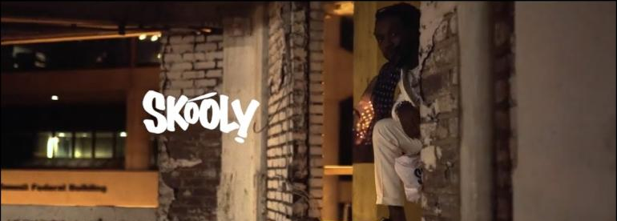
DOWNLOAD SKOOLY PRESS ASSETS HERE

T.R.U. (The Real University) recording artist Skooly completes the narrative in his visual succession of “I’m Really Him” and “Coachella” with the launch of “GOAT.” Watch the Howard Ross-directed visual HERE. The new visual arrives on the heels of the “Neva Know” ft. Lil Baby visual component also directed by Ross.

“GOAT” and “Neva Know” come just days after the release of the Atlanta rapper’s long-awaited full-length album, Nobody Likes Me. The 17-track LP features Lil Baby and 2 Chainz with production from Tay Keith, Chophouze, and more. Nobody Likes Me is available now to stream and download HERE. Complex notes how the project puts “Skooly's electric rap style and vibrant vocals on full display, showcasing his ability to do lyrical acrobatics . . . while simultaneously flexing his singing ability over smooth Tay Keith production. This project is also very reflective of Skooly's Atlanta roots, and the internal battles he's had to try to understand why some people don't want to see him win.” Earlier this month, Skooly dropped the album’s debut single “Go.”

Skooly celebrated the release of Nobody Likes Me with an incredible album listening party and viewing of his documentary at Atlanta’s legendary Startlight Drive-In Theatre. Fans were able to enjoy his new musical effort in the safest way possible – from the comfort of their cars. Watch a recap HERE. Prior to the LP’s release, the tested Atlanta singer and rapper dropped a series of appetizer tracks including the Next Friday-inspired “Nasty,” his co-directed video with Ross for “Mulatto,” and the timely “Coachella” which debuted on the would-be first weekend of the Southern California festival.

ABOUT SKOOLY
Without bragging or boasting, Skooly quietly instigated one wave after another in his hometown of Atlanta. As a result, he left an indelible mark on the game evidenced by tens of millions of streams and glowing critical praise with Pitchfork even arguing he, “Changed the way Atlanta rapped.” At 14-years-old, he introduced himself to the culture as part of the influential group Rich Kidz. Among Straight Like That 1 & 2 [2011] and Everybody Eat Bread [2012], he turned up in the studio alongside icons such as Ludacris, Young Thug, and more. His voice would be heard by billions on instantly recognizable tags for like London On Da Track’s (“We got London On Da Track”). After solo success on the 2015 mixtape Blacc John Gotti, the Don’t Ever Forget Me trilogy, and a series of fiery singles, he ignites the next phase with his T.R.U. and Atlantic Records debut mixtape, Nobody Likes Me.

Setting the stage for the project, Skooly shined on the T.R.U. collective’s 2020 debut compilation, No Face No Case. His energy spiked through tracks like “Reliable” [feat. Quavo], “Jefe Shit,” “Pop Off,” “How I Feel” [feat. Quando Rondo & NoCap], and “Virgil Discount” [feat. 2 Chainz], the latter eclipsing 17 million streams and counting. In addition to plugs from GQ, Sway’s Universe, Genius, MTV, The Breakfast Club, and more, XXL deemed them one of “8 Rising Rap Crews You Need On Your Radar.” Riding this wave, Skooly comments on his place in the game and secures his future with Nobody Likes Me introduced by the single “Go” and highlighted by bangers like “Never Know” [feat. Lil Baby].

“I know Skooly is a superstar,” says 2 Chainz. “I’ve been watching him since he was about 14 in Atlanta. As a little kid, he had a Lil Wayne vibe. I’m staying down with him. He’s 25-years-old, and he’s nowhere near his peak. He really knows where to sing and where to put the bars down.”

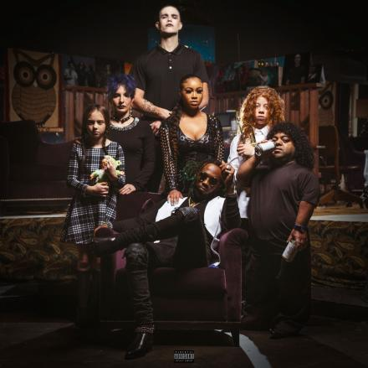
DOWNLOAD HIGH-RES COVER ART HERE

TRACKLISTING
  - American Made (prod: MarioBeats)
  - Opp Boy (prod: Tay Keith)
  - Neva Know feat. Lil Baby (prod: Chophouze)
  - Talented (prod: Uncle Bari)
  - Go (prod: MarioBeats)
  - Soul Search (prod: Big A and Big Zar)
  - Nobody Likes Me (prod: JayTheGreat)
  - Imposter (prod: MikeMvjor and NoiseByNick)
  - Different (prod: JayTheGreat)
  - GOAT (prod: Quay Global)
  - Box Chevy feat. 2 Chainz (prod: Quay Global)
  - Late Night Tease (prod: Mike Mixer, Dun Deal and Eliot)
  - Turned Into A Villain (prod: Ceeo)
  - Genocide (acoustic) feat. Harp Szn
  - Lil Boy Shit (prod: Quay Global) *BONUS*
  - Pop Off (prod: Chophouze) *BONUS*
  - Virgil Discount feat. 2 Chainz (prod: June The Jenius, AJ Costly and Cubeatz) *BONUS*

CONNECT WITH SKOOLY
Instagram | Twitter | YouTube | SoundCloud

SKOOLY PRESS CONTACT
Brittany Bell | Brittany.Bell@atlanticrecords.com

