DON TOLIVER DELIVERS “DRUGS N HELLA MELODIES”
STREAM: DONTOLIVER.LNK.TO/DRUGSNHELLAMELODIES
WATCH: DONTOLIVER.LNK.TO/DRUGSNHELLAMELODIESVID

ON THE HEELS OF “WHAT YOU NEED”
STREAM | WATCH

Don Toliver continues his creative voyage with “Drugs N Hella Melodies” co-starring GRAMMY® Award-winning singer Kali Uchis. Toliver’s music might as well be its own solar system with otherworldly hip-hop, smoked-out R&B, ambitious pop, and a little rock in a planetary orbit around the multi-platinum singer, songwriter, and artist. Shot in Medellìn, Colombia, the Nabil Elderkin directed companion visual transmits another head-nodding hook over immersive psychedelic production from LosHendrix [Kehlani, SZA], DJ Dahi [Kendrick Lamar, Childish Gambino], and Dylan Wiggins. It forges on the dynamic story-line from the initial cinematic Nabil Elderkin directed visual for “What You Need.” Distinguished by Apple Music as an Up Next artist and named Rookie of the Year by Spotify’s Rap Caviar, Don Toliver is just getting started. Buy the ticket, take the ride on his second full-length album, Life of a DON [Cactus Jack/Atlantic Records].

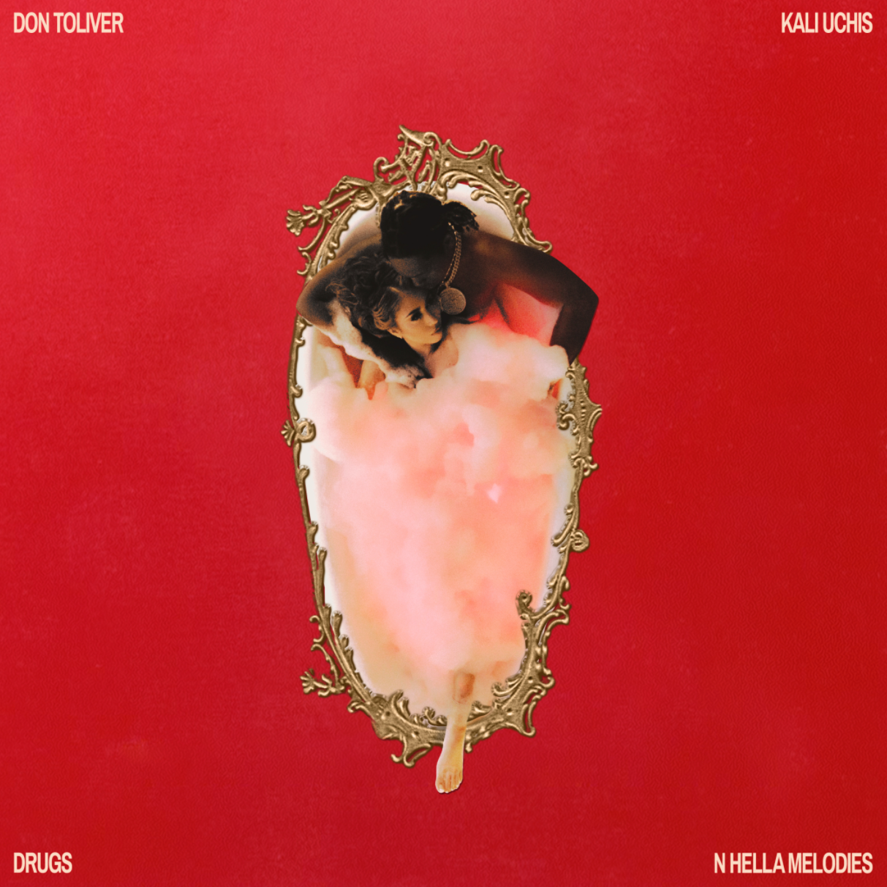

DOWNLOAD PRESS PHOTOS (PC: White Trash Tyler)
DOWNLOAD “DRUGS N HELLA MELODIES” COVER ART

Don Toliver has established himself as one of hip-hop’s fasest rising stars. He’s a star who will be around for a long time.
COMPLEX

One of the biggest breakthrough artists of 2020
ROLLING STONE

The Travis Scott protégé has become one of the most promising artists to emerge from Houston.
HIGHSNOBIETY

Don Toliver has continued to demonstrate himself as one of hip-hop’s most promising newcomers.
HYPEBEAST

There is no replicating a sound this singular. Don proves once again he can enter other artists’ worlds and still leave completely under his own pretense.
INTERVIEW MAGAZINE

PRESS CONTACT: Brittany Bell, Brittany.Bell@atlanticrecords.com

