FOR IMMEDIATE RELEASE
JULY 10, 2020

TEAMARRR DOES IT RIGHT IN “DOIN IT WRONG” VISUAL

SONGSTRESS RECRUITS HER GIRL GANG TO SHOW THE GUYS HOW IT’S DONE
IN JAMES BLAND-DIRECTED OFFICIAL VIDEO

WATCH “DOIN IT WRONG” HERE

BEFORE I SPILL MYSELF AVAILABLE VIA RAEDIO/ATLANTIC HERE

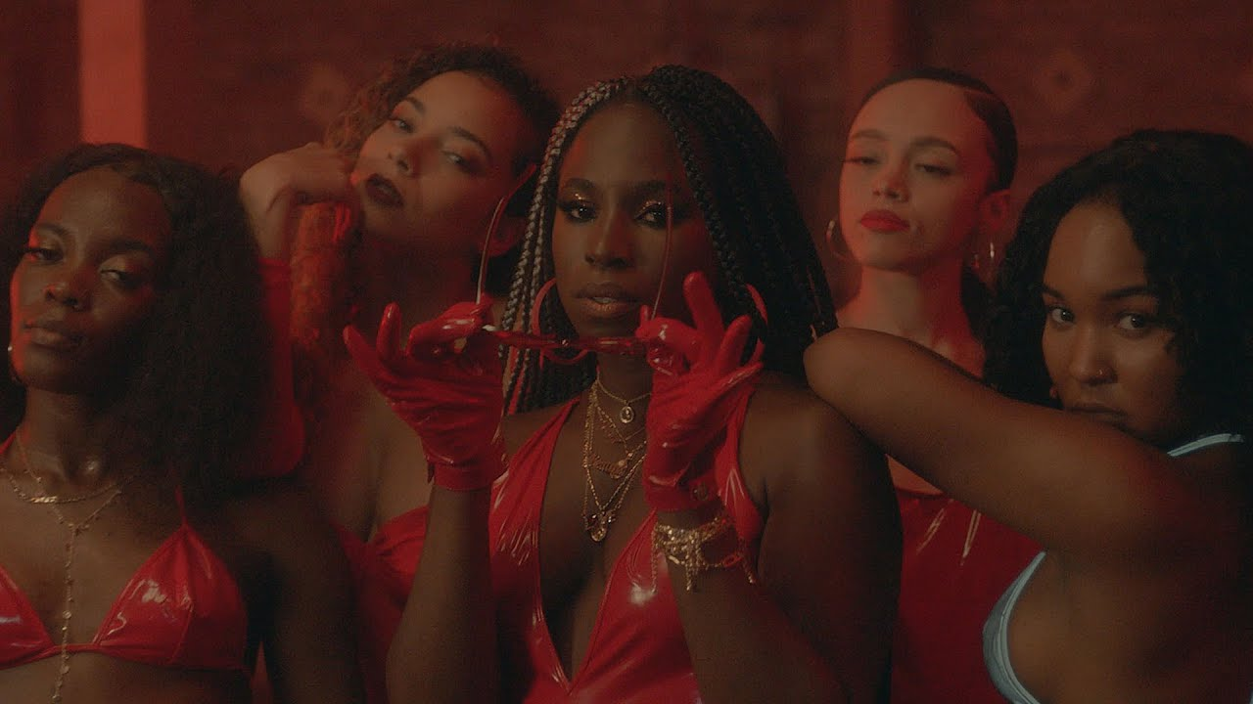
DOWNLOAD PRESS ASSETS HERE

Raedio and Atlantic recording artist TeaMarrr shows the guys how it’s done in the companion visual to “Doin It Wrong.” The songstress enlists the help of her ladies to give a detailed presentation on how to do it right. INSECURE actor, Jean Elie, returns as TeaMarrr’s co-star in “Doin It Wrong” whom she picks up the conversation with where “One Job” left off, and she lets him have it . . . again. Watch the James Bland-directed visual HERE. “Doin It Wrong” is featured on her highly-praised label debut EP BEFORE I SPILL MYSELF.

““Doin It Wrong” is about all the areas in a relationship that can go wrong, one mainly being sex. It lyrically discusses chemistry being off and the annoyance that comes with not being able to get to know each other as friends first,” notes TeaMarrr. “In the visual, the girls and I invite the men in our lives to a private location. We show and tell them what they’ve been doing wrong all – staged in a Broadway-like production. It was fun to play around like that because I’ve always wanted to do stage plays and hopefully win a Tony one day, for doing it right of course.”

BEFORE I SPILL MYSELF was met with critical acclaim from the likes of Complex, OkayPlayer, NPR and more. “At the heart of TeaMarrr’s music, there’s a deep desire and urgency for healing that flows from her blending of pop, hip-hop, and R&B,” notes Grimy Goods. “That altruism takes shape and is given power in her songs, and especially her new EP BEFORE I SPILL MYSELF, in the form of her ability to weave in and out of typical genre barriers–not just in melody and cadence, but in pure aesthetic and production as well.” BEFORE I SPILL MYSELF released alongside the official music video for “Chasing Amy” (963k views), directed by James Bland (creator of Issa Rae Presents’ Daytime EMMY® Award-nominated GIANTS).

The EP, heralded by an exclusive trailer, includes the recent single, “Kinda Love (Feat. D Smoke),” available for streaming and download HERE; an official music video – directed by James Bland – is streaming at YouTube HERE (1.1m views) following an exclusive premiere via Refinery29, which wrote, “TeaMarrr paints a picture of a love story gone awry; when her dream man arrives on her front doorstep, the singer quickly realizes that perfection isn't always what it's cracked up to be. Colorful and picturesque, the video is a warm welcome into TeaMarrr's expansive, ever-evolving world.”

In addition, BEFORE I SPILL MYSELF – which includes additional features from SiR and Rapsody – is highlighted by such new tracks as “Cool Enough,” heard earlier this year on the Season 4 premiere of the award-winning HBO® series, INSECURE. Indeed, TeaMarrr is among the rising new stars showcased on Raedio/Atlantic’s INSECURE: MUSIC FROM THE HBO ORIGINAL SERIES, SEASON 4 soundtrack, available HERE. Her track – the euphoric “Temperature” – was featured on the season’s fourth episode and is available now for streaming and download HERE. “Temperature” is joined by an official companion video, shot at home during quarantine and streaming now via YouTube HERE (122k views).

As if all that weren’t enough, TeaMarrr’s “My Fit” was a hit on Mindy Kaling’s acclaimed Netflix series, NEVER HAVE I EVER, and quickly began trending with the #neverfitin TikTok challenge, resulting in total TikTok views now over 7 billion.

Shaking up pop, hip-hop, R&B, and more with a sharp sense of humor – and even sharper mic skills – TeaMarrr emerged in 2016 and quickly earned more than 4 million worldwide streams and high profile media attention spanning Flaunt and NPR to Ones To Watch and Consequence of Sound, to name but a few. The Boston-born and Los Angeles-based Haitian-American songstress truly broke through in 2018 with the hit single, “One Job,” scoring over 1.2 million streams and the attention of Raedio founder Issa Rae, who soon signed her as the new label’s flagship artist. “One Job” is joined by an official companion video, directed by James Bland and co-starring INSECURE’s Jean Elie, streaming HERE.

“I want people to heal themselves with my sound,” TeaMarrr says. “I hope they walk away thinking, ‘TeaMarrr is my new musical pharmacist.’ My catalog will heal whatever mood you’re in; if you’re in a lovey-dovey vibe put on ‘Kinda Love.’ If you’re angry at your ex and don’t understand why he couldn’t have done the one thing you asked him to, I definitely have a song for that too. Think of me as the sonic doctor prescribing music as medicine to help you heal.”

ABOUT RAEDIO
Launched in 2019, Raedio serves artists and creators at the highest level as an “audio everywhere company,” operating as the home to a dynamic roster of talent. Most importantly, Raedio extends a platform across media to align acts with film and television projects, commercials, podcasts, and beyond. Raedio also provided music supervision services. For more information, please visit twitter.com/theraedio and www.instagram.com/theraedio.

DOWNLOAD HIGH-RES ARTWORK + TRACKLISTING HERE

BEFORE I SPILL MYSELF TRACKLISTING
- Chasing Amy
- Kinda Love (Feat. D Smoke)
- Tick (Feat. SiR)
- Whorey Heart
- Doin It Wrong
- One Job
- Cool Enough
- Done
- I’m That (Feat. Rapsody)

CONNECT WITH TEAMARRR
INSTAGRAM | TWITTER | FACEBOOK | YOUTUBE

PRESS CONTACT
FAIRLEY MCCASKILL | FAIRLEY.MCCASKILL@ATLANTICRECORDS.COM

