FOR IMMEDIATE RELEASE
JULY 30, 2021

“SKATE” TO SILK SONIC
STREAM HERE

SILK SONIC SERENADES SKATERS AT THEIR SUMMERTIME JAM
WATCH HERE

MULTIPLE GRAMMY® AWARD WINNING SUPERSTARS BRUNO MARS & ANDERSON .PAAK
WON BEST GROUP AT THE 2021 BET AWARDS

DEBUT SINGLE “LEAVE THE DOOR OPEN” CLIMBED TO #1 ON THE BILLBOARD HOT 100
STREAM HERE | WATCH HERE | LIVE VERSION HERE

AN EVENING WITH SILK SONIC DUE LATER THIS YEAR

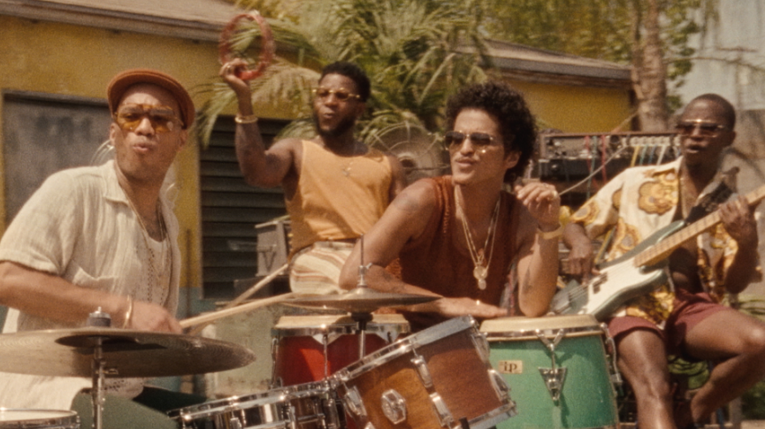
DOWNLOAD HI-RES ARTWORK | DOWNLOAD HI-RES PRESS PHOTO
PHOTO CREDIT: HARPER SMITH

Get ready to glide to the groove. Multiple GRAMMY® Award winners Bruno Mars and Anderson .Paak are here with their silky sophomore single, “Skate.” The boys serenade a smooth skate crew in the summertime vacation-vibe visual directed by Bruno Mars and Florent Déchard and co-directed by Philippe Tayag. Silk Sonic coasted into “Skate” on the wave of success from their debut single “Leave the Door Open,” which earned them Best Group at the 2021 BET Awards. It became the group’s first #1 single on the Billboard Hot 100, spending two non-consecutive weeks at #1 and 18 consecutive weeks in the top 10. They released the live version “Leave The Door Open (Live)” and serenaded audiences three times over at the GRAMMY® Awards, iHeartRadio Music Awards, and the BET Awards.

Silk Sonic introduced “Leave The Door Open” alongside an official music video directed by Mars and Florent Déchard with over 346 million views and counting. The track was followed by a hugely popular social media campaign, #LetSilkSonicThrive and was immediately welcomed by unprecedented critical acclaim. “What’s new, smooth as silk on the ears, and features two stars of R&B?” wrote Billboard, praising Silk Sonic as “a groovy duo” and the single as “lounge at its heart.” Consequence of Sound enthused, “Mars has a voice like a liquid whip, while .Paak raps and sings through a foggy haze. They sound like smoke on the water.”

In 2021, Bruno Mars helped launch SelvaRey a premium rum label and lifestyle brand, with a campaign called 'Tropical Luxury, Wherever You Are.' As a part of the campaign, Mars created a commercial and jingle for SelvaRey that quickly gained millions of views online. Mars also recently debuted his first lifestyle clothing collection, teaming up with Lacoste to launch Ricky Regal. For more information visit www.lacoste.com.

ABOUT SILK SONIC:
The seeds of the collaboration were planted in 2017 when Anderson .Paak and Bruno Mars toured together on the European leg of his 24K Magic World Tour. One late-night jam session on the road unlocked immediate chemistry. Just before the world slipped into quarantine, Bruno called Anderson: “Remember that idea we had back in 2017? Let’s do it.” One studio session grew into to a months-long collaboration, culminating the “setlist of doom.” Legendary Bootsy Collins christened Silk Sonic and came in as the “special guest host” for An Evening With Silk Sonic, their debut album.

Silk Sonic was finally set free on March 5th, 2021. Within less than a month, their debut single “Leave The Door Open” cracked over 230 million streams, and currently sits at 1.2 billion streams with over 346 million official video views. It reeled in rave reviews, including Variety who noted it “could be a Best R&B Song GRAMMY® winner from 1974.” After petitioning the GRAMMY® Awards to #LetSilkSonicThrive, they made their debut performance with “Leave The Door Open” and served up a powerful tribute to Little Richard.

CONNECT WITH SILK SONIC
WEBSITE | FACEBOOK | TWITTER | INSTAGRAM | YOUTUBE | TIKTOK | SPOTIFY | APPLE MUSIC

CONNECT WITH BRUNO MARS
WEBSITE | FACEBOOK | TWITTER | INSTAGRAM | YOUTUBE

CONNECT WITH ANDERSON .PAAK
WEBSITE | FACEBOOK | TWITTER | INSTAGRAM | YOUTUBE

CONTACT FOR SILK SONIC/BRUNO MARS:
SHEILA.RICHMAN@ATLANTICRECORDS.COM
BRITTANY.BELL@ATLANTICRECORDS.COM

CONTACT FOR ANDERSON .PAAK:
KRISTEN.FOSTER@FULLCOV.COM
ERICA.GERARD@FULLCOV.COM

