FOR IMMEDIATE RELEASE
AUGUST 23, 2021

DON TOLIVER ANNOUNCES FALL 2021 HEADLINE LIFE OF A DON TOUR

TICKETS ON SALE STARTING AUGUST 27TH AT 10AM LOCAL TIME ON TICKETMASTER.COM

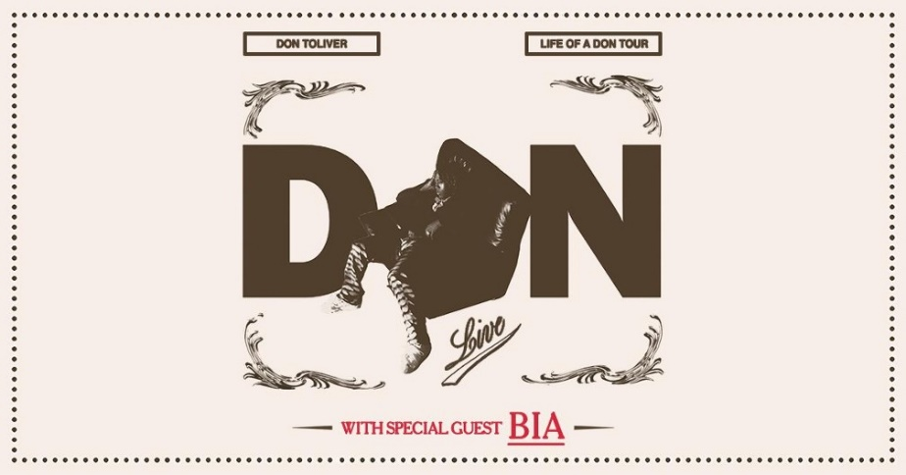

WHO: Don Toliver with special guest BIA

WHAT: Don Toliver: Life Of A Don Tour
Produced by Live Nation, the tour kicks off on September 20th at Austin’s Stubb’s Waller Creek Amphitheater making stops across the U.S. in New York, Philadelphia, Atlanta, and more before wrapping up in Los Angeles at Palladium on October 30th. Don Toliver is just coming off a string of major festival dates including Rolling Loud: Miami, HARD Summer Music Festival, HIVE Music Festival and Lyrical Lemonade, with more to come.

TICKETS: Tickets on sale starting August 27th at 10AM local time on Ticketmaster.com.

LIFE OF A DON TOUR DATES:
Fri Sep 17 – Las Vegas, NV – Life Is Beautiful*
Sat Sep 18 – Phoenix, AZ – Marquee*
Mon Sep 20 – Austin, TX – Stubb’s Waller Creek Amphitheater
Tue Sep 21 – Oklahoma City, OK – The Criterion*
Wed Sep 22 – St. Louis, MO – The Factory*
Fri Sept 24 – Milwaukee, WI – The Rave*
Sat Sep 25 – Chicago, IL – Byline Bank Aragon Ballroom
Tue Sep 28 – Cleveland, OH – Temple Live*
Wed Sep 29 – Detroit, MI – Fillmore Detroit
Thu Sep 30 – Pittsburgh, PA – Stage AE*
Sat Oct 02 – New York, NY – The Rooftop at Pier 17
Sun Oct 03 – Montclair, NJ – Wellmont Theatre
Mon Oct 04 – Boston, MA – House of Blues
Wed Oct 06 – Wallingford, CT – The Dome at Oakdale Theatre
Thu Oct 07 – Philadelphia, PA – Fillmore Philadelphia
Sun Oct 10 – Washington, DC – Echostage
Tue Oct 12 – Raleigh, NC – The Ritz
Wed Oct 13 – Charlotte, NC – Fillmore Charlotte
Fri Oct 15 – Miami, FL – The Oasis*
Sun Oct 17 – Atlanta, GA – Coca Cola Roxy
Wed Oct 20 – Houston, TX – Bayou Music Center
Fri Oct 22 – Dallas, TX – The Bomb Factory*
Sun Oct 24 – Denver, CO – Fillmore Auditorium
Mon Oct 25 – Salt Lake City, UT – The Complex
Sat Oct 30 – Los Angeles, CA – Palladium
Fri Nov 5 – Houston, TX – Astroworld*
Sun Nov 14 – Las Vegas, NV – Day N Vegas*
Sun Dec 12 – Los Angeles, CA – Rolling Loud*
*Not a Live Nation Date

ABOUT DON TOLIVER:
If Don Toliver pulled up in a spaceship, nobody would question it. His music might as well be its own solar system with otherworldly hip-hop, smoked-out R&B, ambitious pop, and a little rock in a planetary orbit around the multiplatinum singer, songwriter, and artist. It might seem like he hails from some far away galaxy, but he calls Houston, TX home. Forged in the fires of his hometown, he grinded out a visionary style in underground shows, elevating the post-genre grime and grit of his city into mainstream focus. After the 2018 mixtape Donny Womack, he assembled his full-length debut, Heaven Or Hell. It claimed spots on mid-year and year-end lists by Complex and XXL, while Rolling Stone championed him among the 10 Biggest Breakthrough Artists of 2020. LOSEminem, Nas, and Rico Nasty recruited him for collaborations. Plus, he joined forces with Internet Money, NAV, and Gunna for the triple-platinum banger “Lemonade,” which they also performed on The Tonight Show Starring Jimmy Fallon. Within three years, he has gathered billions of streams, scored platinum plaques, and received praise courtesy of everybody from High Snobiety to Interview Magazine. However, it’s all a part of his life—as chronicled on his 2021 second full-length album, Life Of A DON [Cactus Jack/Atlantic Records], preceded by “What You Need” and “Drugs N Hella Melodies.”

ABOUT LIVE NATION ENTERTAINMENT:
Live Nation Entertainment (NYSE: LYV) is the world’s leading live entertainment company comprised of global market leaders: Ticketmaster, Live Nation Concerts, and Live Nation Sponsorship. For additional information, visit www.livenationentertainment.com.

MEDIA CONTACTS:
Don Toliver
Brittany Bell | Brittany.Bell@atlanticrecords.com
Chandler Owen | Chandler.Owen@atlanticrecords.com [TOUR]

Live Nation Concerts
Monique Sowinski | moniquesowinski@livenation.com

