FOR IMMEDIATE RELEASE

SEPTEMBER 20, 2018

**ABIR IS “YOUNG & RUDE” IN NEW** [**VIDEO**](https://ad.gt/ynr) **OUT TODAY**

***ACCLAIMED VOCALIST/SONG-WRITER’S LONG-AWAITED DEBUT EP COMING NEXT MONTH***

***U.S. TOUR ALONGSIDE KIIARA GETS UNDERWAY OCTOBER 29TH IN CHICAGO***

***“YOUNG & RUDE” AVAILABLE NOW*** [***HERE***](https://Atlantic.lnk.to/YnRPR)

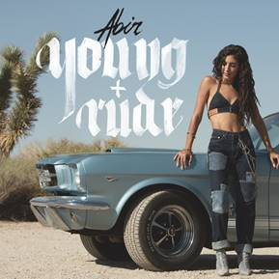

*“One of the most impressive new voices”* – **Billboard**

*“Singer-songwriter ABIR makes infectious, life-affirming tracks that showcase her powerhouse vocals.”*-**PAPER**

*“Genuine talent within the sea of wannabes”* – **NYLON**

*“One of the most promising new singers”* – **Complex**

*“Our favorite new artist”* - **Apple Music**

Atlantic recording artist **ABIR** has announced today’s release of her eagerly awaited new single. Titled **“Young & Rude”,** the track is sure to catch your attention with ABIR’s standout vocals on top of mesmerizing instrumentals. It is available now at all DSPs and streaming services [HERE](https://Atlantic.lnk.to/YnRPR). The track is also joined by a new companion visual, streaming now [HERE](https://ad.gt/ynr). The video was directed by Shomi Patwary, who’s known for creating iconic visuals including Beyonce’s “No Angel”, Belly ft. The Weeknd’s “Might Not”, A$AP Rocky’s “Jukebox” and more. “Young & Rude” marks the first track release from ABIR’s upcoming Atlantic Records debut EP, slated for release October 19th.

On the music video ABIR says, *“It’s part Bonnie & Clyde, but the male lead in the video was not actually an accomplice- he was held captive to my Young & Rude ways. I’m always here for a female empowerment moment! Shooting this video with Shomi was everything, he brought limitless passion and effort. The entire shoot was an epic whirlwind; especially driving the car with my three-day old license!”*

ABIR – whose recent signing to Atlantic was announced exclusively via [*Billboard*](https://www.billboard.com/articles/news/8475172/abir-signs-atlantic-finest-hour-acoustic) – has also just unveiled **“Finest Hour (Acoustic),”** a stripped-down rendition of her smash collaboration with chart-topping electronic production trio **Cash Cash**, “Finest Hour” out now on Big Beat Records. “Finest Hour (Acoustic)” is available now for streaming and download [HERE](https://lnk.to/fhaID); the track’s official companion visual can be viewed [HERE](https://www.youtube.com/watch?v=7jSvOk9hiAI).

Written by ABIR, “Finest Hour” – available for streaming and download [HERE](https://bigbeat.lnk.to/FHID) – was one of this summer’s biggest anthems, topping iTunes’ “Dance Songs” chart for **eight** weeks on its way to the overall **Top 40**. The track is joined by an equally popular companion visual, directed by **Phillip R. Lopez** (Avicii, Kygo, Selena Gomez) and streaming now [HERE](https://www.youtube.com/watch?v=QUuXGUzhKfY).

“Finest Hour” was greeted by widespread critical praise, with [Paper](http://www.papermag.com/cash-cash-abir-finest-hour-2559323156.html) writing, “(ABIR’s) R&B-infused pop pairs uninhibited vocals with intimate, carefully-articulated observations of the world around her…’Finest Hour,’ which layers ABIR’s powerful Sia-esque vocals over Cash Cash’s characteristic wash of booming synth, metronomic drums, and meandering horns. ABIR laments that this isn’t her finest hour, but her confident vocals paired with the ecstatic instrumentals make it clear that she isn’t giving up any time soon.”

Following an appearance on **Elvis Duran**’s Z100 morning show to perform “Finest Hour,” the popular radio host surprised Cash Cash and ABIR with a pledge to donate $2 to St. Jude’s Children’s Research Hospital for every download over a 48-hour span. Cash Cash and ABIR later made a special visit to St. Jude’s to perform and meet patients.

Named by Billboard as one of the “most exciting new voices” in recent pop memory, ABIR followed “Finest Hour” with her own “Way Out,” available for streaming and download [HERE](https://lnk.to/WayOutAY). A companion visual, directed by **Johnny Valencia** (Ed Sheeran, Rudimental), is streaming now at the official ABIR YouTube channel [HERE](https://www.youtube.com/watch?v=mmTRZ6jP9q0). The clip had its world premiere exclusively via [Refinery 29](https://www.refinery29.com/2018/05/199366/abir-way-out-music-video-premiere), which declared it to be “a visual nod to ABIR’s own journey and her three years of traversing (New York City)…’Way Out’ Is a love letter to the city that never stops working.”

ABIR – who joined Cash Cash for performances of “Finest Hour” at this year’s **Coachella** Valley Music & Arts Festival and **Electric Zoo** – has also drawn acclaim as a striking live act, including special guest turns alongside such like-minded artists as Alessia Cara, The-Dream, Bob Moses, Amine and more. Next up is a major U.S. tour supporting **Kiiara**, with dates beginning October 29th at Chicago, IL’s Lincoln Hall and then traveling through November. For complete details, please visit [www.abirmusic.com/#tour](http://www.abirmusic.com/#tour).

ABIR has already made a huge impact on contemporary pop, earning acclaim and attention for her sultry fusion of R&B, dance grooves, and intimate lyricism. In addition to her musical success, the Morocco-born, New York, NY-based artist has also teamed with Clinique and Beats By Dre for popular brand partnerships, not to mention live performances for Fendi and Made at the always-influential New York Fashion Week.

CONNECT WITH ABIR:

[OFFICIAL](https://www.abirmusic.com/) |[INSTAGRAM](https://www.instagram.com/abir/)| [TWITTER](https://twitter.com/abir) | [FACEBOOK](https://www.facebook.com/xoabir/) l [SOUNDCLOUD](https://soundcloud.com/abir)

FOR ALL PRESS INQUIRIES, PLEASE CONTACT:

[Corey.Brewer@atlanticrecords.com](mailto:Corey.Brewer@atlanticrecords.com)

**ABIR**

**ON TOUR**

**ALL DATES W/KIIARA**

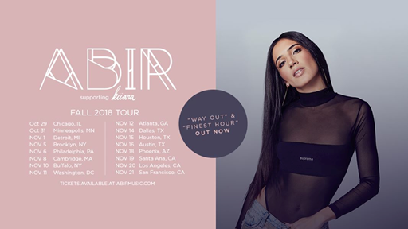

**OCTOBER**

29 – Chicago, IL – Lincoln Hall

31 – Minneapolis, MN – Fine Line Music Café

**NOVEMBER**

1 – Detroit, MI – The Shelter

5 – Brooklyn, NY – Elsewhere

6 – Philadelphia, PA – TLA

8 – Cambridge, MA – The Sinclair

10 – Buffalo, NY – Rec Room

11 – Washington, DC – U Street Music Hall

12 – Atlanta, GA – Terminal West

14 – Dallas, TX – Trees

15 – Houston, TX – Warehouse Live

16 – Austin, TX – Antone’s

18 – Phoenix, AZ – The Crescent Ballroom

19 – Santa Ana, CA – Constellation Room At The Observatory

20 – Los Angeles, CA _ Regent Theater

21 – San Francisco, CA – August Hall

# # #