FOR IMMEDIATE RELEASE
SEPTEMBER 24, 2021

Black Female Artist and Activist in Partnership With Janelle Monáe and the African American Policy Forum (AAPF) Release Protest Song “Say Her Name” to Honor Black Women and Girls Killed By Law Enforcement

The Protest Anthem Aims to Amplify the Stories of the Women Who Have Lost Their Lives at the Hands of Police and Uplift Their Mothers and Families

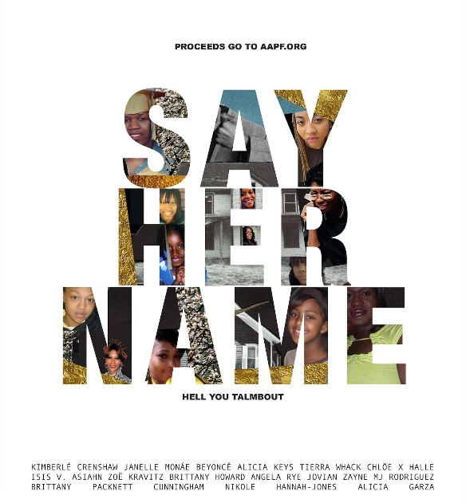

DOWNLOAD HIGH-RES ARTWORK HERE

STREAM AND DOWNLOAD THE SINGLE HERE

WATCH THE LYRIC VIDEO HERE

The single is available to stream and purchase on all platforms today, proceeds from the single and video will benefit the African American Policy Forum’s (AAPF) work.

Become a supporter and donate to AAPF’s work, HERE.

Watch the trailer for the song, HERE.

Los Angeles, CA (September 24, 2021) – Today, The African American Policy Forum (AAPF), Professor Kimberlé Crenshaw, Eight-time Grammy® award nominee Janelle Monáe, Wondaland Records and 15 other black, female artists and activists released the single and lyric video for “Say Her Name” with the goal of providing the AAPF and the #SayHerName Mothers Network with the platform to tell their stories. The song is being released ahead of International Daughter’s Day on Sunday, September 26, 2021.

In the wake of the murder of George Floyd and the killing of Breonna Taylor, Janelle was inspired to revisit this protest anthem for the “Say Her Name” social movement founded by Kimberlé Crenshaw that called attention to the Black women and girls whose deaths at the hands of law enforcement have been silenced.

“This International Daughter’s Day and we are proud to stand with the African American Policy Forum’s #SayHerName Mothers Network & Kimberlé Crenshaw as we honor the Black women and girls who lost their lives at the hands of police,” said Janelle Monáe. “We support the tireless work that #SayHerName has been doing for years to help bring these mothers justice for their daughters. This work is too important to do alone and can only be sustained through our collective voices. We take up this call to action as daughters ourselves trying to create a world where stories like these are no longer commonplace. This is a rally cry. We aim to give reverence to the countless Black women and girls who should be with us today. And to their mothers who have suffered this unbearable loss. They matter. Their names matter. Their stories matter. And justice needs to be served. May we all commit ourselves to protecting Black women and girls and making systemic changes to protect our sisters from the abuse of power in the police force. Please join us and #SayHerName.”

The song honors Rekia Boyd, Latasha Nicole Walton, Atatiana Jefferson, Kendra James, Priscilla Slater, Yuvette Henderson, Renee Davis, Kyam Livingston, Cynthia Fields, Kindra Chapman, India Kager, Shelly Frey, LaJuana Phillips, Kisha Michael, Dannette Daniels, Crystal Ragland, Pamela Turner, Latandra Ellington, Crystalline Barnes, Korryn Gaines, Michelle Cusseaux, India Cummings, Sandra Bland, Symone Marshall, Yvette Smith, Margaret Mitchell, Mya Hall, Tyisha Miller, Alesia Thomas, Kayla Moore, Alberta Spruill, Breonna Taylor, Aiyana Stanley-Jones, Nizah Morris, LaTanya Haggerty, Layleen Polanco, Shereese Francis, Sheneque Proctor, April Webster, Kathryn Johnston, Michelle Shirley, India Beaty, Tanisha Anderson, Sandy Guardiola, Shukri Ali Said, Duanna Johnson, Eleanor Bumpurs, Jessica Williams, Sarah Riggins, Charleena Lyles, Sharmel Edwards, Deborah Danner, Joyce Curnell, Natasha McKenna, Darnesha Harris, Pearlie Golden, Miriam Carey and Tarika Wilson.

”We are honored that Ms. Monae and so many artists have lent their voices to reverse what we’ve called the “loss of the loss,” said Kimberlé Crenshaw. We’ve seen first hand the long term consequences of this unimaginable loss of life at the hands of police. This song comes at an especially challenging moment for the #SayHerName Mothers Network as we gather to mourn the loss of Cassandra Johnson, who witnessed the slaying of her daughter Tanisha Anderson by the Cleveland police during a mental health call. Although her commitment to seek justice for Tanisha sustained her, her death last week makes her another casualty of the brutality that took Tanisha’s life. With this song, we honor Cassandra, Vickie McAdory, another of our sisters who was broken by the killing of India Beaty, and all of the families who have suffered the tragedy of stolen lives and the indignity and trauma that follows. This song tells them that we see them and will bear witness until justice is done.”

The 17-minute single features Kimberlé Crenshaw, Janelle Monáe, Beyoncé, Alicia Keys, Chlöe x Halle, Tierra Whack, Isis V., Zoë Kravitz, Brittany Howard, Asiahn, Mj Rodriguez, Jovian Zayne, Angela Rye, Nikole Hannah-Jones, Brittany Packnett Cunningham and Alicia Garza. Through this song, these women unite – not as just entertainers and activists, but daughters – and aim to educate and share the stories of the women who have died at the hands of police.

“Say Her Name” is a follow up to Janelle Monae & Wondaland’s chant/protest song “Hell You Talmbout,” which she performed at the 2017 Women’s March in Washington D.C. and wrote in response to police violence.

Proceeds from the song and video will benefit the African American Policy Forum.

ABOUT THE AAPF:
“The African American Policy Forum, alongside the Center for Intersectionality and Social Policy Studies at Columbia Law School, founded the #SayHerName campaign in December 2014 to elevate the names and stories of Black women, girls, and femmes who have too often been invisible victims of police violence. From this effort grew the #SayHerName Mothers Network, a community of mothers and family members of Black women, girls and femmes killed by police. The mission of the Mothers Network is to recover the memories of stolen lives, to provide support to other mothers and families who have been impacted by racist police violence, and to advocate for social, judicial, and legal interventions to ensure humane, life-affirming police encounters for communities across the nation.”

For More Information on Janelle Monáe and the Single:

Fairley McCaskill (Atlantic)
Fairley.McCaskill@atlanticrecords.com

Jessica Nall (Atlantic)
Jessica.Nall@atlanticrecords.com

Sheila Richman (Atlantic)
Sheila.Richman@atlanticrecords.com

Court Barrett (ID PR)
cbarrett@id-pr.com

Daniel E. Jackson (ID PR)
djackson@id-pr.com

Elif Mamak (ID PR)
emamak@id-pr.com

For More Information On The African American Policy Forum:

Shermena M. Nelson
shermena.nelson@aapf.org

A/B Partners
AAPFpress@abpartners.co

# # #

