FOR IMMEDIATE RELEASE
SEPTEMBER 28, 2021

DON TOLIVER’S SOPHOMORE ALBUM LIFE OF A DON DUE OCTOBER 8TH
WATCH ALBUM TRAILER HERE
PRE-SAVE LIFE OF A DON HERE

“WHAT YOU NEED” + “DRUGS N HELLA MELODIES” OUT NOW

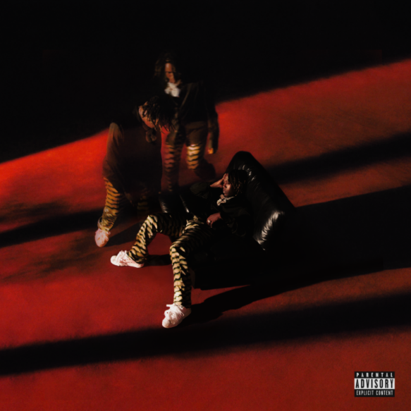
DOWNLOAD LIFE OF A DON COVER ART
DOWNLOAD PRESS PHOTOS (PC: White Trash Tyler)

Don Toliver announces his sophomore album LIFE OF A DON is set for an October 8th release date. Pre-save LIFE OF A DON HERE. Watch the album trailer HERE, featuring unreleased track “Xscape.” With his LIFE OF A DON headline tour sold out in most cities, Toliver continues his voyage across North America on Wednesday in Detroit, MI. Purchase tickets HERE. He recently tapped GRAMMY® Award-winning singer Kali Uchis for “Drugs N Hella Melodies.” Shot in Medellìn, Colombia, the Nabil Elderkin-directed companion visual transmits another head-nodding hook over immersive psychedelic production from LosHendrix [Kehlani, SZA], DJ Dahi [Kendrick Lamar, Childish Gambino], and Dylan Wiggins. It forges on the dynamic story-line from the initial cinematic Nabil Elderkin directed visual for “What You Need.” Distinguished by Apple Music as an Up Next artist and named Rookie of the Year by Spotify’s Rap Caviar, Don Toliver is just getting started.

REMAINING LIFE OF A DON TOUR DATES:
Wed Sep 29 – Detroit, MI – Fillmore Detroit
Thu Sep 30 – Pittsburgh, PA – Stage AE
Sat Oct 02 – New York, NY – The Rooftop at Pier 17
Sun Oct 03 – Montclair, NJ – Wellmont Theatre
Mon Oct 04 – Boston, MA – House of Blues
Wed Oct 06 – Wallingford, CT – The Dome at Oakdale Theatre
Thu Oct 07 – Philadelphia, PA – Fillmore Philadelphia
Sun Oct 10 – Washington, DC – Echostage
Tue Oct 12 – Raleigh, NC – The Ritz
Wed Oct 13 – Charlotte, NC – Fillmore Charlotte
Fri Oct 15 – Miami, FL – The Oasis
Sun Oct 17 – Atlanta, GA – Coca Cola Roxy
Wed Oct 20 – Houston, TX – Bayou Music Center
Fri Oct 22 – Dallas, TX – The Bomb Factory
Sun Oct 24 – Denver, CO – Fillmore Auditorium
Mon Oct 25 – Salt Lake City, UT – The Complex
Sat Oct 30 – Los Angeles, CA – Palladium
Fri Nov 5 – Houston, TX – Astroworld
Sun Nov 14 – Las Vegas, NV – Day N Vegas
Sun Dec 12 – Los Angeles, CA – Rolling Loud

PRAISE FOR DON TOLIVER:
Don Toliver has established himself as one of hip-hop’s fastest rising stars. He’s a star who will be around for a long time.
COMPLEX

One of the biggest breakthrough artists of 2020
ROLLING STONE

The Travis Scott protégé has become one of the most promising artists to emerge from Houston.
HIGHSNOBIETY

Don Toliver has continued to demonstrate himself as one of hip-hop’s most promising newcomers.
HYPEBEAST

There is no replicating a sound this singular. Don proves once again he can enter other artists’ worlds and still leave completely under his own pretense.
INTERVIEW MAGAZINE

ABOUT DON TOLIVER:
If Don Toliver pulled up in a spaceship, nobody would question it. His music might as well be its own solar system with otherworldly hip-hop, smoked-out R&B, ambitious pop, and a little rock in a planetary orbit around the multiplatinum singer, songwriter, and artist. It might seem like he hails from some far away galaxy, but he calls Houston, TX home. Forged in the fires of his hometown, he grinded out a visionary style in underground shows, elevating the post-genre grime and grit of his city into mainstream focus. After the 2018 mixtape Donny Womack, he assembled his full-length debut, Heaven Or Hell. It claimed spots on mid-year and year-end lists by Complex and XXL, while Rolling Stone championed him among the 10 Biggest Breakthrough Artists of 2020. LOSEminem, Nas, and Rico Nasty recruited him for collaborations. Plus, he joined forces with Internet Money, NAV, and Gunna for the triple-platinum banger “Lemonade,” which they also performed on The Tonight Show Starring Jimmy Fallon. Within three years, he has gathered billions of streams, scored platinum plaques, and received praise courtesy of everybody from High Snobiety to Interview Magazine. However, it’s all a part of his life—as chronicled on his 2021 second full-length album, Life Of A DON [Cactus Jack/Atlantic Records], preceded by “What You Need,” “Drugs N Hella Melodies,” and

PRESS CONTACT:
Brittany Bell, Brittany.Bell@atlanticrecords.com

