FOR IMMEDIATE RELEASE
OCTOBER 2, 2020

BRI STEVES FLEXES IN PHILLY FOR “STICK UP”

RAPPER RECRUITS FELLOW PHILLY NATIVE POUNDSIDE POP TO DEFY EXPECTATIONS
OF THE FEMALE RAPPER IN LATEST SINGLE & VISUAL

LISTEN TO “STICK UP” FT. POUNDSIDE POP:
BRISTEVES.LNK.TO/STICKUP

WATCH OFFICIAL VIDEO:
BRISTEVES.LNK.TO/STICKUPVIDEO

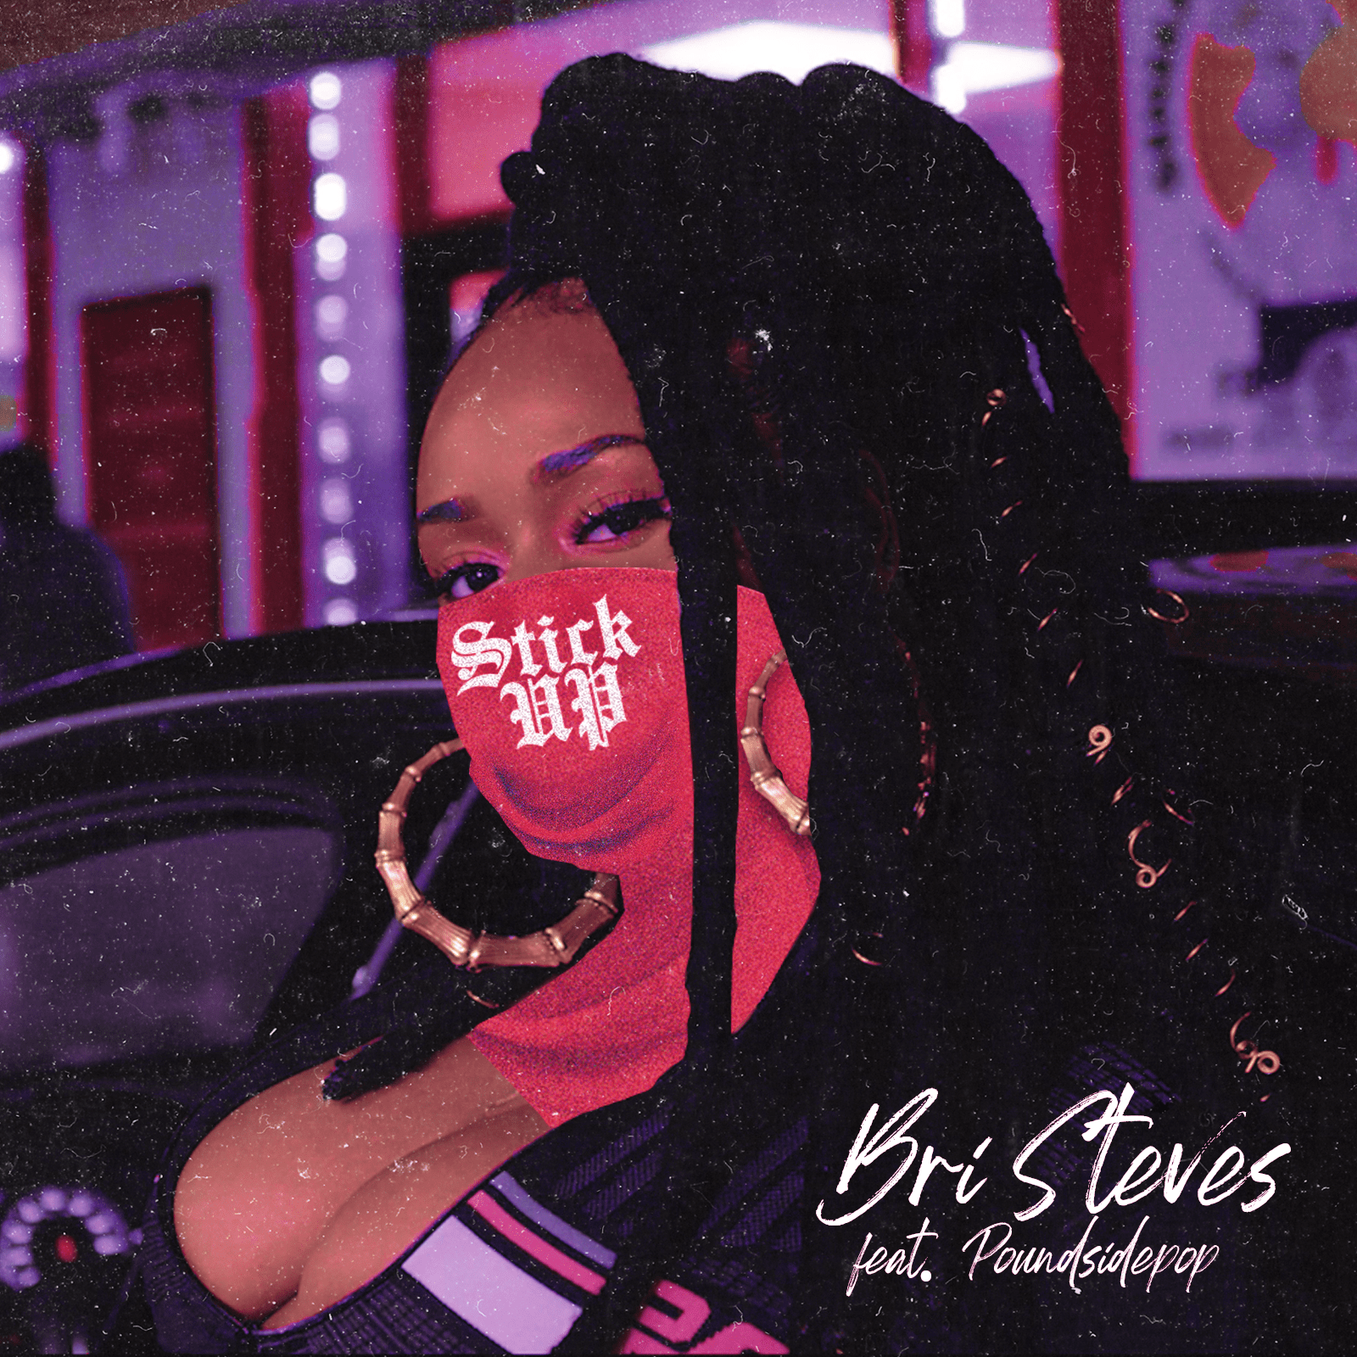
DOWNLOAD PRESS ASSESTS HERE

Atlantic Records’ Bri Steves is back with “Stick Up” alongside fellow Philly rapper, Poundside Pop and refuses to fit in any societal boxes. The lead single and video off her forthcoming EP, “Stick Up” (produced by Nabeyin) is a stellar exhibition of Bri’s talent for penning melody and motivation while breaking the female rapper mold, redefining the experience and unapologetically making it her own. The Janoff-directed visual showcases the two rappers flexing through the streets of “Brotherly Love,” proving the cocoa beauty’s ability to walk into any boy’s club and spit for the entire female experience. Watch via YouTube HERE. “Stick Up” ft. Poundside Pop is available now at all DSPs and streaming services HERE.

“I’ve been so excited to release ‘Stick Up,’” notes Bri. “It’s fun, has crazy energy and I tapped my bro Poundside Pop from my city to hop on it. It’s giving people a taste of what to expect on my project.”

ABOUT BRI STEVES
The 25-year-old, Philadelphian MC is as multi-layered as she is multi-talented. Bri’s music dreams were first inspired by greats like Marvin Gaye and Lauryn Hill. At age 10, she began studying the viola at the Delaware Symphony Orchestra. Some years later, champion lyricists like Biggie, Joey Bada$$ and J. Cole inspired her to start rapping. While attending Temple University, she began experimenting with her singing voice and eventually maturated into a double threat on the mic. Before graduating, she signed with Atlantic Records and balanced her final collegiate year alongside studio time in Miami, Atlanta and Los Angeles where she worked with producers like Sonny Digital.

Her debut single “Jealousy,” produced by T-Minus and Yung Berg, climbed to #15 on the charts and garnered her major media acclaim from outlets like Revolt and Billboard. iHeart anointed Bri an “On The Verge” artist and The Fader named her one of “5 Artists Ready To Be Philadelphia’s Next Champion.” She soon found herself opening for artists like H.E.R., Mary J Blige, Pharrell and mentor Kendrick Lamar. Now, she sets her sights on releasing her debut EP, with “Stick Up” ft. Poundside Pop leading the way. All hail the new highness: Bri Steves.

CONNECT WITH BRI STEVES
OFFICIAL | INSTAGRAM | FACEBOOK | TWITTER | YOUTUBE | SPOTIFY | SOUNDCLOUD

PRESS CONTACT
Fairley McCaskill | Fairley.McCaskill@atlanticrecords.com

