GUCCI MANE DROPS “BIG BOOTY” FT. MEGAN THEE STALLION

SINGLE OFF UPCOMING 101ST PROJECT + 15TH STUDIO ALBUM WOPTOBER II

“BIG BOOTY” STREAMING AT ALL DSPS HERE

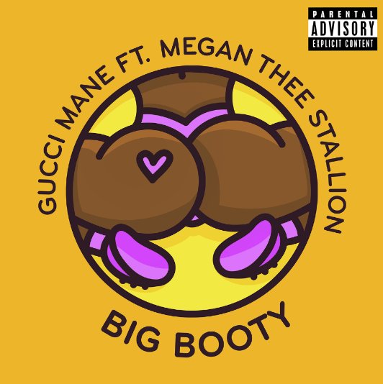
HIGH-RES COVER ART DOWNLOAD HERE

Atlantic recording artist Gucci Mane has dropped “Big Booty” ft. Megan Thee Stallion, the second single off his upcoming highly-anticipated new album, WOPTOBER II. “Big Booty” ft. Megan Thee Stallion is available at all DSPs and streaming services HERE.
The groundbreaking rap icon’s 15th studio album and 101st overall project WOPTOBER II arrives Thursday, October 17th at 9pm PT at all music retailers and streaming services. WOPTOBER II features exclusive cover art from Gucci’s global ad campaign partnership with his namesake luxury brand Gucci. The new Cruise 2020 #ComeAsYouAre_RSVP ad campaign launched on October 1st and was shot by iconic filmmaker/photographer Harmony Korine. Gucci Mane most recently sat front row at the Gucci SS20 fashion show in Milan, following which Hypebeast speculated that there could be something in the works between the two. Hypebeast confirmed the collaboration following Gucci Mane’s album art reveal on Monday. View behind-the-scenes photos from the Gucci campaign HERE. (Photographer credit to Harmony Korine; Creative director credit to Alessandro Michele; Art director credit to Christopher Simmonds.)
The album includes an array of special guest features, including the recently released “Richer Than Errybody (Feat. YoungBoy Never Broke Again & DaBaby).” “Richer Than Errybody” drew acclaim upon its release last month from XXL, Rap Radar, UPROXX, and HYPEBEAST. Complex featured the breakout single in its Best New Music This Week roundup, noting how “Each artist glides over the Lex Luger-produced trap beat, easily handing off to each other on the next verse . . . Tracks that boast a handful of features sometimes feel off-balance, but Gucci Mane expertly enlisted artist that wouldn’t overpower one another on this one. They all shine in their own lane.”

WOPTOBER II arrives hot on the heels of Gucci’s most recent mixtape, DELUSIONS OF GRANDEUR, available now at all music retailers and streaming services HERE. The acclaimed mixtape includes the summer anthems, “Love Thru The Computer (Feat. Justin Bieber),” “Backwards (Feat. Meek Mill),” and “Proud Of You,” all available for individual streaming and download. In addition, both “Backwards (Feat. Meek Mill)” and “Proud Of You” are joined by a new companion video, streaming now at the official Gucci Mane YouTube channel HERE.

Long known as an electrifying live artist, Gucci Mane recently rocked Atlanta, GA’s 10th annual One Musicfest, prompting the Atlanta Journal-Constitution to write, “(Gucci) took the audience on a journey throughout his career both visually and sonically, showcasing old photos of himself on the screen as he rapped both newer songs such as the Migos-assisted ‘I Get the Bag’ and Rae Sremmurd’s ‘Black Beatles,’ and older cuts such as ‘I Think I Love Her,’ ‘Bricks,’ and ‘Make the Trap Say Aye’ (sans OJ Da Juiceman)… Gucci’s hour-long set was a reminder of just how prolific the Zone 6 rapper has been, as well as how intertwined his sound has become with Atlanta’s rap legacy.”

Widely regarded as the most influential underground rapper of the past decade, Gucci Mane has more Top 10 albums on Billboard’s “Top Rap Albums” chart and more Top 20 singles that any other hip-hop artist in history. EVIL GENIUS marked Gucci’s first full-length release since his prolific 2017 culminated with the acclaimed EL GATO: THE HUMAN GLACIER. That album in turn followed the RIAA gold certified MR. DAVIS, highlighted by the 3x platinum hit single, “I Get The Bag (Feat. Migos),” recently certified platinum by the RIAA and joined by a massively popular companion video, now boasting over 376 million views at Gucci Mane’s official YouTube channel alone.

CONNECT WITH GUCCI MANE
OFFICIAL | INSTAGRAM | TWITTER | FACEBOOK | YOUTUBE

For additional press assets, please visit press.atlanticrecords.com/Gucci-mane

PRESS CONTACT
Fairley McCaskill | Fairley.McCaskill@atlanticrecords.com

