FOR IMMEDIATE RELEASE
OCTOBER 14, 2020

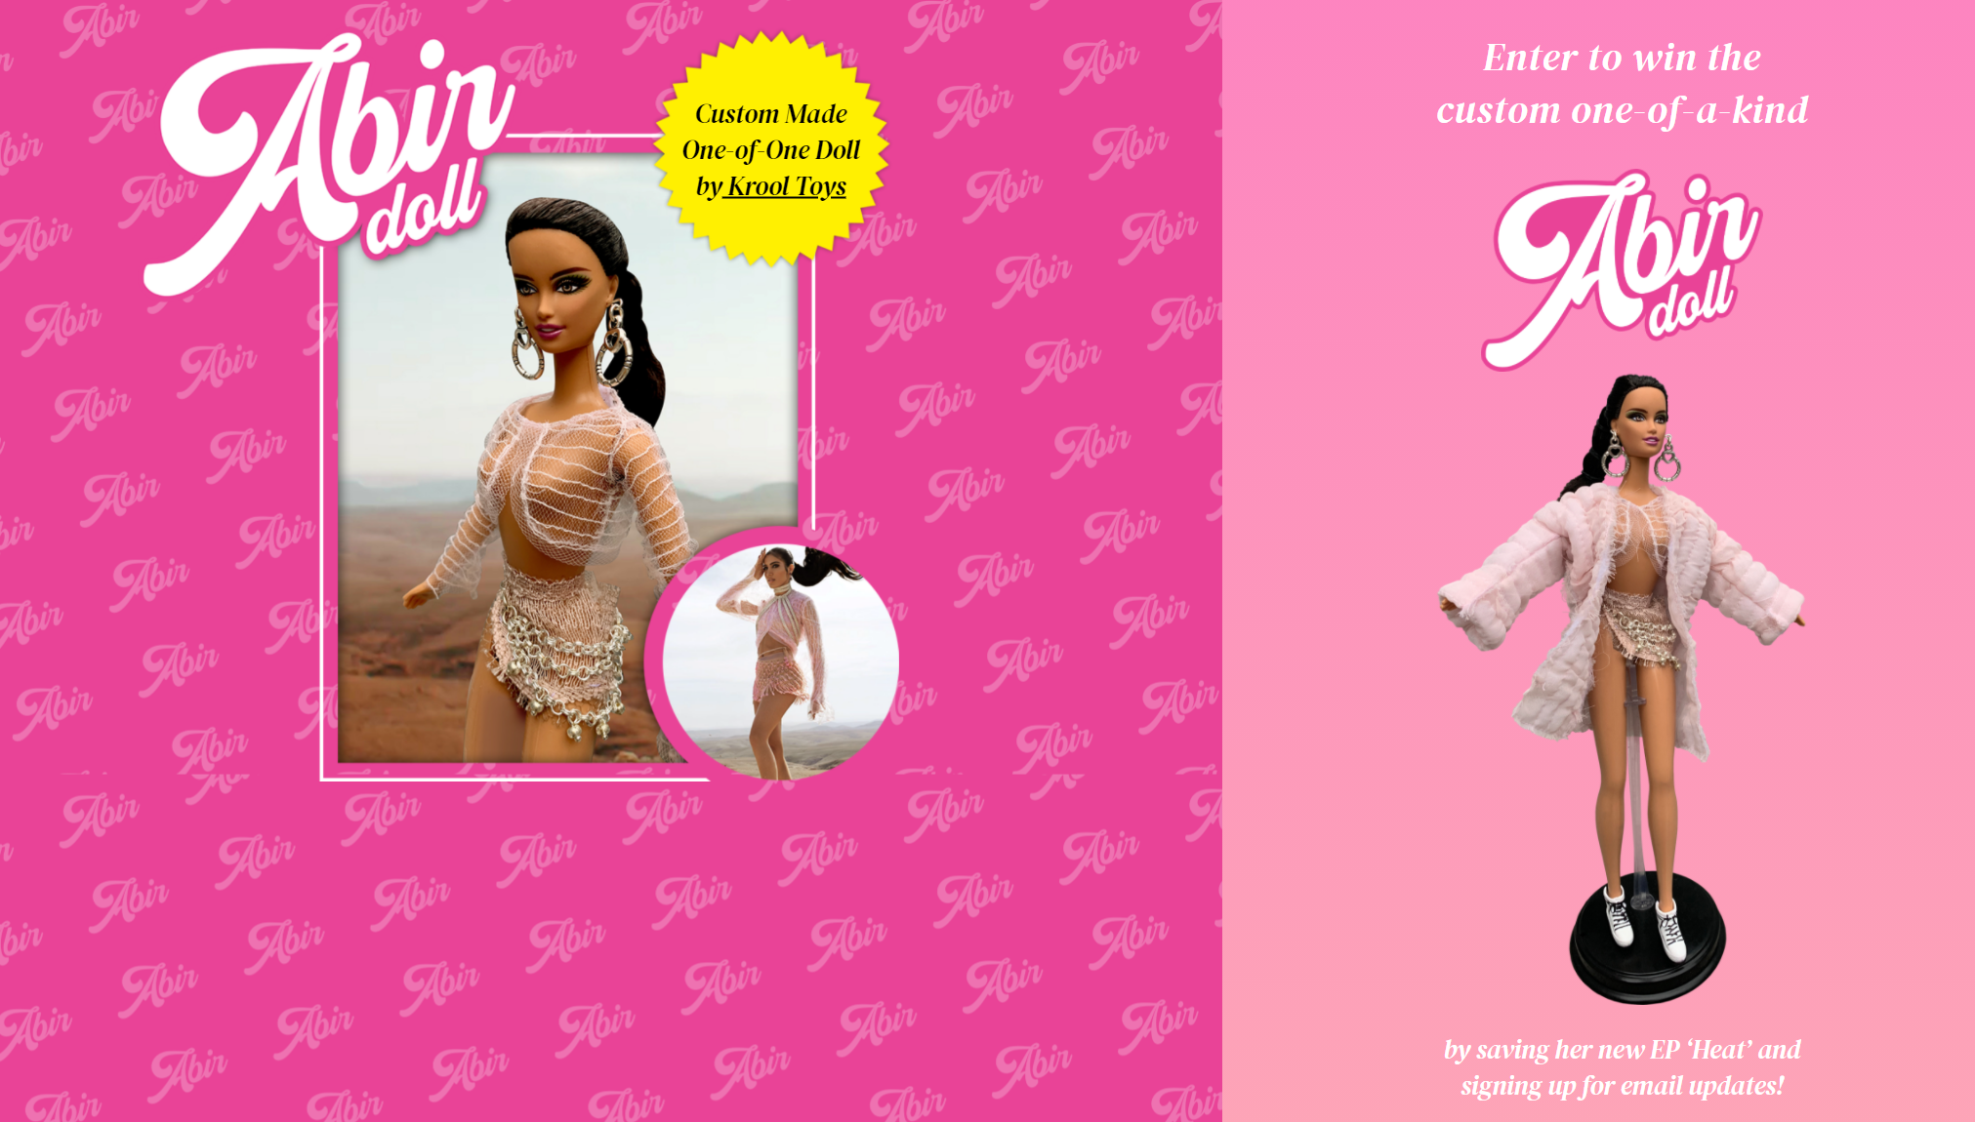

MOROCCAN-AMERICAN POP SONGSTRESS ABIR (عبير) INTRODUCES NEW
CUSTOM DOLL INSPIRED BY “INFERNO” MUSIC VISUAL

WANT THE CHANCE TO WIN THE ABIR DOLL??
ENTER HERE TO WIN

LISTEN TO ABIR’S LATEST EP, HEAT, HERE

WATCH OFFICIAL “INFERNO” VISUAL HERE

WATCH OFFICIAL “YALLAH” VISUAL HERE

ABIR is using Arab-Pop to shatter the Muslim woman stereotype. The singer-songwriter's unapologetic new project HEAT shows that she has something to say — and she's not afraid to get loud.
NYLON

Rising Moroccan-American Pop star, ABIR, has partnered with Krool Toys to bring her fans an exclusive, one-of-a-kind ABIR doll! Enter to win the custom doll HERE. The ABIR doll was inspired by her stunning music visual “Inferno,” which was filmed in Morocco by an all-Arab team. Earlier this summer, ABIR released her highly-anticipated EP, HEAT, which fuses pop sounds from the West and eclectic musical influences from the East. ABIR followed up the “Inferno” video with “Yallah” — a uniquely powerful piece of visual art that showcases the artist’s hypnotic vocal presence.

ABOUT ABIR
Hailed as one of the most promising young artists on the music scene today, ABIR is boldly redefining perceptions of what it means to be an Arab woman in the modern world. Born in Morocco and raised in the U.S., the New York City-based singer first showcased her hypnotic vocal work and extraordinary range on her gold-certified record “Finest Hour” and 2018 debut EP Mint (her inaugural release for Atlantic Records). On her forthcoming sophomore EP Heat, ABIR embraces her heritage more fully than ever, infusing her magnetic take on pop/R&B with elements of the Arab music she grew up on. A daughter of the east and west, ABIR ultimately shatters countless stereotypes while instilling a thrilling new energy into the pop landscape.

For additional press assets, visit her press site press.atlanticrecords.com/abir.

CONNECT WITH ABIR
OFFICIAL |INSTAGRAM| TWITTER | FACEBOOK l YOUTUBE

PRESS CONTACT
FAIRLEY MCCASKILL | FAIRLEY.MCCASKILL@ATLANTICRECORDS.COM

