POWERHOUSE VOCALIST ABIR UNVEILS LONG AWAITED DEBUT EP “MINT”

NEW SINGLE AND VISUAL, “YOUNG & RUDE,” SURPASSES 1.5 MILLION STREAMS IN LESS THAN A MONTH

U.S. TOUR ALONGSIDE KIIARA GETS UNDERWAY OCTOBER 29TH

“MINT” AVAILABLE TODAY AT ALL DSPS AND STREAMING SERVICES

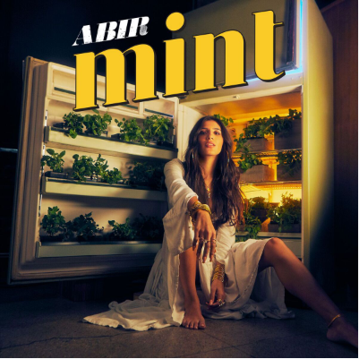

Atlantic recording artist ABIR has announced today’s release of hugely anticipated label debut EP, “MINT,” available at all DSPs and streaming services HERE. “MINT” includes a special guest feature from rising rapper Buddy on the standout track, “Lose Me.” Listen HERE.

“MINT” is highlighted by the new single, “Young & Rude,” available for individual streaming and download HERE. The track is joined by a new companion visual, directed by Shomi Patwary (Beyoncé, Beally Feat. The Weeknd) and streaming now at ABIR’s official YouTube channel HERE.

“Young & Rude” received online applause upon its arrival last month, with Idolator raving, “ABIR is shaping up to be one of the breakout stars of 2018…The amazingly-titled ‘Young & Rude’ (is) an instantly anthemic pop song about letting your hair down and living in the moment. Those themes are conveyed perfectly in the video.”

ABIR – whose signing to Atlantic was announced last month exclusively via Billboard – has also unveiled “Finest Hour (Acoustic),” a stripped-down rendition of her smash collaboration with chart-topping electronic production trio Cash Cash, “Finest Hour” out now on Big Beat Records. “Finest Hour (Acoustic)” is available now for streaming and download HERE; the track’s official companion visual can be viewed HERE.

Written by ABIR, “Finest Hour” – available for streaming and download HERE – was one of this summer’s biggest anthems, topping iTunes’ “Dance Songs” chart for eight weeks on its way to the overall Top 40. The track is joined by an equally popular companion visual, directed by Phillip R. Lopez (Avicii, Kygo, Selena Gomez) and streaming now HERE.

“Finest Hour” was greeted by widespread critical praise, with Paper writing, “(ABIR’s) R&B-infused pop pairs uninhibited vocals with intimate, carefully-articulated observations of the world around her…’Finest Hour,’ which layers ABIR’s powerful Sia-esque vocals over Cash Cash’s characteristic wash of booming synth, metronomic drums, and meandering horns. ABIR laments that this isn’t her finest hour, but her confident vocals paired with the ecstatic instrumentals make it clear that she isn’t giving up any time soon.”

Following an appearance on Elvis Duran’s Z100 morning show to perform “Finest Hour,” the popular radio host surprised Cash Cash and ABIR with a pledge to donate $2 to St. Jude’s Children’s Research Hospital for every download over a 48-hour span. Cash Cash and ABIR later made a special visit to St. Jude’s to perform and meet patients.

Named by Billboard as one of the “most exciting new voices” in recent pop memory, ABIR followed “Finest Hour” with her own “Way Out,” available for streaming and download HERE. A companion visual, directed by Johnny Valencia (Ed Sheeran, Rudimental), is streaming now at the official ABIR YouTube channel HERE. The clip had its world premiere exclusively via Refinery 29, which declared it to be “a visual nod to ABIR’s own journey and her three years of traversing (New York City)…’Way Out’ Is a love letter to the city that never stops working.”

ABIR – who joined Cash Cash for performances of “Finest Hour” at this year’s Coachella Valley Music & Arts Festival and Electric Zoo – has also drawn acclaim as a striking live act, including special guest turns alongside such like-minded artists as Alessia Cara, The-Dream, Bob Moses, Amine and more. Next up is a major U.S. tour supporting Kiiara, with dates beginning October 29th at Chicago, IL’s Lincoln Hall and then traveling through November. For complete details, please visit www.abirmusic.com/#tour.

ABIR has already made an impact on contemporary pop, earning acclaim and attention for her sultry fusion of R&B, dance grooves, and intimate lyricism. In addition to her musical success, the Morocco-born, New York, NY-based artist has also teamed with Clinique and Beats By Dre for popular brand partnerships, not to mention live performances for Fendi and Made at the always-influential New York Fashion Week.

CONNECT WITH ABIR:
OFFICIAL |INSTAGRAM| TWITTER | FACEBOOK l SOUNDCLOUD

FOR ALL PRESS INQUIRIES, PLEASE CONTACT:
Corey.Brewer@atlanticrecords.com

ABIR
ON TOUR
ALL DATES W/KIIARA

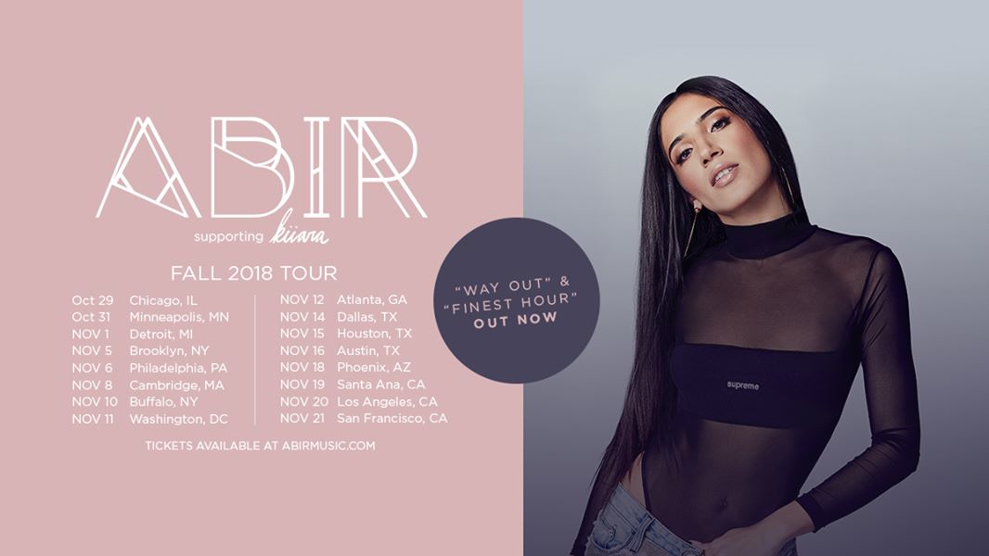

OCTOBER
29 – Chicago, IL – Lincoln Hall
31 – Minneapolis, MN – Fine Line Music Café

NOVEMBER
1 – Detroit, MI – The Shelter
5 – Brooklyn, NY – Elsewhere
6 – Philadelphia, PA – TLA
8 – Cambridge, MA – The Sinclair
10 – Buffalo, NY – Rec Room
11 – Washington, DC – U Street Music Hall
12 – Atlanta, GA – Terminal West
14 – Dallas, TX – Trees
15 – Houston, TX – Warehouse Live
16 – Austin, TX – Antone’s
18 – Phoenix, AZ – The Crescent Ballroom
19 – Santa Ana, CA – Constellation Room At The Observatory
20 – Los Angeles, CA _ Regent Theater
21 – San Francisco, CA – August Hall

# # #

