FOR IMMEDIATE RELEASE
NOVEMBER 11, 2020

BRI STEVES HATES BEING “SOBER”

RAPPER SLOWS IT DOWN & TAKES US TO THE CLUB IN LATEST SINGLE & VISUAL

ON THE HEELS OF “STICK UP” FT. POUNDSIDE POP
LISTEN | WATCH

FORTHCOMING PROJECT DUE EARLY 2021

STREAM “SOBER”:
BRISTEVES.LNK.TO/SOBER

WATCH “SOBER”:
BRISTEVES.LNK.TO/SOBERVIDEO

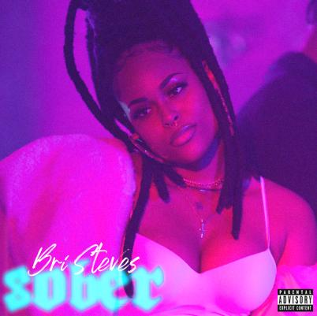
DOWNLOAD PRESS ASSESTS HERE

Atlantic Records’ Bri Steves has us reminiscing nights at the club with the Janoff-directed visual for “Sober.” The rapper embraces her feminine side in the bedroom while holding it down in the bar neon lights at the bar in the visual for her latest single off the forthcoming EP. The track was written by Bri Steves and Akeel Henry (Ty Dolla $ign, Jeremih) and Michel Holmes, and produced by DZL (Future, Meek Mill, Chris Brown, 6lack, Teyana Taylor) and Akeel Henry. Watch the visual offering via YouTube HERE. “Sober” is available now at all DSPs and streaming services HERE.

“I wrote “Sober” about my ex,” notes Steves. “We’ve always had this toxic relationship, and I’d always call him when I was drunk. That’s what “Sober” is all about – the past, just like the liquor... It’s all intoxicating.”

Most recently Steves arrived with “Stick Up” alongside fellow Philly rapper, Poundside Pop, refusing to fit in any societal boxes. The lead single and video off her forthcoming EP, “Stick Up” (produced by Nabeyin) is a stellar exhibition of Bri’s talent for penning melody and motivation while breaking the female rapper mold, redefining the experience and unapologetically making it her own. The Janoff-directed visual showcases the two rappers flexing through the streets of “Brotherly Love,” proving the cocoa beauty’s ability to walk into any boy’s club and spit for the entire female experience.

ABOUT BRI STEVES
The 25-year-old, Philadelphian MC is as multi-layered as she is multi-talented. Bri’s music dreams were first inspired by greats like Marvin Gaye and Lauryn Hill. At age 10, she began studying the viola at the Delaware Symphony Orchestra. Some years later, champion lyricists like Biggie, Joey Bada$$ and J. Cole inspired her to start rapping. While attending Temple University, she began experimenting with her singing voice and eventually maturated into a double threat on the mic. Before graduating, she signed with Atlantic Records and balanced her final collegiate year alongside studio time in Miami, Atlanta and Los Angeles where she worked with producers like Sonny Digital.

Her debut single “Jealousy,” produced by T-Minus and Yung Berg, climbed to #15 on the charts and garnered her major media acclaim from outlets like Revolt and Billboard. iHeart anointed Bri an “On The Verge” artist and The Fader named her one of “5 Artists Ready To Be Philadelphia’s Next Champion.” She soon found herself opening for artists like H.E.R., Mary J Blige, Pharrell and mentor Kendrick Lamar. Now, she sets her sights on releasing her debut EP, with “Stick Up” ft. Poundside Pop and “Sober” leading the way. All hail the new highness: Bri Steves.

CONNECT WITH BRI STEVES
OFFICIAL | INSTAGRAM | FACEBOOK | TWITTER | YOUTUBE | SPOTIFY | SOUNDCLOUD

PRESS CONTACT
Fairley McCaskill | Fairley.McCaskill@atlanticrecords.com

