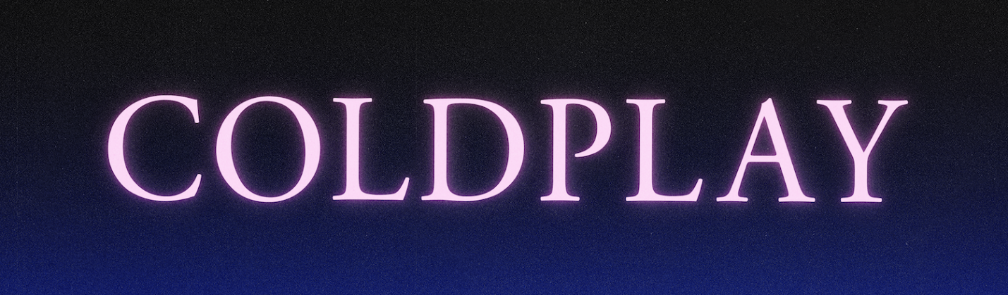
COLDPLAY TO RELEASE HIGHER POWER
NEW SINGLE OUT FRIDAY, MAY 7

Coldplay’s brand new single, Higher Power, has today been confirmed for release on Friday, May 7 via Parlophone / Atlantic.

Said Coldplay on Twitter: “Higher Power is a song that arrived on a little keyboard and a bathroom sink at the start of 2020. It was produced by Max Martin who is a true wonder of the universe. It’s out on Friday 7 May. Love c, g, w & j”

The announcement confirms fan rumors that have circulated since last week, when cryptic billboards around the world pointed to a mysterious website called alienradio.fm.

Fans managed to decipher the letter-like symbols to uncover the song title and release date.

The track is available to pre-order / pre-save on streaming platforms, from here.

Click here to download the single artwork and press images in hi-res.

For more information please visit Coldplay.com or contact:
Sheila Richman (Atlantic Records) – sheila.richman@atlanticrecords.com
Ted Sullivan (Atlantic Records) – ted.sullivan@atlanticrecords.com

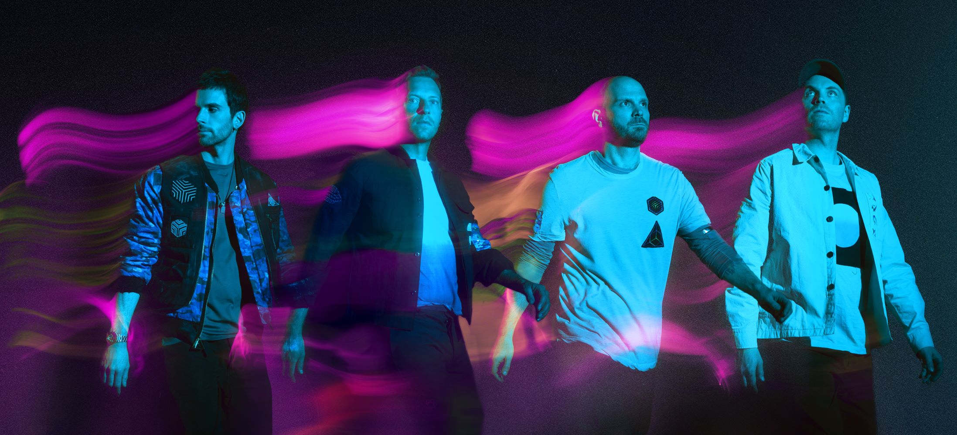
Photo by Dave Meyers and art direction by Pilar Zeta (download high-res)
Higher Power billboard in New York City, April 22, 2021 (download high-res)

