**A BOOGIE WIT DA HOODIE RECRUITS LIL DURK FOR “24 HOURS”**

***MORE MUSIC COMING VERY SOON…***

[**DOWNLOAD/STREAM: “24 Hours (Feat. Lil Durk)”**](https://aboogie.lnk.to/24Hours)

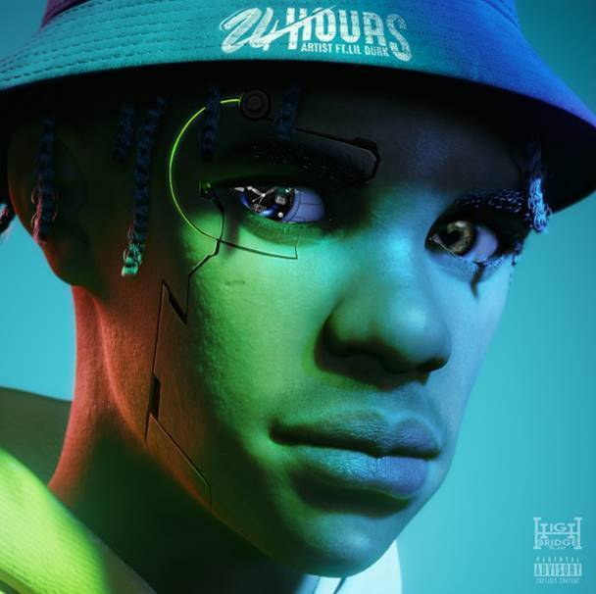

[DOWNLOAD HIGH-RES ARTWORK HERE](https://nam04.safelinks.protection.outlook.com/?url=https%3A%2F%2Fpress.atlanticrecords.com%2Fa-boogie-wit-da-hoodie%2F&data=04%7C01%7CBrian.Sommer%40atlanticrecords.com%7C50ee6a6f7d5b442d9a0108d91bd71610%7C8367939002ec4ba1ad3d69da3fdd637e%7C0%7C0%7C637571432861781892%7CUnknown%7CTWFpbGZsb3d8eyJWIjoiMC4wLjAwMDAiLCJQIjoiV2luMzIiLCJBTiI6Ik1haWwiLCJXVCI6Mn0%3D%7C1000&sdata=HnAYyD9QvQE%2FOw0BCurIO2PcgKwproEK8fbo3yW%2F4Xc%3D&reserved=0)

**CONNECT WITH A BOOGIE WIT DA HOODIE:**

[INSTAGRAM](https://nam04.safelinks.protection.outlook.com/?url=https%3A%2F%2Fwww.instagram.com%2Faboogievsartist%2F%3Fhl%3Den&data=04%7C01%7CBrian.Sommer%40atlanticrecords.com%7C50ee6a6f7d5b442d9a0108d91bd71610%7C8367939002ec4ba1ad3d69da3fdd637e%7C0%7C0%7C637571432861791889%7CUnknown%7CTWFpbGZsb3d8eyJWIjoiMC4wLjAwMDAiLCJQIjoiV2luMzIiLCJBTiI6Ik1haWwiLCJXVCI6Mn0%3D%7C1000&sdata=vBcTUey09hcyTb3kTTC55kDT9j9s8eb2WEn6L4QJ79o%3D&reserved=0) | [TWITTER](https://nam04.safelinks.protection.outlook.com/?url=https%3A%2F%2Ftwitter.com%2FArtistHBTL%3Fref_src%3Dtwsrc%255Egoogle%257Ctwcamp%255Eserp%257Ctwgr%255Eauthor&data=04%7C01%7CBrian.Sommer%40atlanticrecords.com%7C50ee6a6f7d5b442d9a0108d91bd71610%7C8367939002ec4ba1ad3d69da3fdd637e%7C0%7C0%7C637571432861801879%7CUnknown%7CTWFpbGZsb3d8eyJWIjoiMC4wLjAwMDAiLCJQIjoiV2luMzIiLCJBTiI6Ik1haWwiLCJXVCI6Mn0%3D%7C1000&sdata=2F1QY8VhSjRmpppuI4Vx3zknHsM1dDiMrlDtnJn3Zn8%3D&reserved=0) | [FACEBOOK](https://nam04.safelinks.protection.outlook.com/?url=https%3A%2F%2Fwww.facebook.com%2FArtistHBTL&data=04%7C01%7CBrian.Sommer%40atlanticrecords.com%7C50ee6a6f7d5b442d9a0108d91bd71610%7C8367939002ec4ba1ad3d69da3fdd637e%7C0%7C0%7C637571432861801879%7CUnknown%7CTWFpbGZsb3d8eyJWIjoiMC4wLjAwMDAiLCJQIjoiV2luMzIiLCJBTiI6Ik1haWwiLCJXVCI6Mn0%3D%7C1000&sdata=n1nibGCcu7LWIfKFLbDqN4oGEh64FMd7GXH69U7a99s%3D&reserved=0) | [YOUTUBE](https://nam04.safelinks.protection.outlook.com/?url=https%3A%2F%2Fwww.youtube.com%2Fc%2FArtistHBTL%2Ffeatured&data=04%7C01%7CBrian.Sommer%40atlanticrecords.com%7C50ee6a6f7d5b442d9a0108d91bd71610%7C8367939002ec4ba1ad3d69da3fdd637e%7C0%7C0%7C637571432861811877%7CUnknown%7CTWFpbGZsb3d8eyJWIjoiMC4wLjAwMDAiLCJQIjoiV2luMzIiLCJBTiI6Ik1haWwiLCJXVCI6Mn0%3D%7C1000&sdata=P7kmdvxnapI%2Fl4uWjG5CYISzW6kjRt%2BkQVhxYIp1yOM%3D&reserved=0) | [PRESS SITE](https://nam04.safelinks.protection.outlook.com/?url=https%3A%2F%2Fpress.atlanticrecords.com%2Fa-boogie-wit-da-hoodie%2F&data=04%7C01%7CBrian.Sommer%40atlanticrecords.com%7C50ee6a6f7d5b442d9a0108d91bd71610%7C8367939002ec4ba1ad3d69da3fdd637e%7C0%7C0%7C637571432861811877%7CUnknown%7CTWFpbGZsb3d8eyJWIjoiMC4wLjAwMDAiLCJQIjoiV2luMzIiLCJBTiI6Ik1haWwiLCJXVCI6Mn0%3D%7C1000&sdata=OEZR6ImXZmuj%2BWE9rqTa%2F4W5pWxqHmB4mo6P4LYiFFY%3D&reserved=0)

**PRESS CONTACT:**

JASON DAVIS – [JASON.DAVIS@ATLANTICRECORDS.COM](mailto:JASON.DAVIS@ATLANTICRECORDS.COM)