

**A BOOGIE WIT DA HOODIE RELEASES LONG AWAITED DELUXE EDITION OF *ARTIST 2.0* WITH A PAIR OF HIGH-PROFILE VISUALS FOR LIL UZI VERT & YOUNG THUG COLLABORATIONS**

**WATCH:** [**“REPLY (FEAT. LIL UZI VERT)”**](https://www.youtube.com/watch?v=9f9sQ2Kis9Q&feature=youtu.be)

**WATCH:** [**“MIGHT NOT GIVE UP (FEAT. YOUNG THUG)”**](https://www.youtube.com/watch?v=UDHVxd76EUw&feature=youtu.be)

***ARTIST 2.0 (DELUXE)* OUT TODAY**

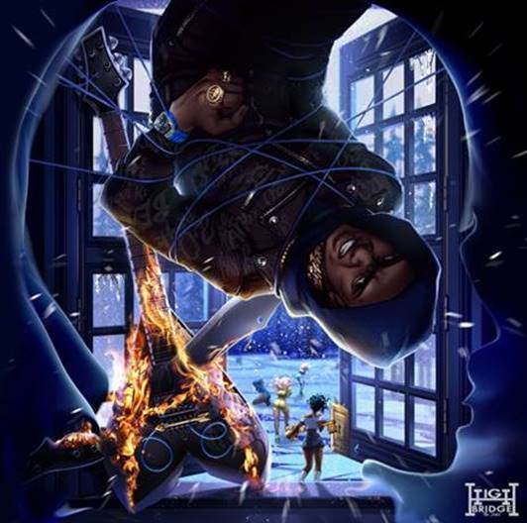

[DOWNLOAD HIGH-RES ARTWORK](https://nam04.safelinks.protection.outlook.com/?url=http%3A%2F%2Fpress.atlanticrecords.com%2Fa-boogie-wit-da-hoodie%2F&data=02%7C01%7CBrian.Sommer%40atlanticrecords.com%7C0b10d4fb673c4b4a123f08d813d08aff%7C8367939002ec4ba1ad3d69da3fdd637e%7C0%7C0%7C637281133696699190&sdata=HEbZRcnjKSil51GA1K%2BsVsl1WXJo5DsbNPbGrITD3qc%3D&reserved=0)

**New York, NY – June 19th, 2020 –** Multi-platinum recording artist **A Boogie Wit Da Hoodie** hasreleased two new videos for his RIAA certified-platinum single, [**“Reply (Feat. Lil Uzi Vert),”**](https://nam04.safelinks.protection.outlook.com/?url=https%3A%2F%2Fyoutu.be%2F9f9sQ2Kis9Q&data=02%7C01%7CBrian.Sommer%40atlanticrecords.com%7C0b10d4fb673c4b4a123f08d813d08aff%7C8367939002ec4ba1ad3d69da3fdd637e%7C0%7C0%7C637281133696689195&sdata=jCOpB58kBvqHMoxINsEFiqsXogFbeYOq%2FT8jgwrT2Wc%3D&reserved=0) directed by **Kid Art** and the fan-favorite collaboration [**“Might Not Give Up (Feat. Young Thug),”**](https://nam04.safelinks.protection.outlook.com/?url=https%3A%2F%2Fyoutu.be%2FUDHVxd76EUw&data=02%7C01%7CBrian.Sommer%40atlanticrecords.com%7C0b10d4fb673c4b4a123f08d813d08aff%7C8367939002ec4ba1ad3d69da3fdd637e%7C0%7C0%7C637281133696689195&sdata=Ssi1e47al4n05%2FnIu9X8ZFjE2YysjeN%2FupI5FkGkUhQ%3D&reserved=0)directed by **Hype Williams.**

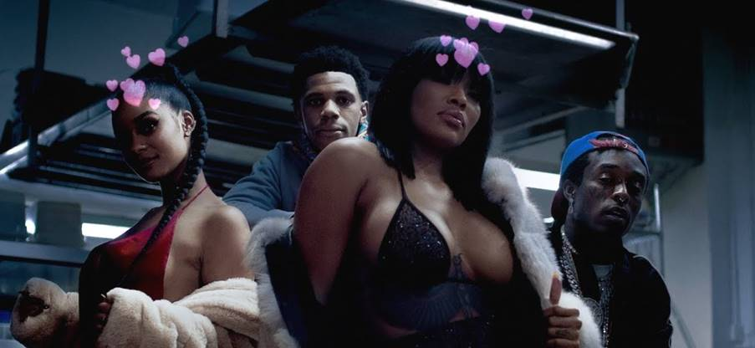

The new companion visuals arrive as the Bronx-bred superstar raises the curtain on the deluxe edition of his chart-topping third studio album, ***ARTIST 2.0***, available now via Highbridge The Label/Atlantic Records – [**LISTEN HERE**](https://nam04.safelinks.protection.outlook.com/?url=https%3A%2F%2Faboogie.lnk.to%2FArtist2Deluxe&data=02%7C01%7CBrian.Sommer%40atlanticrecords.com%7C0b10d4fb673c4b4a123f08d813d08aff%7C8367939002ec4ba1ad3d69da3fdd637e%7C0%7C0%7C637281133696699190&sdata=bY9lqlI5pMuIH%2FNwcKAUlMXSj4eerws3pMzLMhGQwek%3D&reserved=0).

***ARTIST 2.0 (Deluxe)*** introduces nine brand new songs, including a collaboration with A Boogie’s daughter Melody, to the **Billboard #1 Rap Album**’s already expansive track list which hosts features including industry superstars **DaBaby, Young Thug, Roddy Ricch, Summer Walker, Khalid, Lil Uzi Vert, Gunna, London On Da Track** and **Trap Manny**.

**A Boogie** officially announced the new release last week in tandem with his personal pledge to donate $100,000 worth of laptops and tablets to his former elementary school, PS 126.

**A Boogie** kicked off the rollout of ***ARTIST 2.0 (Deluxe)*** earlier this week with the release of his New York drill-inspired track, [**“Bleed,”**](https://nam04.safelinks.protection.outlook.com/?url=https%3A%2F%2Fyoutu.be%2FZdhVDWcrh6c&data=02%7C01%7CBrian.Sommer%40atlanticrecords.com%7C0b10d4fb673c4b4a123f08d813d08aff%7C8367939002ec4ba1ad3d69da3fdd637e%7C0%7C0%7C637281133696709179&sdata=jzEGmtKW9sjh8jDx9UKz%2Bm6%2FYNNLG%2F%2BU9QMfsS9HZwo%3D&reserved=0) alongside its **AWGE**-directed music video.

***ARTIST 2.0 (Deluxe)*** is available to purchase/stream now on all major DSPs and digital retailers.

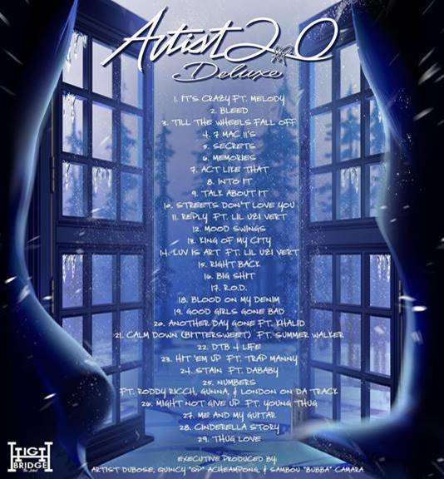

[DOWNLOAD HIGH-RES ARTWORK](https://nam04.safelinks.protection.outlook.com/?url=http%3A%2F%2Fpress.atlanticrecords.com%2Fa-boogie-wit-da-hoodie%2F&data=02%7C01%7CBrian.Sommer%40atlanticrecords.com%7C0b10d4fb673c4b4a123f08d813d08aff%7C8367939002ec4ba1ad3d69da3fdd637e%7C0%7C0%7C637281133696709179&sdata=bxFml6FQvOcm9UR%2BK1jJKPkvv3CZ1vwL5Tfy3FeYubI%3D&reserved=0)

***Artist 2.0 (Deluxe) Track List:***

1.It’s Crazy (Feat. Melody)*

2. Bleed*

3. Till The Wheels Fall Off*

4. 7 Mac 11’s*

5. Secrets*

6. Memories*

7. Act Like That*

8. Into It*

9. Talk About It*

10. Streets Don’t Love You

11. Reply (Feat. Lil Uzi Vert)

12. Mood Swings

13. King of My City

14. Luv Is Art (Feat. Lil Uzi Vert)

15. Right Back

16. Big Shit

17. R.O.D.

18. Blood On My Denim

19. Good Girls Gone Bad

20. Another Day Gone (Feat. Khalid)

21. Calm Down (Bittersweet) [Feat. Summer Walker]

22. DTB 4 Life

23. Hit ‘Em Up (Feat. Trap Manny)

24. Stain (Feat. DaBaby)

25. Numbers (Feat. Roddy Ricch, Gunna & London On Da Track)

26. Might Not Give Up (Feat. Young Thug)

27. Me and My Guitar

28. Cinderella Story

29. Thug Love

*\* Deluxe Edition Track*

**CONNECT WITH A BOOGIE WIT DA HOODIE:**

[INSTAGRAM](https://nam04.safelinks.protection.outlook.com/?url=https%3A%2F%2Fwww.instagram.com%2Fartisthbtl%2F%3Fhl%3Den&data=02%7C01%7CBrian.Sommer%40atlanticrecords.com%7C0b10d4fb673c4b4a123f08d813d08aff%7C8367939002ec4ba1ad3d69da3fdd637e%7C0%7C0%7C637281133696709179&sdata=MTGUk0cqAsskSUGxtRMyUvqgWS0CpArP1Wvp%2FKgc4oY%3D&reserved=0) | [TWITTER](https://nam04.safelinks.protection.outlook.com/?url=https%3A%2F%2Ftwitter.com%2FArtistHBTL%3Fref_src%3Dtwsrc%255Egoogle%257Ctwcamp%255Eserp%257Ctwgr%255Eauthor&data=02%7C01%7CBrian.Sommer%40atlanticrecords.com%7C0b10d4fb673c4b4a123f08d813d08aff%7C8367939002ec4ba1ad3d69da3fdd637e%7C0%7C0%7C637281133696719178&sdata=2e10d8D1ebtG6tPBs5H1dn9H0Cu0jbDIx2rvzxcs5Kg%3D&reserved=0) | [FACEBOOK](https://nam04.safelinks.protection.outlook.com/?url=https%3A%2F%2Fwww.facebook.com%2FArtistHBTL%2F&data=02%7C01%7CBrian.Sommer%40atlanticrecords.com%7C0b10d4fb673c4b4a123f08d813d08aff%7C8367939002ec4ba1ad3d69da3fdd637e%7C0%7C0%7C637281133696719178&sdata=uja4O3eT8rmEUoZbOukFafUWBGvrp1vKs4TSNfHLJbk%3D&reserved=0) | [YOUTUBE](https://nam04.safelinks.protection.outlook.com/?url=https%3A%2F%2Fwww.youtube.com%2Fchannel%2FUCfgsFOdVScKetBXYrFNr5LQ&data=02%7C01%7CBrian.Sommer%40atlanticrecords.com%7C0b10d4fb673c4b4a123f08d813d08aff%7C8367939002ec4ba1ad3d69da3fdd637e%7C0%7C0%7C637281133696729173&sdata=kb5mhQ5DgWCwRSeuo8%2F1QGnjkB4BmlgwN1G%2BFC%2F1da4%3D&reserved=0) | [PRESS SITE](https://nam04.safelinks.protection.outlook.com/?url=http%3A%2F%2Fpress.atlanticrecords.com%2Fa-boogie-wit-da-hoodie%2F&data=02%7C01%7CBrian.Sommer%40atlanticrecords.com%7C0b10d4fb673c4b4a123f08d813d08aff%7C8367939002ec4ba1ad3d69da3fdd637e%7C0%7C0%7C637281133696729173&sdata=wH8PpsNdl40oX1Ph3LzQAAxSXkp2ILgQj32nwp21xuM%3D&reserved=0)

**PRESS CONTACT:**

JASON DAVIS | [JASON.DAVIS@ATLANTICRECORDS.COM](mailto:JASON.DAVIS@ATLANTICRECORDS.COM)

# # #