**A BOOGIE WIT DA HOODIE ROCKS TONIGHT SHOW**

**PERFORMANCE OF “ME AND MY GUITAR” ACCOMPANIED BY H.E.R.**

**THIRD LP *ARTIST 2.0* DEBUTED AT #1 ON BILLBOARD’S TOP RAP ALBUMS CHART**

**AFTER SECOND-HIGHEST STREAMING DEBUT OF THE DECADE**

**STREAMING TRAILBLAZER DEBUTED AT #2 SPOT ON THE BILLBOARD HOT 100**

[**WATCH PERFORMANCE HERE**](https://youtu.be/mAPE7AgyRqo)

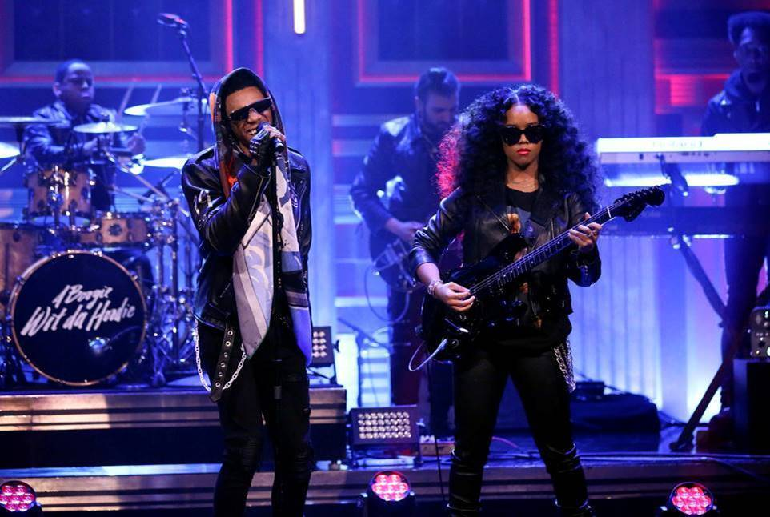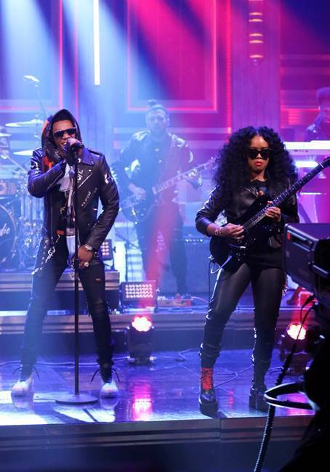

***[Photo Credit: Andrew Lipovsky/NBC]***

**New York, NY – February 29th, 2020 –** After an outstanding **#1 debut on Billboard’s Top Rap Albums Chart** and **#2 on the Billboard Hot 100** with his latest album, ***Artist 2.0*** ([**LISTEN HERE**](https://nam04.safelinks.protection.outlook.com/?url=https%3A%2F%2Faboogie.lnk.to%2FArtist2&data=02%7C01%7CBrian.Sommer%40atlanticrecords.com%7C10fde610ff1b4cf84e8008d7bcaeaad8%7C8367939002ec4ba1ad3d69da3fdd637e%7C0%7C0%7C637185330972209727&sdata=khlOGWvEyayPTle%2B1rQ2Z3IwK0wFlfwIn8tW%2BwQJfug%3D&reserved=0)), multi-platinum recording artist **A Boogie Wit Da Hoodie** rocked his performance of [**“Me and My Guitar”**](https://nam04.safelinks.protection.outlook.com/?url=https%3A%2F%2Fwww.youtube.com%2Fwatch%3Fv%3DR-QfE5Cuo2Y&data=02%7C01%7CBrian.Sommer%40atlanticrecords.com%7C10fde610ff1b4cf84e8008d7bcaeaad8%7C8367939002ec4ba1ad3d69da3fdd637e%7C0%7C0%7C637185330972219717&sdata=9ZkAq86MG4sp6bPJHkuDSD1XZiGZOXX0%2BVVIz%2BWyZiE%3D&reserved=0) last night on **The Tonight Show Starring Jimmy Fallon** accompanied by GRAMMY® award-winning songstress **H.E.R.** on guitar.

In its first week, the Bronx-born phenom’s latest offering logged a massive **141M+ streams**, the **second-highest streaming debut** of the decade behind Eminem’s *Music to be Murdered By*. A Boogie demolished his career record established by his RIAA certified-platinum sophomore LP, ***HOODIE SZN***, by soaring past its first-week streaming numbers and nearly doubling its first-week album equivalents.

Decorated with industry superstars including **DaBaby, Young Thug, Roddy Ricch, Summer Walker, Khalid, Lil Uzi Vert, Gunna, London On Da Track** and **Trap Manny,** ***Artist 2.0*** was released on the Valentine’s Day anniversary of A Boogie’s breakout mixtape, ***Artist***, in 2016.

Heralded by a steady stream of singles including **“Mood Swings,”** **“Reply (feat. Lil Uzi Vert)”** and **“King of My City,”** ***Artist 2.0*** is A Boogie’s first project since the smash success of ***HOODIE SZN***, which also made its Billboard Hot 100 debut at #2 before scoring the #1 spot for three non-consecutive weeks. The 20-track collection also includes the fan-favorite tracks **“Numbers (feat. Roddy Ricch, Gunna and London On Da Track)” and “Thug Love.”**

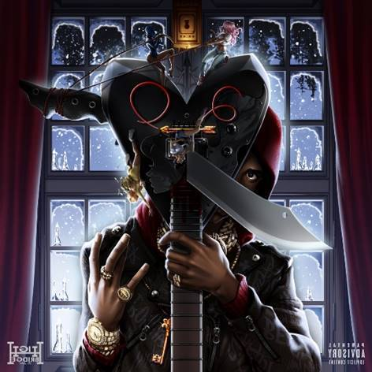

[**DOWNLOAD ARTWORK HERE**](https://nam04.safelinks.protection.outlook.com/?url=https%3A%2F%2Fpress.atlanticrecords.com%2Fwp-content%2Fuploads%2F2020%2F02%2Fartist-2.0-cover.jpg&data=02%7C01%7CBrian.Sommer%40atlanticrecords.com%7C10fde610ff1b4cf84e8008d7bcaeaad8%7C8367939002ec4ba1ad3d69da3fdd637e%7C0%7C0%7C637185330972219717&sdata=zGjFyoMvUrFIM9byZaewz5tu5Gp2cQI9Zzo7Vhqrfyk%3D&reserved=0)

***Artist 2.0 Track List:***

1. Thug Love

2. Cinderella Story

3. Me and My Guitar

4. Might Not Give Up (feat. Young Thug)

5. Numbers (feat. Roddy Ricch, Gunna & London on da Track)

6. Stain (feat. DaBaby)

7. Hit ‘Em Up (feat. Trap Manny)

8. DTB 4 Life

9. Calm Down (Bittersweet) (feat. Summer Walker)

10. Another Day Gone (feat. Khalid)

11. Good Girls Gone Bad

12. Blood on My Denim

13. R.O.D.

14. Big Shit

15. Right Back

16. Luv Is Art (feat. Lil Uzi Vert)

17. King of My City

18. Mood Swings

19. Reply (feat. Lil Uzi Vert)

20. Streets Don’t Love You

***About A Boogie Wit Da Hoodie:***

The Bronx-bred artist Artist Dubose, better known as A Boogie Wit Da Hoodie, first hit the rap scene with the breakout hit “Still Think About You” which was featured on his 2016 debut mixtape, ARTIST. The mixtape also introduced fans to “My Shit” which has since become RIAA certified 2x platinum and was also listed as one of “The Best Songs of 2016” on Apple Music. A Boogie quickly proved himself to be one of the game’s newest heavyweights after XXL dubbed him as “one of the hottest and newest up-and-comers in hip-hop” and included him in the 2017 Freshman Class. The young star also went on to release the 4x platinum single “Drowning feat. Kodak Black” and 3x platinum “Look Back At It,” along with the 2x platinum certified single “Jungle” and platinum certified “Timeless.” During the fall of 2017, A Boogie went on to release his highly anticipated, now gold certified, debut album, THE BIGGER ARTIST, which quickly sprung into the Top 5 on Billboard’s Top 200. He also became the top emerging acting in the U.S. as he simultaneously sprung to #1 on Billboard’s Emerging Artists chart. It is easy to see why The New York Times named A Boogie “the most promising young rapper the city has produced in some time.” A Boogie earned a BET Award Nomination for “Best New Artist” at the end of 2018 in addition to releasing his gold-certified sophomore album, *HOODIE SZN*, which made its debut at #2 before spending three nonconsecutive weeks at #1 and maintaining a stunning 17-week streak within the top 10 on the Billboard Top 200 chart. The album also soared on streaming, garnering over 83 million streams the week it went #1. Following his latest album as well as his sold out “A Boogie Vs. Artist” tour, there’s no doubt A Boogie will continue to make waves and redefine the sound of New York rap.

**NEW PRESS PHOTO:**

***[Photo Credit: Xavier Codie]***

[**DOWNLOAD HERE**](https://app.box.com/s/5s9f6c99z675bdagbn5y6gri0zte2n8t)

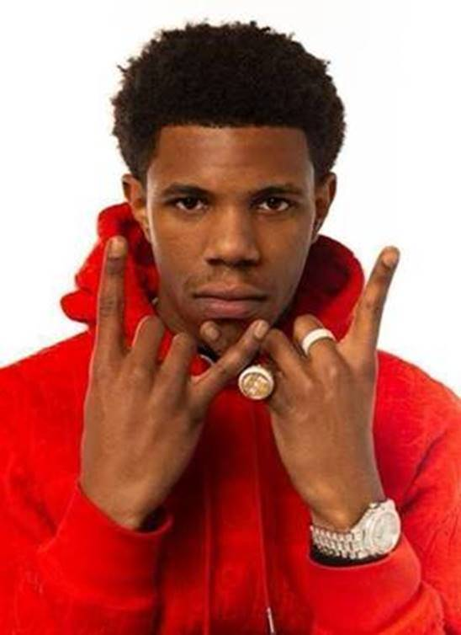

**CONNECT WITH A BOOGIE WIT DA HOODIE:**

[INSTAGRAM](https://nam04.safelinks.protection.outlook.com/?url=https%3A%2F%2Fwww.instagram.com%2Fartisthbtl%2F%3Fhl%3Den&data=02%7C01%7CBrian.Sommer%40atlanticrecords.com%7C10fde610ff1b4cf84e8008d7bcaeaad8%7C8367939002ec4ba1ad3d69da3fdd637e%7C0%7C0%7C637185330972229717&sdata=PK6QTjbgBht%2FCg54T%2BZi4tiyIRThF2A3g5ioZOjoC7s%3D&reserved=0) | [TWITTER](https://nam04.safelinks.protection.outlook.com/?url=https%3A%2F%2Ftwitter.com%2FArtistHBTL%3Fref_src%3Dtwsrc%255Egoogle%257Ctwcamp%255Eserp%257Ctwgr%255Eauthor&data=02%7C01%7CBrian.Sommer%40atlanticrecords.com%7C10fde610ff1b4cf84e8008d7bcaeaad8%7C8367939002ec4ba1ad3d69da3fdd637e%7C0%7C0%7C637185330972229717&sdata=gFJm3wSspQV6rF%2BzbFwKcVZMUQxJkWvyweikL%2Bx0iB0%3D&reserved=0) | [FACEBOOK](https://nam04.safelinks.protection.outlook.com/?url=https%3A%2F%2Fwww.facebook.com%2FArtistHBTL%2F&data=02%7C01%7CBrian.Sommer%40atlanticrecords.com%7C10fde610ff1b4cf84e8008d7bcaeaad8%7C8367939002ec4ba1ad3d69da3fdd637e%7C0%7C0%7C637185330972239702&sdata=bPFyRCUfW0wJWPYgaa%2FMVKZVW4xd7qi09mmYHcCnHcg%3D&reserved=0) | [YOUTUBE](https://nam04.safelinks.protection.outlook.com/?url=https%3A%2F%2Fwww.youtube.com%2Fchannel%2FUCfgsFOdVScKetBXYrFNr5LQ&data=02%7C01%7CBrian.Sommer%40atlanticrecords.com%7C10fde610ff1b4cf84e8008d7bcaeaad8%7C8367939002ec4ba1ad3d69da3fdd637e%7C0%7C0%7C637185330972239702&sdata=b4C8UaHMuivtY1sJKDvzbByZyWIun5RYlg7pZhVLCfE%3D&reserved=0) | [PRESS SITE](https://nam04.safelinks.protection.outlook.com/?url=http%3A%2F%2Fpress.atlanticrecords.com%2Fa-boogie-wit-da-hoodie%2F&data=02%7C01%7CBrian.Sommer%40atlanticrecords.com%7C10fde610ff1b4cf84e8008d7bcaeaad8%7C8367939002ec4ba1ad3d69da3fdd637e%7C0%7C0%7C637185330972799375&sdata=ov1OPc3zr7kiQQ4tEs0%2BvNzJy9JH7DokbVXJiVViX%2Fg%3D&reserved=0)

**PRESS CONTACT:**

JASON DAVIS – [JASON.DAVIS@ATLANTICRECORDS.COM](mailto:JASON.DAVIS@ATLANTICRECORDS.COM)