**A Boogie Wit Da Hoodie Drops Warm Up Single “King of My City” with Visual to Forthcoming *Artist 2.0*  
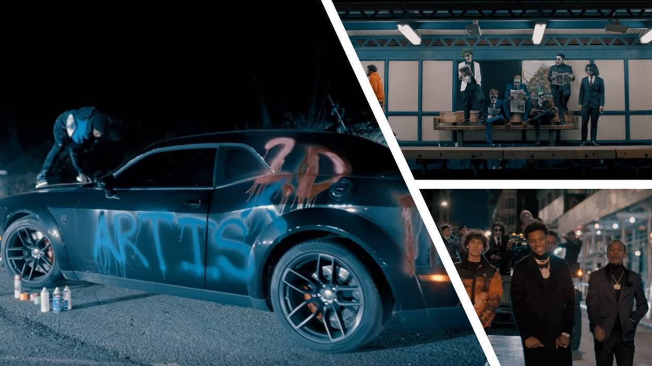**

**Click** [**Here**](https://aboogie.lnk.to/KingofMyCity) **to Buy/Stream/Download “King of My City”  
Click** [**Here**](https://www.dropbox.com/sh/xalwuwltbgsgt2i/AAAUBXDOL0uDPy2UdjQIHsjZa?dl=0) **for “King of My City” Artwork**

**Click** [**Here**](https://aboogie.lnk.to/KingofMyCityPR/youtube) **to Watch “King of My City” Music Video**

**Click** [**Here**](https://warnermusicgroup.app.box.com/s/cx9ya60cth47yk57mdc1otn2kq9fwbk8) **to Download Hi-Res Images of A Boogie wit da Hoodie**

**New York, NY - February 3, 2020** *-* Last Friday, multi-platinum Artist and Entrepreneur **Artist Dubose** P.K.A. **A Boogie Wit Da Hoodie** drops his new single **“King of My City”** along with accompanying music video via **Highbridge The Label/Atlantic Records**. This is the third offering from A Boogie’s highly anticipated album *Artist 2.0*, following hit singles “Reply” featuring Lil Uzi Vert and “Mood Swings”.

“King of My City” delivers a fresh, predestined look at what is to come from *Artist 2.0,* which promises to showcase A Boogie’s musical evolution. No longer is he the up and coming kid from the Bronx, he is now poised for worldwide superstardom.

The song opens with the familiar city sounds of police sirens, dogs barking, and A Boogie’s proclamation “I’m from the Bronx not Benny!” quickly setting the scene in the MC’s native city. With his lyrical guidance and the track’s inviting yet aggressive beat, the listener is transported into the hectic atmosphere that inspired Artist on his ladder to success.

The visual complements the anthem track by opening with a Highbridge the Label spotlight over Brooklyn Bridge, announcing A Boogie's arrival in an intentional way. We then follow him as he roams through landmarks significant to his youth as an Artist, such as the 4 train, his old apartment building, and the steps made famous by Todd Phillips’ Joker film (located in Highbridge), before showing him as the A Boogie we know who rose to fame in Gotham city.

Since it's release, “King Of My City” has been widely featured on Spotify, Apple Music, Amazon, YouTube Music and Tidal, spotlighted as the cover of Spotify’s New Music Friday and Beats & Rhymes, Apple Music’s #OnRepeat, and Tidal’s Hip-Hop Tidal Masters playlists. In addition to the covers, KOMC was featured on Spotify’s Pop Rising, State of Mind, RapCaviar and Get Turnt; Apple Music’s Gymflow, Rap Life and The Plug; Amazon’s Rap Rotation and Brand New Music; Tidal’s Rap Bars & Melodies and Brand New Music; YouTube Music’s On Everything and Rap Star Status.

A Boogie released “Mood Swings” in September which received over 84.4M streams Worldwide and debuted #22 on iTunes Top 200 Hip Hop / Rap Songs. In 2018, Boogie released his album *Hoodie SZN* which has received over 3.3B Streams Worldwide, spent 3 nonconsecutive weeks at #1 on Billboard’s Top 200 Albums, debuted  #1 on iTunes Top 200 Overall Albums Chart, and #1 on iTunes Top 200 Hip Hop / Rap Albums. Named one of [Billboard’s Albums Of The Decade In The 2010s](https://www.billboard.com/articles/news/list/8543722/best-albums-of-the-2010s-top-100), A Boogie's *Hoodie SZN* is RIAA Certified Platinum in the US and Canada, and RIAA Certified Gold in Denmark. It included hits such as 2X RIAA Certified Platinum in US; 3x RIAA Certified Platinum in Canada “Look Back At It,” RIAA Certified Platinum “Startender,” 3x RIAA Certified Platinum “Swervin,” RIAA Certified Gold “Demons & Angels,” and RIAA Certified Gold “Love And Drugs.”

**About A Boogie Wit Da Hoodie:**

The Bronx-bred Artist Artist Dubose, better known as A Boogie Wit Da Hoodie, first hit the rap scene with the breakout hit “Still Think About You” which was featured on his 2016 debut mixtape, ARTIST. The mixtape also introduced fans to “My Shit” which went on to become RIAA certified platinum and was also listed as one of “The Best Songs of 2016” on Apple Music. A Boogie quickly proved himself to be one of the game’s newest heavyweights after XXL dubbed him as “one of the hottest and newest up-and-comers in hip-hop” and included him in the 2017 Freshman Class. The young star also went on to release the 3x platinum “Drowning feat. Kodak Black” along with the platinum certified singles “Jungle” and “Timeless.” During the fall of 2017, A Boogie went on to release his highly anticipated, now gold certified, debut album, THE BIGGER ARTIST, which quickly sprung into the Top 5 on Billboard’s Top 200. He also became the top emerging acting in the U.S. as he simultaneously sprung to #1 on Billboard’s Emerging Artists chart. It is easy to see why The New York Times named A Boogie “the most promising young rapper the city has produced in some time.” A Boogie earned a BET Award Nomination for “Best New Artist” at the end of 2018 in addition to releasing his gold-certified sophomore album, HOODIE SZN, which made its debut at #2 before spending three nonconsecutive weeks at #1 and maintaining a stunning 17 week streak within the top 10 on the Billboard Top 200 chart. The album also soared on streaming, garnering over 83 million streams the week it went #1. Following his latest album as well as his sold out “A Boogie Vs. Artist” tour, there’s no doubt A Boogie will continue to make waves and redefine the sound of New York rap.

[Click here to view Twitter](https://twitter.com/ArtistHBTL)

[Click here to view Instagram](https://www.instagram.com/artisthbtl/)

[Click here to view Facebook](https://www.facebook.com/ArtistHBTL/)

**PRESS CONTACT:**

JASON DAVIS | [JASON.DAVIS@ATLANTICRECORDS.COM](mailto:JASON.DAVIS@ATLANTICRECORDS.COM)