**A Boogie Wit Da Hoodie and Lil Uzi Vert Team Up for New Track “Reply” from Highly Anticipated *Artist 2.0***

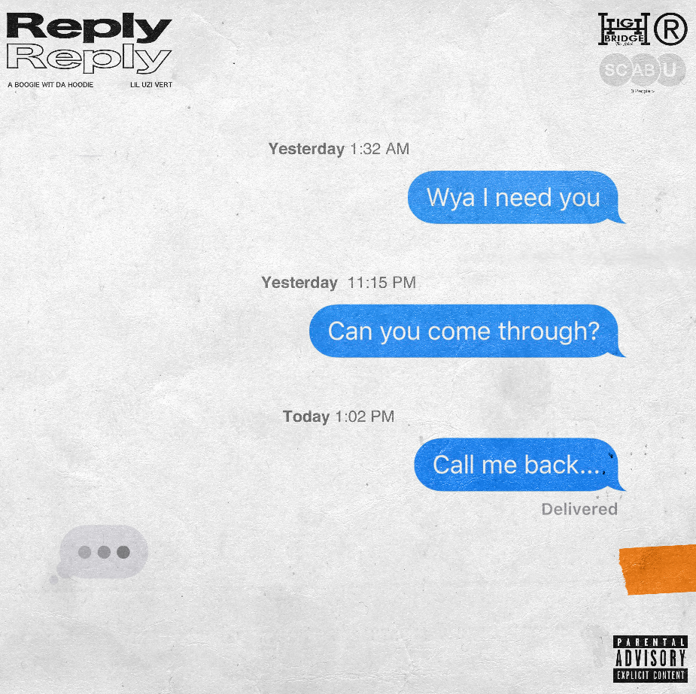

[**Click Here to Buy/Stream/Download “Reply”**](https://aboogie.lnk.to/Reply)

**[Click Here to Download Single Artwork](https://warnermusicgroup.box.com/s/l1t8leiuxpffai99bkuo7i2b4y09q535)**

**Click** [**Here**](https://www.dropbox.com/sh/72l2kcdx86octzn/AABdbnT3lDSH8Ui7mqzKjS0Ka?dl=0) **to Download Hi-Res Image of A Boogie**

**November 15, 2019 -** Today, multi-platinum hip-hop artist and entrepreneur [**A Boogie Wit Da Hoodie**](https://www.instagram.com/artisthbtl/?hl=en) drops his second offering from ***Artist 2.0***, featuring two-time Grammy-nominated rapper, singer, and songwriter, **Lil Uzi Vert**.

Marking the second time the two have collaborated, “**Reply**” percolates with desire and longing, and finds the pair questioning the motives behind their lover’s interest and whether or not it’s real.

The track begins with Lil Uzi Vert*/If I write you girl will you reply/*before he goes on to denounce that she only wants him “because [his] life is televised, [he] can see all the lies in [her] eyes.” Uzi’s crooning rap continues to lament a love who doesn’t want him the way he wants her. The track escalates as Boogie joins, filled with the same deep-seated longing and craving for a love who doesn’t feel the same for him.

The two weave together an intensely melodic and smooth track that draws in the listener enveloping them in the deep desire-laden verses. “Reply” simmers into a slow burn as Boogie laments*/If I write you can you reply/*leaving the listener with a sense of longing, wanting more.

**About A Boogie Wit Da Hoodie:** The Bronx-bred rapper Artist Dubose, better known as A Boogie Wit Da Hoodie, first hit the rap scene with the breakout hit “Still Think About You” which was featured on his 2016 debut mixtape, ARTIST. The mixtape also introduced fans to “My Shit” which went on to become RIAA certified platinum and was also listed as one of “The Best Songs of 2016” on Apple Music. A Boogie quickly proved himself to be one of the game’s newest heavyweights after XXL dubbed him as “one of the hottest and newest up-and-comers in hip-hop” and included him in the 2017 Freshman Class. The young star also went on to release the 3x platinum “Drowning feat. Kodak Black” along with the platinum certified singles “Jungle” and “Timeless.” During the fall of 2017, A Boogie went on to release his highly anticipated, now gold certified, debut album, THE BIGGER ARTIST, which quickly sprung into the Top 5 on Billboard’s Top 200. He also became the top emerging acting in the U.S. as he simultaneously sprung to #1 on Billboard’s Emerging Artists chart. It is easy to see why The New York Times named A Boogie “the most promising young rapper the city has produced in some time.” A Boogie earned a BET Award Nomination for “Best New Artist” at the end of 2018 in addition to releasing his gold-certified sophomore album, HOODIE SZN, which made its debut at #2 before spending three nonconsecutive weeks at #1 and maintaining a stunning 17 week streak within the top 10 on the Billboard Top 200 chart. The album also soared on streaming, garnering over 83 million streams the week it went #1. Following his latest album as well as his “A Boogie Vs. Artist” tour which wrapped with 26 of its 30 dates sold out, there’s no doubt A Boogie will continue to make waves and redefine the sound of New York rap.

**About Lil Uzi Vert:** Grammy nominated artist Lil Uzi Vert flaunts a vision and fashion sense just as loud as his “futuristic trap” sound and dynamic voice. The Philadelphia native first began to set the internet on fire with his explosive appearance on Carnage’s single “WDYW” alongside A$AP Ferg and Rich The Kid and later his turn on “Big Racks” for Young Thug’s Slime Season 2. Lil Uzi Vert later went on to rock the world with his highly acclaimed debut album, *LUV IS RAGE 2*, which quickly struck #1 on the Billboard 200 and became RIAA certified gold in less than two months following its release. One of the album’s hit singles “XO Tour Llif3” also went on to earn 5x platinum certification in addition to being recognized as the “Song of the Summer” at the 2017 Video Music Awards. Pitchfork proclaimed the project to be “the Philadelphia native’s most musically developed work” while THE FADER declared that the rapper has “cemented himself as this oft-maligned generation’s true pioneer.” He also went on to surprise the word with the release of “New Patek” that ROLLING STONE proclaimed to be “a sugar rush that never subsides.” In addition to Lil Uzi Vert’s 2018 Grammy nomination as “Best New Artist”, he’s also received the “Breakout Artist of the Year Award” and the “Breakthrough Artist” award during Billboard’s 2017 Touring Awards. The rap superstar has also been featured on a number of record-breaking tracks including Migos’ RIAA 4X platinum certified and Grammy nominated “Bad and Boujee” along with DJ Esco’s gold certified “Too Much Sauce” with Future, to name a few. Lil Uzi Vert has notably graced the cover of Billboard’s 2017 “The Year In Music” issue, XXL’s 20th Anniversary Issue and The FADER’s “Sex Issue.”

**NEW PRESS PHOTO:**

*[Photo Credit: Jimmy Fontaine]*

[DOWNLOAD HIGH-RES IMAGE HERE](http://press.atlanticrecords.com/wp-content/uploads/2019/09/Main-Press-Photo-PC-Jimmy-Fontaine.jpeg)

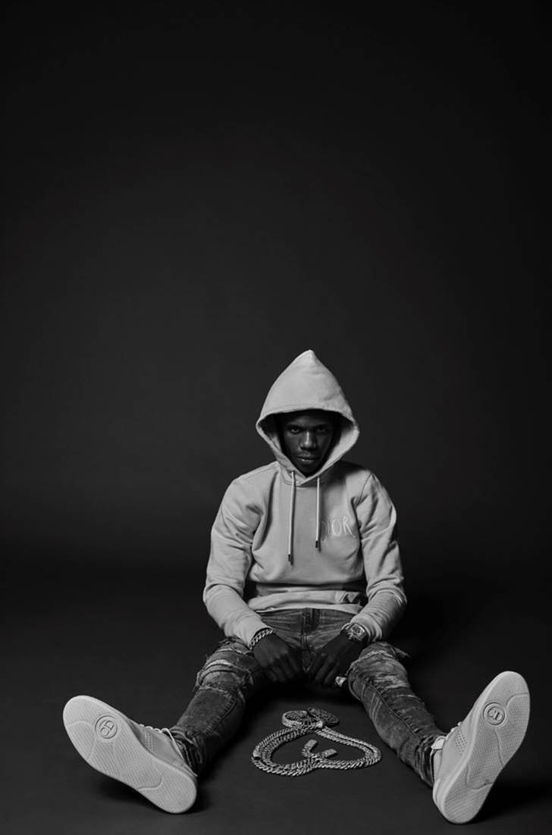

[Click here to view Twitter](https://twitter.com/ArtistHBTL)

[Click here to view Instagram](https://www.instagram.com/artisthbtl/)

[Click here to view Facebook](https://www.facebook.com/ArtistHBTL/)