FOR IMMEDIATE RELEASE
MARCH 21, 2019

ARLIE RELEASE OFFICIAL MUSIC VIDEO FOR “TOO LONG”

ANNOUNCE PRE-ORDER FOR EXCLUSIVE VINYL
EDITION OF DEBUT EP ‘WAIT’

FRESH OFF SUPPORT SLOTS FOR ROSTAM,
COLD WAR KIDS, COIN & MT. JOY +
SOLD OUT HEADLINE SHOWS AT BABY’S ALL RIGHT
AND MERCY LOUNGE

WATCH HERE

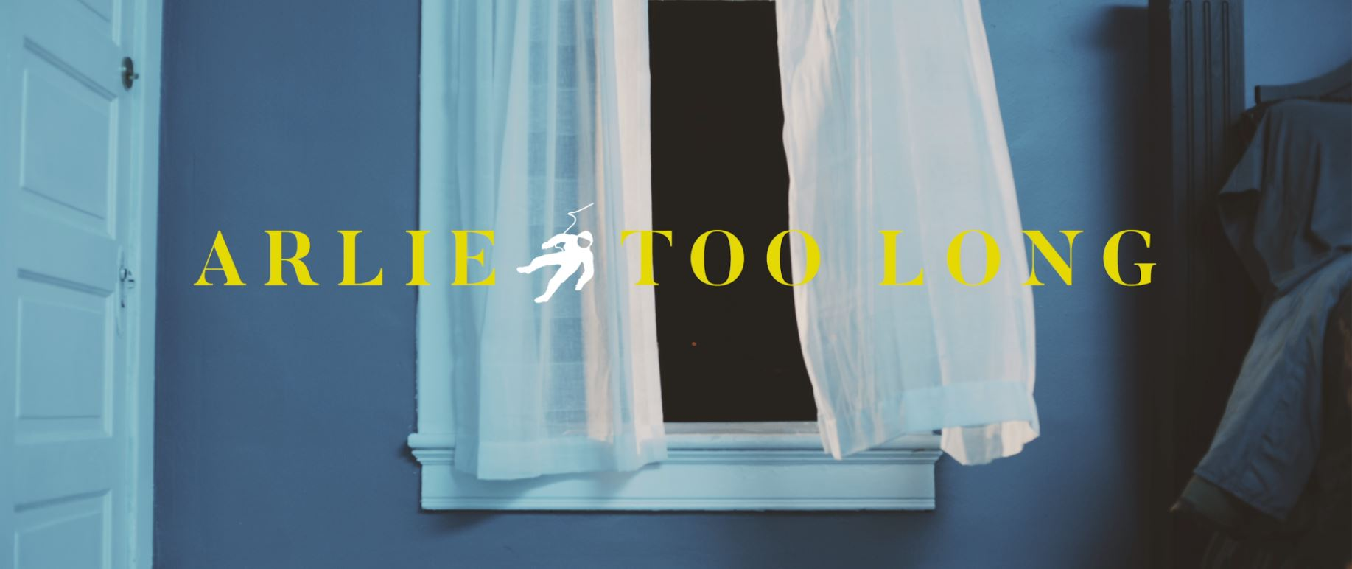

Nashville-based artists Arlie have today dropped a new music video for “Too Long,” off the band’s debut EP ‘Wait’ – released this past September via Atlantic Records and amassing millions of streams globally. The visual, directed by Sam Boyette, finds lead singer Nathaniel Banks crooning the song’s lyrics while navigating an enigmatic house party – view HERE.

“Too Long” is the fifth track off ‘Wait’ to earn an official music video, following visuals for “barcelona boots,” “big fat mouth,” “didya think,” and “water damage.”

Coinciding with today’s video release, the band also announced an exclusive vinyl version of the EP which will be released in partnership with record subscription service Vinyl Me Please. Fans can pre-order the exclusive edition here.

Arlie is fresh off direct supporting slots for Rostam, Cold War Kids, Mt. Joy and COIN, as well as a slew of festival performances including Bonnaroo, SXSW, Forecastle and Sloss Fest. In December, the band performed sold-out headline shows at the iconic Brooklyn venue Baby’s All Right, Washington DC’s DC 9, and Nashville’s Mercy Lounge.

Arlie was recently named to Relix’s “5 Artists You Should Know About,” as well as NME’s annual feature “100 New Bands for 2019,” with the magazine declaring them to be a “winsome college indie band taking on the world,” and lauding the EP as “pop triumphs you can definitely sink your teeth into.”

‘Wait EP’ Tracklist:
big fat mouth
barcelona boots
too long
water damage
didya think
tossing and turning

Connect with Arlie:
https://arlie.band/
Facebook: https://www.facebook.com/arliemusic/
Instagram: https://www.instagram.com/arlieband/
Twitter: https://twitter.com/arlieband

