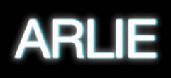

ARLIE RELEASE NEW SINGLE ‘wait a minute’

SINGLE HARKENS BACK TO THE BEST OF 1960'S POP | ARRIVES ALONGSIDE OFFICIAL MUSIC VIDEO STARRING THE BAND

LISTEN TO “wait a minute” HERE | WATCH OFFICIAL MUSIC VIDEO HERE

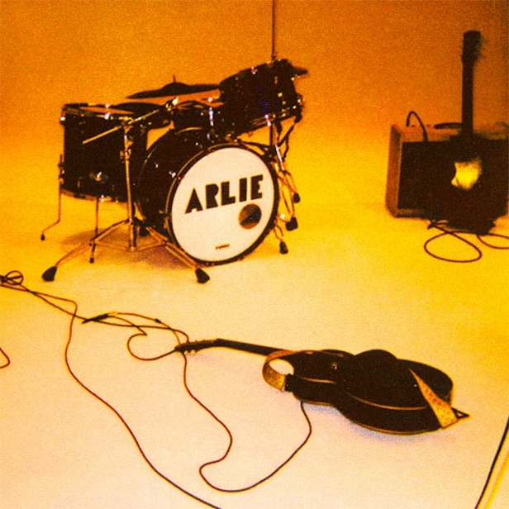

“Fusing a sound both futuristic and vintage…Arlie flirts with an aroma of nostalgic youth, like a mix between a 1984 Testarossa and The Jetsons’ hovercraft.”
– FLAUNT

“A true collage of everything from pop to alternative, pulled together with a squelching kaleidoscopic flare…beaming with lyrical savviness that exudes alternative infatuation.”
– ONES TO WATCH

Visionary indie-pop outfit Arlie has today released their nostalgic lite-rock new single “wait a minute” – out now via Atlantic Records (listen here). The new single poses the ultimate questions about life and our time on earth over a 1960s harmony that harkens back to the sounds of The Beach Boys and the early days of The Beatles. The song arrives with an official music video starring lead singer/songwriter/producer Nathaniel Banks and the entire band – Adam Lochemes, Carson Lystad, and Ryan Savage (watch here).

From Arlie’s leader Nathaniel –
“I wrote this song while I was still in college, and we've been playing it live since our first shows as Arlie. WAM was a response to a collage of musical sentiments and ideas I was consuming at the time, via existentialist writers like Camus and Dostoyevsky, along with The Beach Boys, The Kinks, and The Zombies. I actually got school credit for making the original demo of this song, as part of an independent study with one of my favorite professors, who is a mentor of mine and whose car is featured in the music video! I was thrilled to have a chance to reference Tom Sawyer's funeral prank in a song about existentialism. And the irony of singing “If it's paradise that's after life, I wonder why we waste our time on the world" over a 60s psychedelic / baroque-pop musical kaleidescope allows me to have a sense of humor about my own suffering -- this song is a triumph, as long as you don't take the advice of the speaker too literally.”

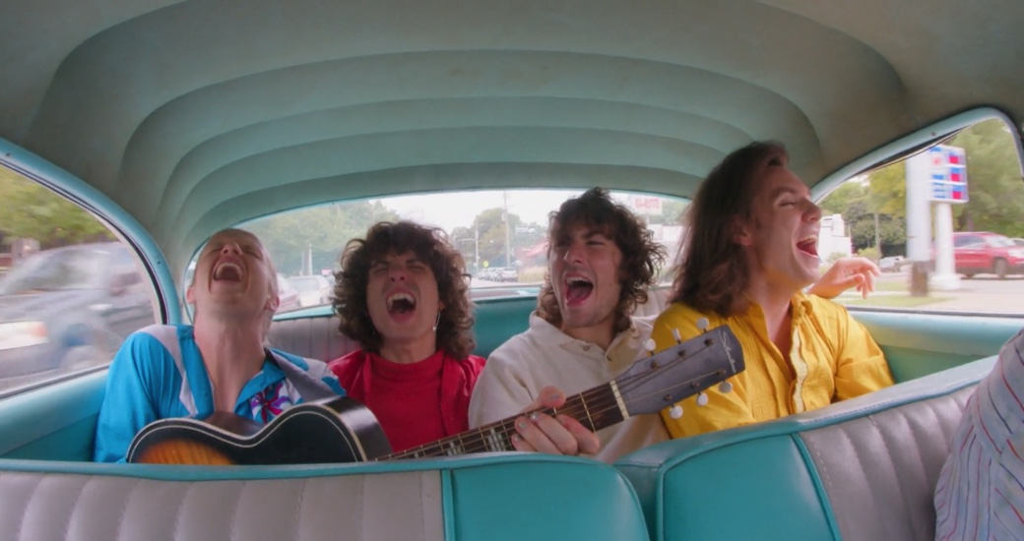

Today’s release follows last month’s “poppin” which arrived with an official music video shot in Los Angeles featuring roller skating influencer Nena (aka @ziggystardussttwhich) and “karma” which marked the first new music from Arlie since their breakthrough Wait EP, released in 2018

“poppin” was heralded by Atwood Magazine as “A poignant heart-on-sleeve serenade, Arlie’s latest release burns bright with tender, buoyant indie pop and bittersweet, raw honesty,” with pop music blog Milky exclaiming “Indie-pop outfit Arlie have unveiled their shimmering new single ‘poppin.’ Built upon bright sonics and 70’s inspired soundscapes, the track explores the fast-paced lives we lead today.”

Hailed for its striking synthesis of classic pop melodies with wildly creative modern production, the band’s 2018 Wait EP included such hit singles as “didya think” and “big fat mouth,” both joined by official music videos.

The project immediately drew acclaim for its invigorating songcraft, meticulous production, and playful, summertime energy. Upon release, FLAUNT praised the EP for “fusing a sound both futuristic and vintage…Arlie flirts with an aroma of nostalgic youth, like a mix between a 1984 Testarossa and The Jetsons’ hovercraft.” Ones to Watch similarly declared it: “A true collage of everything from pop to alternative, pulled together with a squelching kaleidoscopic flare…beaming with lyrical savviness that exudes alternative infatuation.”

Arlie followed the Wait EP with nearly non-stop touring, including tours with Rostam, Mt Joy, COIN, and Cold War Kids, show-stealing sets at such festivals as Bonnaroo and Forecastle, and an East Coast headline run (supported by Briston Maroney) that included sold-out shows in both Nashville and Brooklyn.

With over 54M worldwide streams and counting, Arlie have fast risen from a lo-fi solo project to critically acclaimed indie pop sensations. Founded in 2015 as the bedroom pop brainchild of Nashville-based singer-songwriter-producer Nathaniel Banks, Arlie expanded into a full-fledged band and quickly began growing a fervent fan following in Music City and beyond. Genre-blurring tracks like “big fat mouth” and “Too Long” lit up playlists across the country and have only grown in popularity in the years that followed. In fact, Arlie’s overall streaming audience has grown during that time to over 550K monthly listeners.

# # #

CONNECT WITH ARLIE:
OFFICIAL | INSTAGRAM | FACEBOOK | YOUTUBE | TWITTER

FOR ALL PRESS INQUIRIES, PLEASE CONTACT:
Libby Kober | Libby.Kober@AtlanticRecords.com
Trish Mollo | Trish.Mollo@AtlanticRecords.com

