

**ED SHEERAN IS BACK!**

**GLOBAL SUPERSTAR RETURNS WITH NEW SINGLE “BAD HABITS”**

**ALONGSIDE CINEMATIC DAVE MEYERS-DIRECTED OFFICIAL VIDEO**

[**DOWNLOAD/STREAM**](http://es.lnk.to/BadHabits) **|** [**WATCH OFFICIAL MUSIC VIDEO**](https://es.lnk.to/BadHabits/youtube)

***“Feels great to be back with my new single. I wanted the video for Bad Habits to play on the nature of habits in a fantastical way so I decided on vampires. It was mega fun getting into character except for the heights (that wasn’t so fun). Enjoy x” – Ed Sheeran***

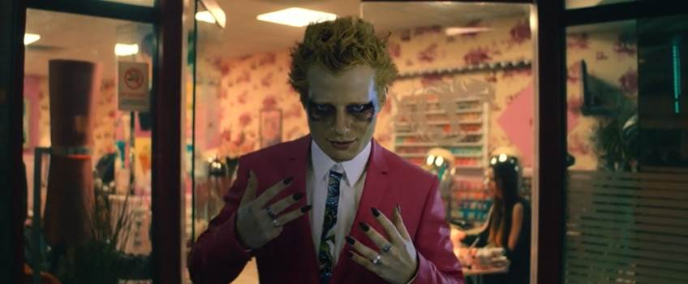

**ACCLAIMED SINGER/SONGWRITER SET FOR WEEK-LONG RESIDENCY ON**

***THE LATE LATE SHOW WITH JAMES CORDEN* BEGINNING THIS MONDAY, JUNE 28TH**

**SHEERAN WILL PERFORM AT TODAY’S TIKTOK’S UEFA 2020 SHOW**

**AIRS LIVE AT 4PM EST FROM IPSWICH TOWN’S PORTMAN ROAD**

**STREAMING ON TIKTOK ([@EDSHEERAN](https://www.tiktok.com/@edsheeran?))**

**“Bad Habits” co-written & co-produced by: Ed Sheeran, Johnny McDaid & FRED**

[**DOWNLOAD “BAD HABITS” SINGLE ARTWORK & APPROVED NEW PRESS IMAGES**](https://warnermusicgroup.box.com/s/u0ngtwtjboaih2haavbuqwn3lqf7sutj)

(New York, NY – June 25, 2021) Global superstar **Ed Sheeran** officially returns with his new single ***“Bad Habits,”*** alongside the Dave Meyers-directed official video. [Download/Stream](http://es.lnk.to/BadHabits) | [Watch Official Music Video](https://es.lnk.to/BadHabits/youtube)

Spending the last few years out of the spotlight following his record-breaking two-year Divide tour and the arrival of his first daughter, Ed Sheeran marks his official return with the euphoric, song-of-summer contender, **“Bad Habits.”**Sheeran is an artist who motors on nonconformity, with **“Bad Habits”** landing as something unexpected yet wholly his; a testament to a forward-thinking artist who continues to push his art into new dimensions. Deploying an up-tempo, guitar-laced summer anthem, “Bad Habits” is a song that channels escapist energy and most importantly makes you want to dance. Ed co-wrote and co-produced **“Bad Habits”**with long-time collaborators, Johnny McDaid (*“Shape of You”*) and FRED (*No.6 Collaborations Project).*

In the accompanying official video - directed by **Dave Meyers** (Billie Eilish, Kendrick Lamar) - we see Ed as we’ve never seen him before as he depicts an alter-ego vampire character. Trading his distinct ginger hair for bleached white and his teeth for fangs, the dark-humor narrative serves as a metaphor for ‘bad habits’ as Ed embarks on a wild night out alongside his crew of ghouls, before morphing back to his real self the next morning, ginger hair intact, as the sun rises over him. The official video made its global broadcast premiere on MTV Live/MTVU/MTV’s global network of channels today, as was also trailed on ViacomCBS Times Square billboard.

Ed Sheeran says – ***“Feels great to be back with my new single. I wanted the video for Bad Habits to play on the nature of habits in a fantastical way so I decided on vampires. It was mega fun getting into character except for the heights (that wasn’t so fun). Enjoy x”***

To celebrate the release of “Bad Habits,” Ed will be performing live today from Ipswich Town’s Portman Road – his home team’s football stadium in Suffolk, England - for TikTok’s UEFA Euro 2020 show, streaming globally on TikTok starting at 4pm EST today. Directed by long-time collaborator, Emil Nava, today’s performance will see Sheeran performing “Bad Habits” live, for the first time ever, as well as fan favorites. **Follow Ed on TikTok** [**@EdSheeran**](https://www.tiktok.com/@edsheeran?)**.**

Adding to all this excitement, Sheeran is set for a week-long residency on The Late Late Show with James Corden, starting this Monday, June 28th (check local listings). During his residency, Sheeran will not only perform some of his biggest hits, live in-studio, each night, kicking off with the television debut of “Bad Habits,” but will also sit down for a chat with Corden and feature in the show’s comedy segments throughout the week.

Furthermore, Sheeran will deliver an all-new, live performance for the 2021 “iHeartRadio KIIS FM Wango Tango,” hosted by Ryan Seacrest on Wednesday, June 30th at 7pm PT/10pm ET. The virtual event will stream exclusively on LiveXLive.com and broadcast on more than 95 iHeartRadio stations across the country. For more information, please visit iHeartRadio.com/WangoTango.

**“Bad Habits”** marks Sheeran’s first*official* release since 2019’s Platinum-certified, GRAMMY-nominated ‘***No.6 Collaborations Project****,’*which includes the multi-platinum, chart-topping hits “I Don’t Care (with Justin Bieber)” and “Beautiful People (feat. Khalid),” and features guest appearances from 22 of his favorite artists including Travis Scott, Eminem, Bruno Mars, Cardi B and Camila Cabello, just to name a few.

Ed Sheeran is currently recording his new album.

**For more information please contact:**

Glenn Fukushima - [GlennFukushima@elektra.com](mailto:GlennFukushima@elektra.com)

Jason Davis - [Jason.Davis@atlanticrecords.com](mailto:Jason.Davis@atlanticrecords.com)

* * *

**ABOUT ED SHEERAN:**

Ed Sheeran is an era-defining artist. From record-breaking sales across his recorded music and live performances, and a plethora of award wins to his name, the British singer-songwriter is the boundless talent behind some of the biggest songs in history.  The four-time GRAMMY award winner has consistently resonated with fans across the world with his peerless songcraft and exceptional music palate. With four multiplatinum, critically acclaimed albums under his belt – ‘+’ (2011), ‘x’ (2014), ‘÷’ (2017) and ‘No.6 Collaborations Project’ (2019) - Sheeran has amassed more than 60 billion streams and sold over 50 million albums, globally to date; he is also one of only six artists to have three songs – “Thinking Out Loud,” “Perfect,” and “Shape Of You” - earn RIAA Diamond-certification, for sales equivalents exceeding 10 million in the US alone.  An unparalleled live performer, Sheeran’s most recent, two-year ÷ world tour made history becoming the most-attended and highest-grossing tour of all time.