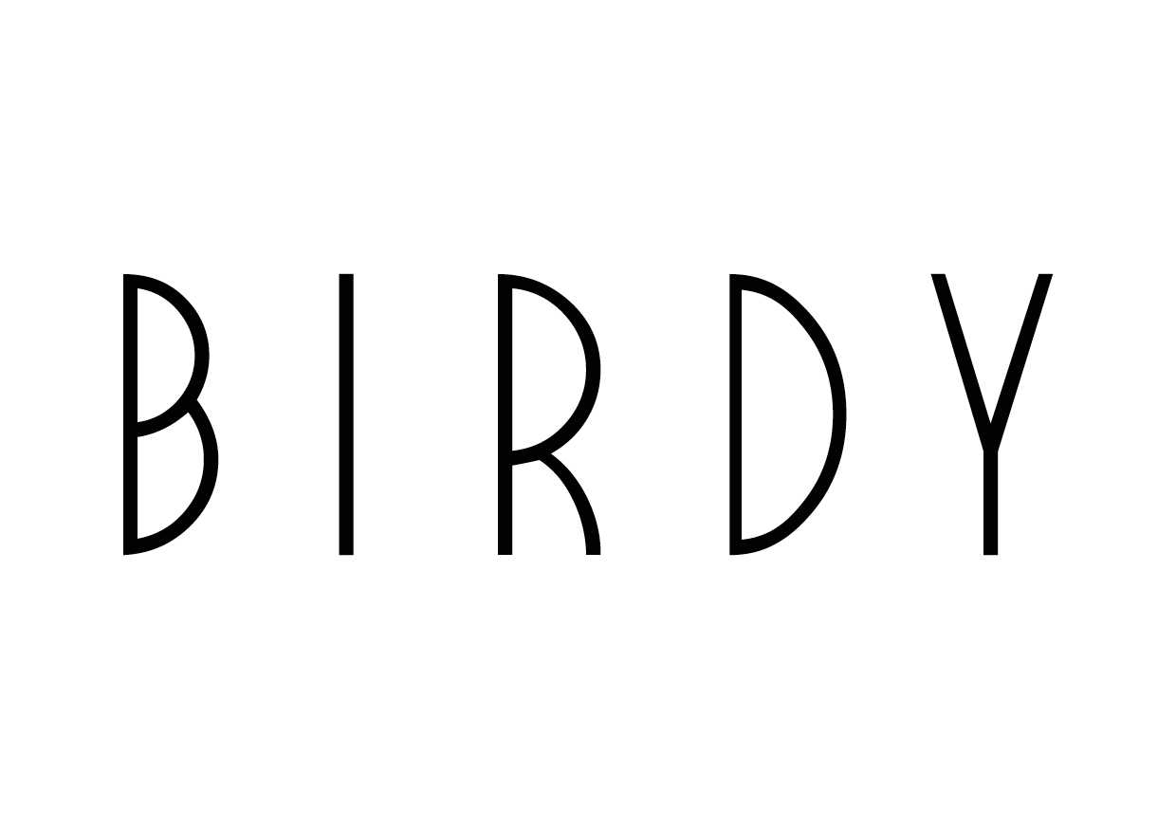

**BIRDY REVEALS MUSIC VIDEO FOR ‘WORDS’**

**WATCH** [**HERE**](https://www.youtube.com/watch?v=Lc8X3FXwQCg)**!**

**BIRDY SET TO PERFORM “KEEPING YOUR HEAD UP” ON THE LATE LATE SHOW WITH JAMES CORDEN JUNE 23**

***BEAUTIFUL LIES* AVAILABLE NOW**



UK sensation Birdy has unveiled the official music video for “Words” from her album *Beautiful Lies* out now via Atlantic Records. The stunning Bison-directed video (London Grammar, Bastille) shows an ethereal and dreamy journey with Birdy. Watch here: <https://www.youtube.com/watch?v=Lc8X3FXwQCg>.

The singer/songwriter’s *Beautiful Lies* North American headline tour is currently underway through the end of the month (full itinerary below). Birdy is set to perform lead single “[Keeping Your Head Up](https://www.youtube.com/watch?v=m8AXUq5uA0Y)” on CBS’ The Late Late Show with James Corden on June 23 ahead of her sold-out show at The Fonda Theatre in Los Angeles on June 24.

*Beautiful Lies* charted in the Top 10 in 43 countries worldwide, including number 4 in the UK.

***Beautiful Lies*** North American tour

June 24 **Hollywood, CA** Fonda Theatre

June 25 **Sacramento, CA** Ace of Spades

June 26 **San Francisco** The Fillmore

June 28 **Portland, OR** Wonder Ballroom

June 29 **Seattle, WA** Neumos Crystal Ball Reading Room

***

*Since bewitching the nation at the age of 14 with her rendition of Bon Iver’s “Skinny Love,” this extraordinarily talented 19-year-old has released three albums, toured the world, performed at the Paralympics Opening Ceremony, been nominated for a Brit Award (for British Female Solo Artist), written songs for the hit movies The Fault in Our Stars and The Hunger Games and sung on Mumford & Sons’ Grammy-winning song “Learn Me Right” (part of the soundtrack for the Pixar animation, Brave). A long list of international accolades includes Best International Female (Echo Awards, Germany 2013) and Best International Female (Principales, Spain 2014) and many more. She has accumulated over 413 million views on Youtube and sold over 10.5 million records worldwide to date.*