FOR IMMEDIATE RELEASE
JULY 22, 2021

MULTI-PLATINUM ARTST BAZZI IS BACK WITH “I LIKE THAT”

BOASTING BILLIONS OF STREAMS, CHART-TOPPING SINGER-SONGWRITER-PRODUCER
MAKES EPIC RETURN WITH NEW SUMMER SINGLE

POP PHENOMENON ANNOUNCES UPCOMING MUSIC VIDEO STARRING SOME OF HIS CLOSEST FRIENDS INCLUDING LUCA SABBAT AND SCARLETT ROSE LEITHOLD

LISTEN TO “I LIKE THAT” HERE
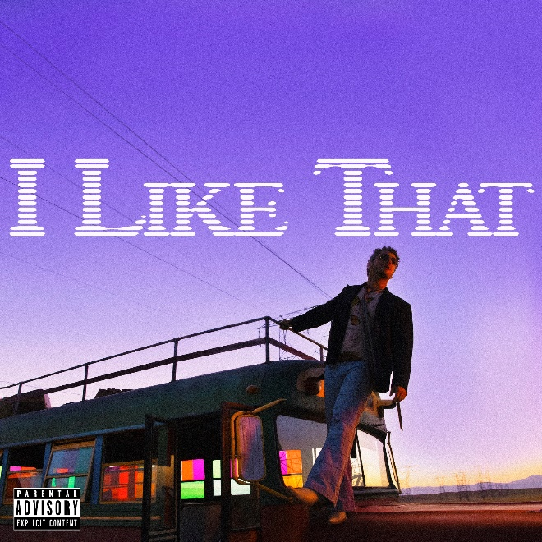
DOWNLOAD ARTWORK + PRESS PHOTO HERE

Multi-platinum pop phenomenon Bazzi has made his highly anticipated return with the intoxicating summer track “I Like That,” available now HERE. Watch out for the official music video, out soon, directed by Christian Breslauer (Roddy Ricch, Doja Cat, Yungblud) and starring some of his closest friends including influencers Luca Sabbat and Scarlett Rose Leithold.

About the track, Bazzi shared, “’I Like That’ is the start of a new era for me. I’m exploring new things sonically & just having more fun making music. This song signifies a feeling of gratitude coming back into a new world and atmosphere."

Having spent much of last year honing his uniquely personal songcraft on a series of million-streaming single releases, “I Like That” marks the launch of a bold new era for Bazzi, alive with raw sensuality, creative energy, and ever-increasing confidence. The multi-talented singer-songwriter-producer is currently hard at work in the studio, with more new music to follow in the coming months.

Born to a Lebanese immigrant father and American mother in Canton, MI, Bazzi and his dad moved to California during his senior year where he single-handedly wrote and produced a series of viral smashes like “Alone” and “Beautiful,” earning millions of worldwide streams and top 10 placement on a variety of influential playlists. Now with over 1.7 billion streams to date, 2018’s 5x RIAA platinum certified “Mine” proved Bazzi’s true breakthrough, ascending to #1 at CHR/Top 40 and making the top 20 on Billboard’s “Hot 100” after reaching #1 on virtually all streaming platforms. As if all that weren’t enough, the “Mine” companion video boasts over 184 million views via YouTube alone. Praised by Playboy for its “genre-bending…warts-and-all approach to songwriting,” Bazzi’s RIAA platinum certified debut album, COSMIC, debuted among the top 15 on the SoundScan/Billboard 200 upon its 2018 release, earning over 2B global streams with hits like the 4x platinum certified, top 40 hit duet version of “Beautiful (Ft. Camila Cabello),” accompanied by a spectacular companion visual now with over 175 million views. In 2019, Bazzi unveiled his first ever mixtape, SOUL SEARCHING, collecting such RIAA platinum certified singles as “I.F.L.Y.” and “Paradise.” Hailed by Billboard as “his most personal work to date,” the project made a top 20 debut on the Billboard 200, while “Paradise” proved one of Bazzi’s biggest hits with more than TK global streams and counting.

Bazzi made the most of his 2020, releasing a string of intimate and deeply confessional tracks – including “Young & Alive,” “Renee’s Song,” “I Got You,” “I Don’t Think I’m Okay,” and “Crazy” – all of which drew millions of streams around the world. Now fully focused on the future, Bazzi is hard at work writing and recording new music, as always cross-pollinating modern pop with more traditional aspects of craft and performance.

CONNECT WITH BAZZI
BAZZIOFFICIAL.COM | INSTAGRAM| FACEBOOK| TWITTER| YOUTUBE

For press inquiries, please contact:
Kelly McWilliam // Kelly.McWilliam@atlanticrecords.com

