BAZZI DROPS VIDEO TO BREEZY LATEST TRACK “I.F.L.Y.”

PERFORMING AT UPCOMING MADE IN AMERICA FESTIVAL

WATCH VISUAL HERE

“PARADISE” STREAMING NOW HERE

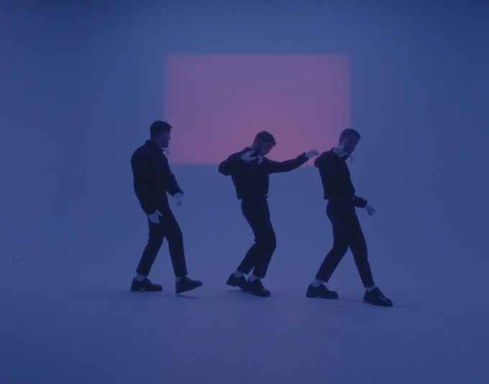

Coming off “Focus” featuring 21 Savage released last month, Bazzi returns today with the accompanying visual for his latest sun kissed track “I.F.L.Y.” Watch Bazzi bring the lyrics to life in a vintage pastel paradise as he croons “I f**king love you.” “I.F.L.Y.” furthers Bazzi’s string of lauded releases this year including his summer smash “Paradise,” which he performed at the 2019 MTV Movie & TV Awards on June 17th, politically aimed “Caught In The Fire”, “Focus” ft. 21 Savage, in addition to feature appearances on Netsky’s “I Don’t Even Know You Anymore” with Lil Wayne and Tyga’s latest album ‘Legendary’ on the R&B cut “Made Me.”

“Paradise”, released in April, has reached over 170 million streams globally and the official music video has over 9 million views. The track is also featured in the major Warner Bros. film The Sun Is Also A Star. “Caught In The Fire” was released a few days before “Paradise”, and premiered via Zane Lowe on Apple Music’s Beats 1. The track was described by Idolator as a “call for change” and showcases Bazzi’s evolution, both musically and socially/politically.

A 2018 MTV Video Music Award “Best New Artist” nominee, Bazzi has played select shows this year, with a performance at the Made in America Festival in Philadelphia right around the corner. He made his Coachella debut this year, performed at NY’s Gov Ball, and had a co-headline show with fellow Atlantic artist Lizzo in June. For complete details and ticket availability, please visit www.bazziofficial.com.

Bazzi’s debut album, COSMIC, is RIAA platinum certified and available for streaming and download HERE. Now boasting over two billion global streams and counting, the album proved an unequivocal worldwide success upon its release last year, fueled in part by the breakthrough hit singles, “Mine” and “Beautiful.”

Currently certified 3x platinum by the RIAA, “Mine” is a true pop sensation, reaching #1 at CHR/Top 40 while ascending to top 3 at Rhythmic and #11 on the overall Billboard “Hot 100.” Named among Billboard’s “50 Best Songs of 2018 (So Far),” the single went on to be ranked as the year’s 13th most played track, as well as the only track on Variety‘s “Most-Consumed Songs of 2018” chart to be written entirely by one person.

Having over 1.1 Billion streams to date, “Mine” reached #1 on Apple Music’s “Pop Streaming” chart and Shazam’s “Global Top 100,” and went top 5 on Spotify’s overall “Global Top 50.” Indeed, the single proved a worldwide favorite, earning 2x platinum in Australia, 3x platinum in Canada, and platinum in both New Zealand and Sweden. As if that weren’t enough, the “Mine” companion video is a massive favorite, now with over 141 million views via YouTube alone HERE.

“Beautiful (Ft. Camila Cabello)“ – available for streaming and download HERE – followed and quickly proved Bazzi’s second top 40 hit on Billboard’s “Hot 100,” ultimately earning 2x platinum certification in the United States, along with both Australia and Canada. The track came accompanied by a spectacular companion visual, now boasting over 121 million views HERE.

COSMIC – which also features such stand-out tracks as “Honest,” “Myself,” “3:15“ and “Why?“ – reached the top 15 on the SoundScan/Billboard 200, with similar rankings in Canada, Denmark, Finland, New Zealand, Norway, and more. The album received wide-ranging critical acclaim alongside its popular success, with Billboard praising its “slinky, R&B-infused pop” and Playboy hailing the collection as “genre-bending,” praising Bazzi’s “warts-and-all approach to songwriting.” “Bazzi’s COSMIC seems primed to linger near the top of the albums chart for quite a while,” wrote Stereogum, while USA Today echoed, “Bazzi’s career is just getting started.”

Hailed by Rolling Stone as an “Artist You Need To Know,” Bazzi spent much of last year on THE COSMIC TOUR, including a sold-out headline run, a special guest role on Camila Cabello’s sold out “Never Be The Same” North American tour, support on the European leg of Justin Timberlake’s blockbuster “Man Of The Woods Tour,” and a number of iHeartRadio Jingle Ball shows. Bazzi is also an in-demand TV performer, with a dozen high profile live performances throughout 2018 and 2019, including NBC’s TODAY, The Tonight Show Starring Jimmy Fallon, ABC’s Jimmy Kimmel LIVE!, Dick Clark’s New Year’s Rockin’ Eve, the 2018 MTV Video Music Awards, 2019 MTV Movie & TV Awards, Macy’s Thanksgiving Day Parade, Late Night with Seth Meyers, and two visits to the nationally syndicated Ellen DeGeneres Show.

CONNECT WITH BAZZI:
bazziofficial.com I Instagram| Facebook| Twitter| YouTube| SoundCloud| Press Assets

CONTACT:
Corey Brewer | corey.brewer@atlanticrecords.com

