BIRDY REVEALS NEW TRACK “DEEPEST LONELY” – PLUS LIVE PERFORMANCE VIDEO FROM THE POOL STUDIOS IN LONDON
WATCH HERE | LISTEN HERE

ANNOUNCES CAREER-SPANNING GLOBAL LIVESTREAM SET FROM WILTON’S MUSIC HALL ON APRIL 15TH | TICKETS AVAILABLE FRIDAY, MARCH 26TH

LONG-AWAITED NEW ALBUM ‘YOUNG HEART’ OUT APRIL 30TH

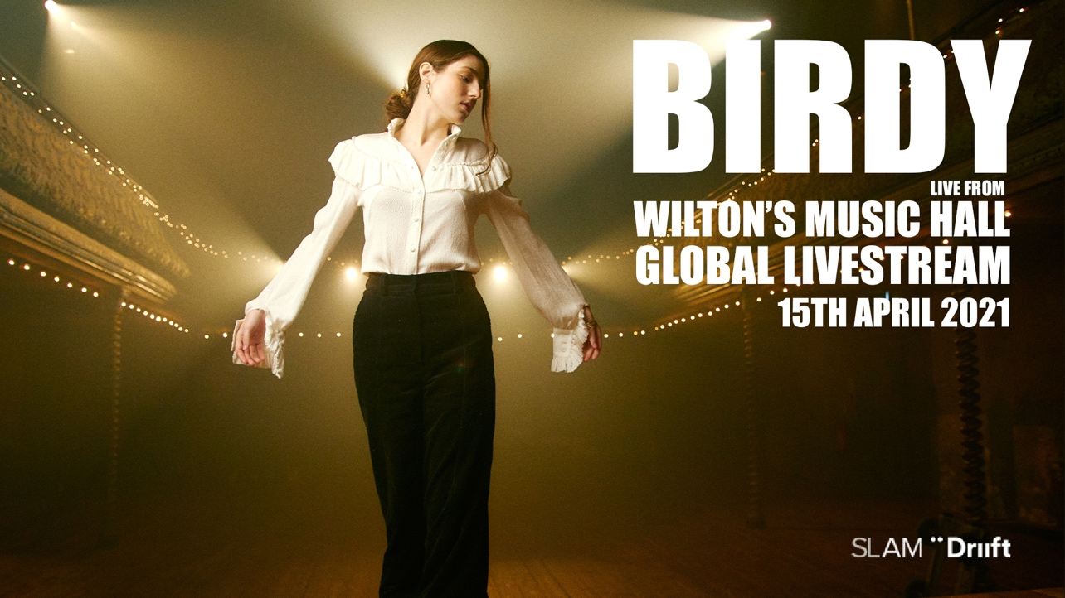
(Credit: Gobinder Jhitta)
download Birdy press images here

Grammy-nominated, multi-platinum recording artist Birdy has today released a brand new track “Deepest Lonely.” Accompanied by a stunning live performance video from The Pool Studios in London, this heartfelt track is the third single to be lifted from her highly-anticipated new album ‘Young Heart,’ following previous singles “Loneliness” and “Surrender.” Young Heart is set for release on April 30th.

Listen to “Deepest Lonely” here
Watch Birdy’s live performance from The Pool Studios here

Today also sees Birdy announce a global livestream event, Live from Wilton’s Music Hall on April 15th 2021, via Driift. Tickets on sale Friday, March 26th here.

Performing live from the oldest music hall in the world, Birdy will perform a career-spanning set ahead of the release of her new album. Accompanied by a band that includes 8 string players, a clarinet player and a French horn player, the show will be different to anything Birdy has ever done before and beautifully shot by acclaimed film director Ed Coleman.

Speaking about the global livestream, Birdy says: “I can’t put into words how excited I am to be in a room with my band rehearsing, (We’re also going to have a string section which I’m SO excited about!) Can’t wait to perform old and new songs for you all, playing live is what I love doing most and I have missed it so much!”

The global livestream is produced by Driift, the pioneering UK-based business behind acclaimed online ticketed events for Nick Cave, Niall Horan, Laura Marling, Dermot Kennedy, Andrea Boccelli, Kylie Minogue and James Bay. As befits such a special occasion, this will be a one-off live event with ticket purchase being the only way to see Birdy’s performance in this extraordinary venue. There will be no access to replays.

Ticket purchasers can choose from one of the following viewing times below:

LIVESTREAM #2 (US & CANADA EAST COAST & CENTRAL/SOUTH AMERICA): 8PM EDT
LIVESTREAM #3 (US & CANADA WEST COAST): 8PM PDT
LIVESTREAM #1 (UK, IRELAND & EUROPE): 8PM BST / 9PM CEST
LIVESTREAM #4 (AUSTRALIA, NEW ZEALAND & ASIA): 8PM AEST / 10PM NZST / 7PM JST & KST (ON FRIDAY, APRIL 16TH)

‘Young Heart’ is quite the departure from Birdy’s previous album, 2015’s dramatic ‘Beautiful Lies.’ Where Beautiful Lies was a fairy tale, Young Heart is a gritty realist portrait of the artist in pain, looking for the light. The songs on the album tussle between light and dark, between that vastness of space and the interior of home. The conflict between wanting to hide away and being compelled to go away, to new places and new experiences play out across the record.

Album opener “Voyager” is a beautifully written song about the knowledge and pain that you need to end a relationship, but the no-man’s land where your partner doesn’t know yet. From there, the record speaks of the fallout – the loneliness, the pain of missing the person one still loves, the acceptance of grief being central to love and loss, longing for travel but the pull of the familiarity of home.

Pre-order Birdy’s fourth studio album ‘Young Heart’ here: https://birdy.lnk.to/young-heart/

‘Young Heart’ Tracklisting:
- The Witching Hour – Intro
- Voyager
- Loneliness
- The Otherside
- Surrender
- Nobody Knows Me Like You Do
- River Song
- Second Hand News
- Deepest Lonely
- Lighthouse
- Chopin Waltz in A Minor – Interlude
- Evergreen
- Little Blue
- Celestial Dancers
- New Moon
- Young Heart

Birdy, discovered at the age of just 12 years old, has amassed over 1.6 billion audio streams worldwide, 1 billion YouTube views, 7.1 million monthly Spotify listeners and 4.7 million album sales to date. At the age of just 24, she has achieved 21 platinum singles worldwide, been nominated for a GRAMMY and Brit Award, and achieved number 1 albums all around the world, including in the US, UK, Australia, and more. Her passionate fanbase exceeds 8.1 million on social media and has seen her sell out venues such as The Roundhouse London, Hammersmith Apollo (twice), Sydney Opera House, Albert Hall Manchester and Shepherd’s Bush Empire and perform at the world’s largest award ceremonies including the BAFTA Awards and Paralympic London 2012 Olympics Opening Ceremony. Her brand work has seen Birdy announced as the face of REDValentino S/S 2017 and GAP’s ‘Lived In’ campaign in the US, photographed by David Sims. A highly syncable artist, Birdy has written songs for film and TV soundtracks, including The Hunger Games (2012), Disney PIXAR’s Brave (2012), The Fault in Our Stars (2014), and The Edge of Seventeen (2016).

US Press Contact: Libby Kober | Libby.Kober@atlanticrecords.com

