BIRDY REVEALS NEW TRACK ‘ISLAND LIGHTS’
TAKEN FROM ‘PIANO SKETCHES’ EP

BUY/STREAM: HERE
WATCH OFFICIAL LYRIC VIDEO: HERE

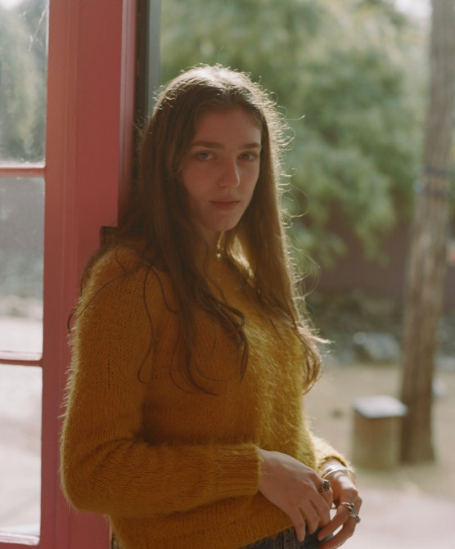
DOWNLOAD IMAGES HERE

Today, Birdy reveals new track “Island Lights” taken from her forthcoming ‘Piano Sketches’ EP, set for release on November 6th via Atlantic Records. “Island Lights” is a hauntingly beautiful track that demonstrates the power and mesmerism of Birdy’s vocals. Listen to “Island Nights” here.

Birdy said of the track "Some days end and take whole chapters of our lives with them, this song is about one of those nights.”

Written and produced independently during her time away from the spotlight, ‘Piano Sketches’ offers fans a 4 track reintroduction to Birdy’s incredible talent and artistic growth since 2016’s critically acclaimed album ‘Beautiful Lies’. Now aged 24, the multi-platinum, internationally acclaimed, Brit and Grammy nominated artist also recently announced her highly anticipated new album for 2021, details will be announced in due course.

Birdy says “I’ve spent the last few years recording a new album coming next year which I’m super-excited to share. I wrote a load of music I’m so proud of that might not normally have seen the light of day - I’ll be releasing the tracks stripped back over the coming months ahead of the album.”

Birdy, discovered at the age of just 12 years old, has amassed over 3 billion streams worldwide, just under a billion YouTube views, 7.1 million monthly Spotify listeners and 4.7 million album sales to date. At the age of just 24, she has achieved 21 platinum singles worldwide, been nominated for a Brit Award and achieved number 1 albums all around the world, including UK, U.S, Australia, Belgium, Netherlands and more. Her passionate fanbase exceeds 8.1 million on social media and has seen her sell out venues such as The Roundhouse London, Hammersmith Apollo (twice), Sydney Opera House, Albert Hall Manchester and Shepherd’s Bush Empire and perform at the world’s largest award ceremonies including British Academy of Film and Television Arts’ BAFTA Awards and Paralympic London 2012 Olympics Opening Ceremony. Her brand work has seen Birdy announced as the face of REDValentino S/S 2017 and GAP’s ‘Lived In’ campaign in the US, photographed by David Sims. A highly syncable artist, Birdy has written songs for film and TV soundtracks, including The Hunger Games (2012), Brave (2012), The Fault in Our Stars (2014) and The Edge of Seventeen (2016).

###

