CARYS RELEASES “NO MORE”
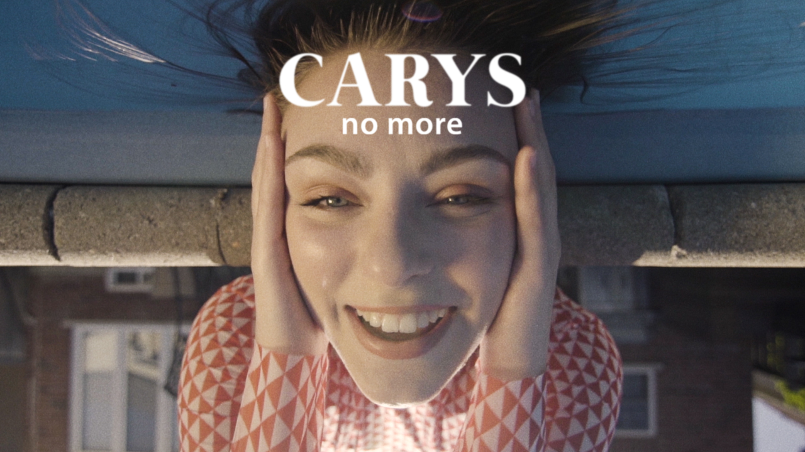
WATCH HERE: https://www.youtube.com/watch?v=t2HQeMbQzaM
LISTEN HERE: https://CARYS.lnk.to/NoMoreID

June 26, 2020 – Warner Music Canada / Atlantic Records recording artist CARYS has released her new single “No More.” The track, produced by Ryan Stewart (Carly Rae Jepsen, Tyler Shaw) is the follow up to her breakout hit “Princesses Don’t Cry,” which garnered over 50 million streams around the world. “No More” arrives with an official video, directed remotely by Ryan Faist (bülow, Dizzy) and shot during self-isolation in CARYS childhood home, fittingly enough by her brother and aspiring film maker, Nicolas Mongillo.” CARYS will be joining her fans at 11:00 AM EDT today to premiere the video on YouTube – click here to join the chat.
Of the new single, CARYS says “’No More’ is a song about realizing you’re a freaking sensation and the person you’ve been talking to does NOT appreciate how truly awesome you are. If you’ve ever been out with someone, made a fool of yourself to their disapproval, then decided that was the night to cut them off because they clearly suck - then this song is yours.”
CARYS has kicked off the “No More” campaign herself with a series of fun TikToks. The videos feature CARYS dancing to “No More” with a list of things that she wants “No More” of. Click through to her TikTok here to watch and share these videos.
CARYS will be releasing new music in the coming months. To stay up to date on all her upcoming projects, be sure to follow CARYS on TikTok, Instagram, YouTube, Facebook and Twitter.

