FOR IMMEDIATE RELEASE

JANUARY 16, 2018

CHARLOTTE CARDIN UNVEILS BIGGEST HEADLINE TOUR TO DATE

ACCLAIMED MONTREAL-BASED SINGER-SONGWRITER SETS NORTH AMERICAN TOUR

DATES BEGIN APRIL 13TH IN BOSTON, MA

“THE KIDS” COMPANION VISUAL PREMIERES TODAY VIA PAPER MAGAZINE

SOLD OUT TREK SUPPORTING BØRNS BEGINS TONIGHT IN OAKLAND, CA

“MAIN GIRL” EP AVAILABLE NOW

Atlantic recording artist Charlotte Cardin has announced plans for her biggest North American headline tour thus far. The dates begin April 13th at Boston MA’s Greatest Scott and then travel the United States and Canada into early May (see attached itinerary). Additional dates will be unveiled soon. Cardin will also join BØRNS as special guest for an eagerly awaited – and almost completely sold out – North American tour, beginning tomorrow at Oakland, CA’s famed Fox Theater. For complete details and ticket availability, please see www.charlottecardin.com.

Cardin is celebrating the tour announcement with the debut of a powerful new video, “The Kids,” premiering today at Paper Magazine, while also streaming at the official Charlotte Cardin YouTube channel.

“The Kids” is of course featured on Cardin’s major label debut EP, MAIN GIRL, available now at all DSPs and streaming services. The EP is highlighted by the breakthrough single/title track, “Main Girl,” also joined by a breathtaking companion video, now boasting over 3 million views at YouTube alone. “Filmed across the beautiful natural landscapes of Iceland, Cardin isn't afraid to explore messy emotions as she says goodbye to the person who is off to be with the titular ‘main girl,’” wrote Refinery 29 in its exclusive premiere.

The MAIN GIRL EP features three brand new songs – “Main Girl,” “Paradise Motion” and “The Kids” – alongside a trio of tracks first featured on the Montreal-based singer-songwriter’s breakthrough 2016 Canadian EP release, BIG BOY. Highlights include “Dirty Dirty,” available now at all DSPs and streaming services. The track is joined by a new live video, streaming now at Cardin’s official YouTube channel.

2016 saw the arrival of her “BIG BOY” EP (via Cult Nation), highlighted by the sultry, electro-jazz title track as well as such equally potent original songs as “Dirty Dirty” and “Like It Doesn’t Hurt (Feat. Husser).” The EP proved a phenomenon for the multitalented vocalist, musician, and songwriter, reaching #1 on Canada’s iTunes Store while earning over 10 million streams on Spotify alone.

Cardin and BIG BOY quickly amassed critical attention here in the US, with Interview hailing “the smoky, jazz-tinged alto's vocal sophistication and adept wordplay…Cardin puts musicianship at the forefront; she sings confidently in both English and French over minimalist R&B productions and minor piano tickling.” The FADER applauded “Like It Doesn’t Hurt” as “a seriously smooth, beat-heavy track...Cardin's sultry voice carries this minimalistic song all the way through,” while NYLON praised “the sultry track” as “a dialogue about a dysfunctional love that burns with eternal passion…fueled by tons of drama that eventually leads to the extreme.” “(Cardin’s) got a voice that’ll make you stop whatever you’re doing, and listen,” raved Pigeons and Planes, noting “BIG BOY” “showcases a range of different styles. On some songs, Cardin explores a more jazzy and soulful vibe. On others, she slows things down to deliver an emotive pop ballad…Regardless of the genre, Cardin handles the track with the confidence of someone far more experienced. She knows when to let the song breath and, adversely, when to let her voice steer.” “All it takes is one listen to ‘BIG BOY’ to understand that (Cardin) has a certain je ne sais quoi,” wrote NOISEY, further praising her “remarkable control and maturity.”

Fast becoming known as a uniquely compelling live performer, Cardin has toured nearly non-stop over the past year, including a major US tour alongside Nick Murphy, countless Canadian live dates – both as headliner and support – as well as show-stealing performances at an array of North American festivals including Bonnaroo, Osheaga, and Le Festival d’Été de Québec, the latter of which saw her as special guest to Sting and Peter Gabriel.

CHARLOTTECARDIN.COM * FACEBOOK * TWITTER * INSTAGRAM * YOUTUBE * SPOTIFY

(TOUR ITINERARY ATTACHED)

CHARLOTTE CARDIN
NORTH AMERICA 2018
* Supporting BØRNS
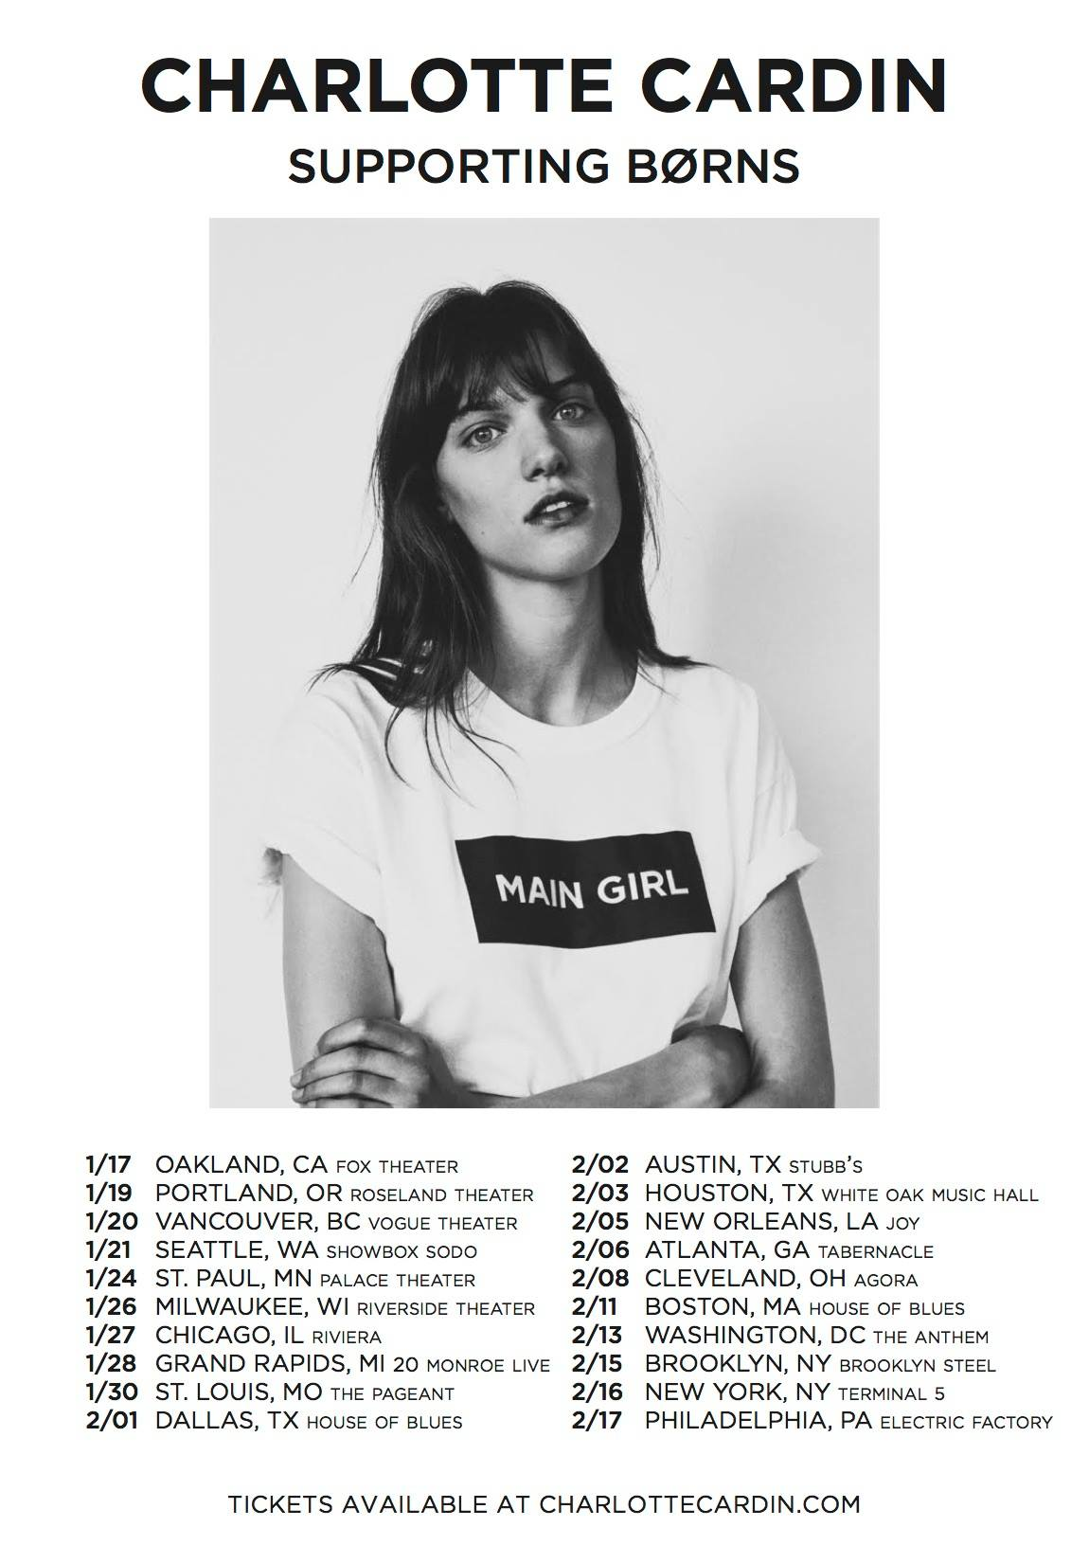
JANUARY
17 – Oakland, CA – Fox Theater – SOLD OUT *
19 – Portland, OR – Roseland Theater – SOLD OUT *
20 – Vancouver, BC – Vogue Theater – SOLD OUT *
21 – Seattle, WA – Showbox Sodo – SOLD OUT *
24 – St. Paul, MN – Palace Theater – SOLD OUT *
26 – Milwaukee, WI – Riverside Theater *
27 – Chicago, IL – Riviera – SOLD OUT *
28 – Grand Rapids, MI – 20 Monroe Live – SOLD OUT *
30 – St. Louis, MO – The Pageant – SOLD OUT *

FEBRUARY
1 – Dallas, TX – House of Blues – SOLD OUT *
2 – Austin, TX – Stubb’s – SOLD OUT *
3 – Houston, TX – White Oak Music Hall – SOLD OUT *
5 – New Orleans, LA – Joy Theater *
6 – Atlanta, GA – Tabernacle – SOLD OUT *
8 – Cleveland, OH – Agora *
11 – Boston, MA – House of Blues – SOLD OUT *
13 – Washington, DC – The Anthem *
15 – Brooklyn, NY – Brooklyn Steel – SOLD OUT *
16 – New York, NY – Terminal 5 – SOLD OUT *
17 – Philadelphia, PA – Electric Factory – SOLD OUT *

CHARLOTTE CARDIN HEADLINE TOUR

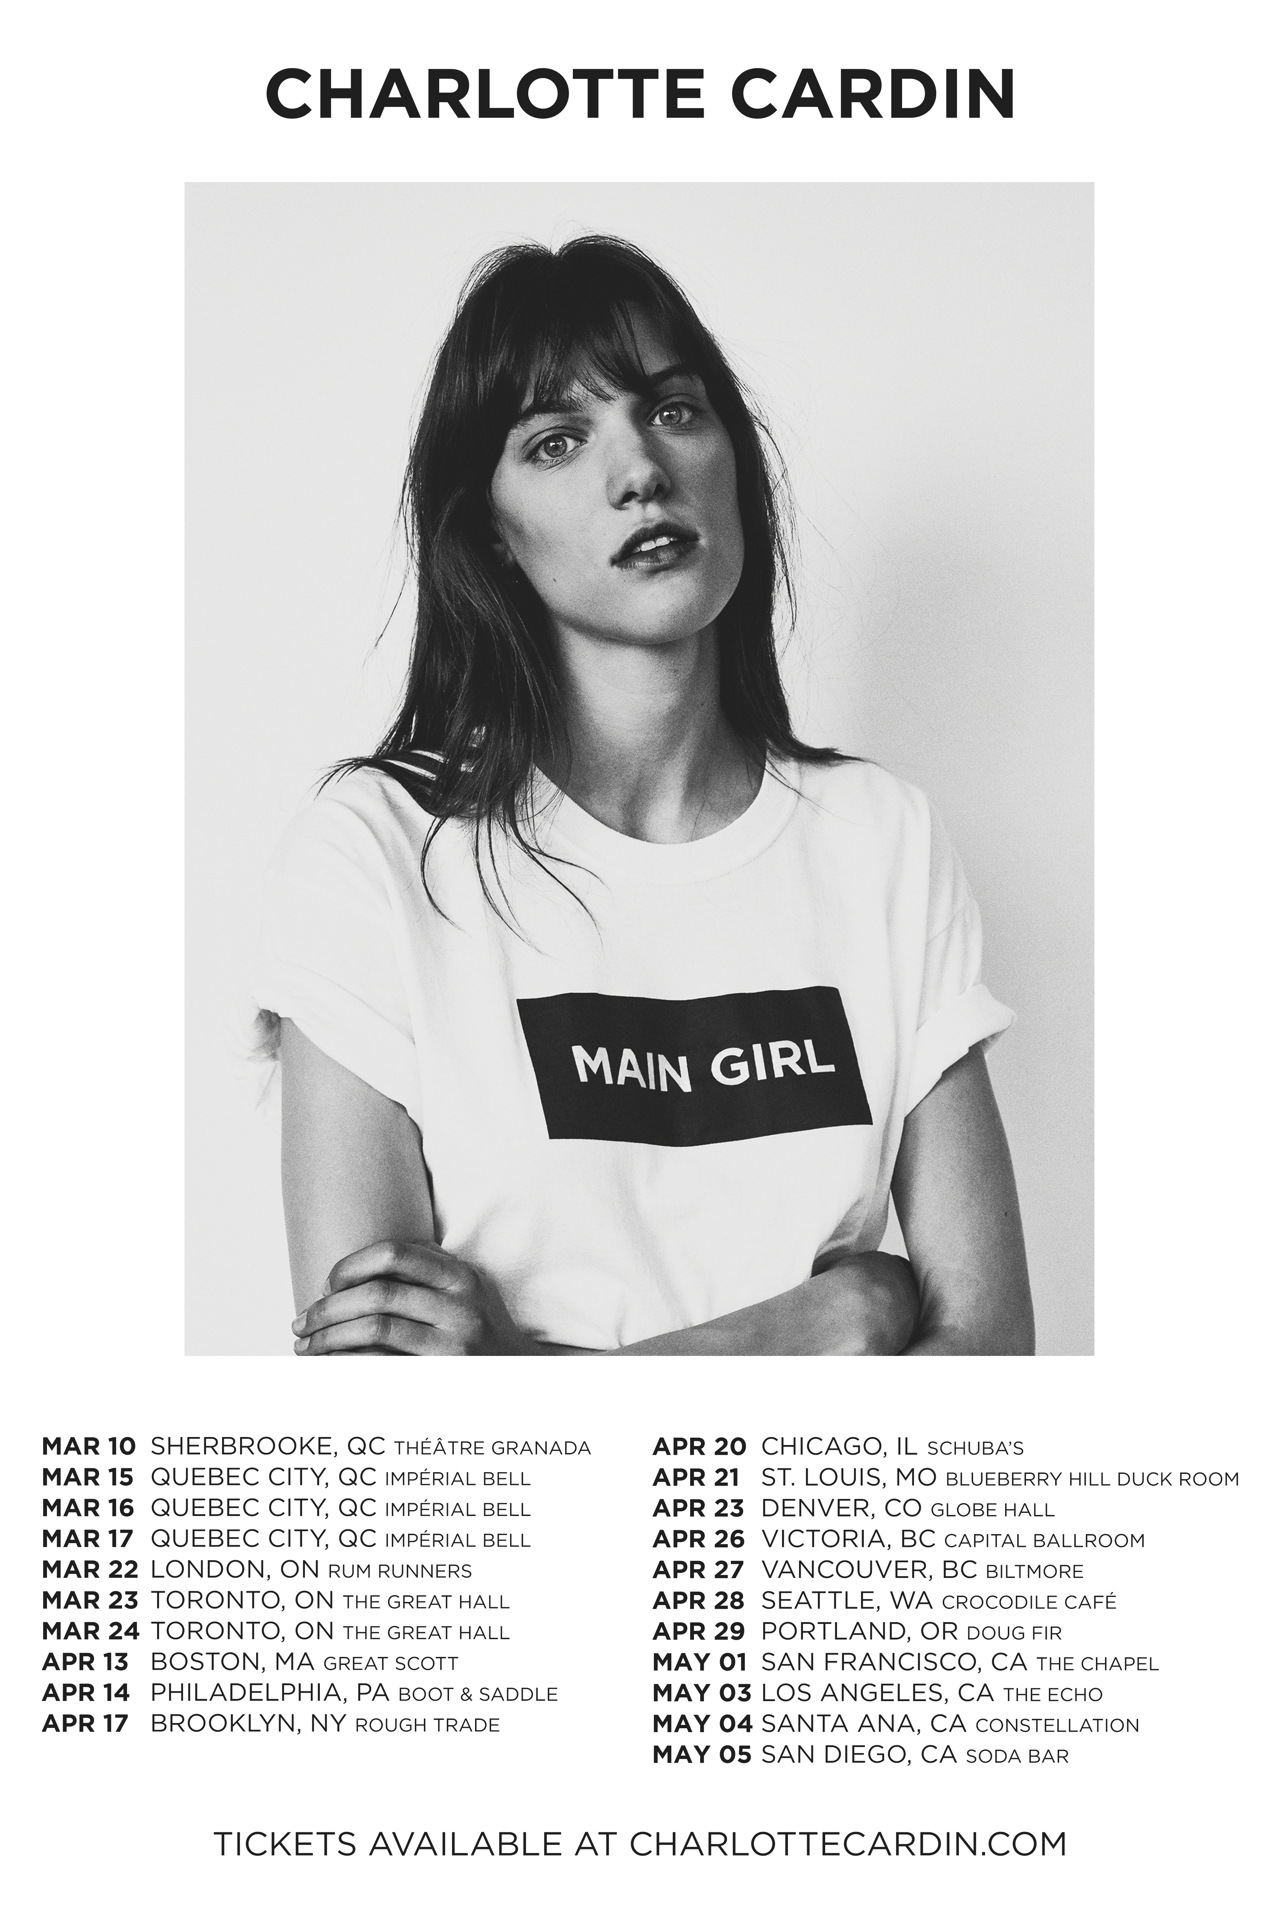

APRIL
13 – Boston MA – Great Scott
14 – Philadelphia, PA – Boot & Saddle
18 – Brooklyn, NY – Rough Trade
20 – Chicago, IL – Schuba’s
21 – St. Louis, MO – Blueberry Hill Duck Room
23 – Denver, CO – Globe Hall
26 – Victoria, BC – Biltmore
28 – Seattle, WA – Crocodile Café
29 – Portland, OR – Doug Fir

MAY
1 – San Francisco, CA – The Chapel
3 – Los Angeles, CA – The Echo
4 – Santa Ana, CA – Constellation
5 – San Diego, CA – Soda Bar

ADDITIONAL DATES TO BE ANNOUNCED

CHARLOTTECARDIN.COM

# # #

