FOR IMMEDIATE RELEASE
SEPTEMBER 18, 2019

CHARLOTTE LAWRENCE RELEASES “WHY DO YOU LOVE ME”
REMIX BY HIPPIE SABOTAGE

Headline ‘Navy Blue Tour’ kicks off November 7th

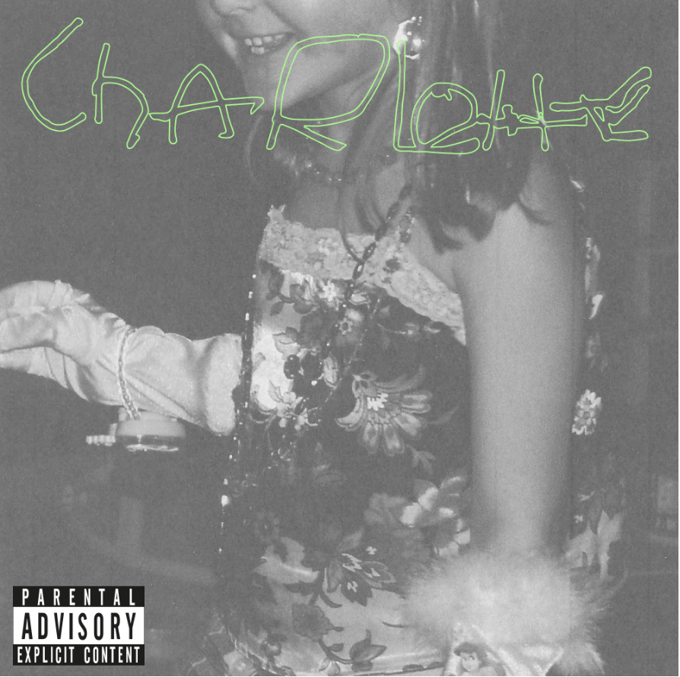
DOWNLOAD HIGH-RES IMAGE

STREAM “WHY DO YOU LOVE ME” (HIPPIE SABOTAGE REMIX): https://charlottelawrence.lnk.to/HippieSabotageRmxPR

Acclaimed pop singer-songwriter Charlotte Lawrence has teamed up with genre-bending duo Hippie Sabotage for the latest remix of “Why Do You Love Me” – her debut single release via Gold Tooth/Atlantic Records. The release follows recent mixes by Riton and Klingande, in addition to a stunningly stripped back version of the song and Alasdair McLellan-directed original music video.

Written/produced alongside Andrew Watt, Louis Bell, Ryan Tedder, Ali Tamposi and Charlie Puth, “Why Do You Love Me” sees Lawrence exploring a fresh new sound with a deliciously darker aesthetic. The single was praised as “a haunting take on pop rock” by Billboard, while DuJour declared “(Lawrence) is a force to be reckoned with” and Flaunt echoed “(Lawrence) is the latest teenage pop icon to emerge and dominate the music charts.”

Since exploding on the scene in recent years, Lawrence has seen widespread critical acclaim and millions of worldwide streams for breakthrough hits “Just The Same” and “Sleep Talking” off her 2018 debut EP YOUNG. She has graced the cover of V Magazine’s Spring 2019 preview issue, in addition to being featured prominently via PAPER, W Magazine, Harper’s BAZAAR, Wonderland, Teen Vogue & more.

This fall will see Lawrence embarking on her headline Navy Blue Tour, kicking off November 7th in Atlanta, GA with stops at Webster Hall in New York, NY and The Fonda in Los Angeles, CA. The newly announced dates follow recent tours of both the U.S. and Europe, runs highlighted by sold out shows in cities spanning New York and Los Angeles to Amsterdam, Manchester, and Cologne. For complete details and ticket information, please visit charlottelawrencemusic.com.

About Hippie Sabotage:
Widely recognized for their eclectic, genre-bending sounds, Hippie Sabotage is made up of brothers Kevin and Jeff Saurer. They broke through with their remix of Tove Lo’s “Habits (Stay High),” which has over 366 million Spotify streams and 726 million YouTube views. Hippie Sabotage have since broken 1 billion Spotify streams, produced for Denzel Curry, and remixed tracks from Billie Eilish, Khalid, and G-Eazy. Over the years, their sound has evolved, taking cues from hip hop, psych rock, and chill wave, but what sets them apart is their incorporation of live instrumentation in their music and live show – you can always catch Jeff ripping on guitar at their live shows. Known for their explosive performances, Hippie Sabotage are a staple across the US festival circuit this year, playing at Hangout Fest, Splash House, Bumbershoot, Made in America, Austin City Limits, Day N Vegas, and more.

CHARLOTTE LAWRENCE: NAVY BLUE TOUR 2019
November 7 – Atlanta, GA – Vinyl
November 8 – Nashville, TN – The Cowan
November 9 – Chicago, IL – Subterranean
November 11 – Columbus, OH – A&R Music Bar
November 13 - Toronto, ON – Velvet Underground
November 14 – Boston, MA – Brighton Music Hall
November 15 – Philadelphia, PA – The Foundry
November 16 – Washington, DC – U Street Music Hall
November 18 – New York, NY – Webster Hall
November 21 – San Diego, CA – House of Blues - San Diego
November 23 – Los Angeles, CA – The Fonda Theatre
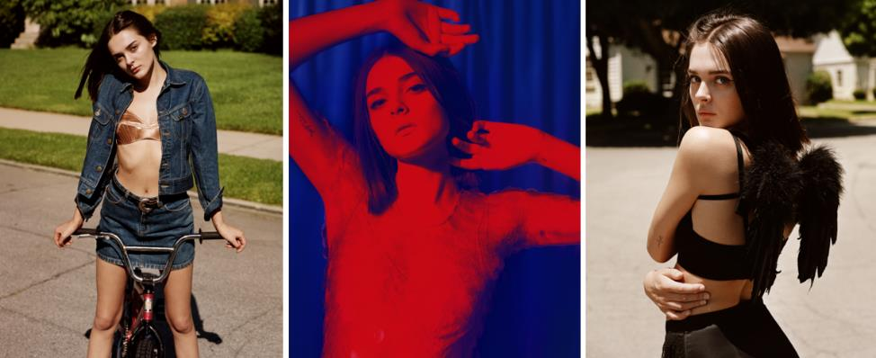
DOWNLOAD HIGH-RES IMAGES

CONNECT:
OFFICIAL | FACEBOOK | TWITTER | INSTAGRAM | PRESS ASSETS

