CHARLI XCX PARTIES IN AN ALTERNATE DIMENSION IN THE VIDEO FOR ‘CLAWS’
NEW ALBUM ‘how i’m feeling now’ RELEASED IN 14 DAYS

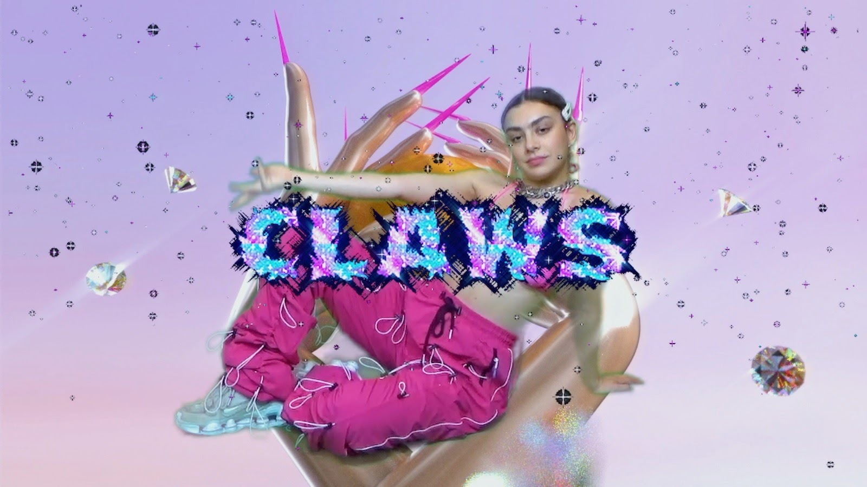

WATCH THE VIDEO HERE

Today Charli XCX unveils the music video for ‘claws’, the Angel-selected second single from her forthcoming new album, ‘how i’m feeling now’.

Directed by Charli and Charlotte Rutherford, the visual transports Charli to multiple alternate realities from the comfort of her home while she’s self-isolating. Using a green screen, Charli parties with a metallic snake, hovers above groups of people below her, performs as a severed head and more, finding a place to leave it all behind in hyperreality before the video’s glitched-out final moments.

Yesterday Charli held her fourth weekly Zoom conference for 1000 fans, taking questions on the album’s songwriting process from the likes of Drag Race winner Aquaria, LA based musicians Simi + Haze, NME Radar award winner Beabadoobee and sex positive icon Sophie Anderson. Watch the session back here.

A short, sharp burst of energy, ‘claws’ crackles with futuristic spirit. Produced by Dylan Brady of 100 gecs, the track blends pop, hip hop, electronica and trance with Charli flowing dexterously over the top of the track’s unrelenting instrumental. Exploring the feeling of being close to the one you love every day - ‘claws’ captures the manic jubilation of love in lockdown in a refreshing way; with synths teetering on the edge of discordance, full bodied 808s and Charli’s innocent delivery juxtaposing and complimenting each other simultaneously before descending into a trance-infused euphoria.

To be released on May 15th 2020, Charli XCX’s forthcoming new album ‘how i’m feeling now’ is a completely unique project. Written, recorded and released in quarantine due to the COVID-19 pandemic, the album invites collaboration in a new way, welcoming fans to give feedback on every aspect of the record; from contributing to videos, to songwriting choices, to single selection and more.

To support those suffering with the effects of COVID-19 if you are in a position to, please consider donating to the following charity:

LA ALLIANCE

LA Alliance are an organization that fights for the rights and protection of homeless peoples in Los Angeles who are currently campaigning for their protection from COVID-19. More info on what they do here.
To donate to the LA Alliance: click here
Hi-res press image here.
Charli XCX: Facebook | Twitter | Instagram

For more information please contact Huxley: anna@huxley.world / jemma@huxley.world / mitch@huxley.world

