CHARLI XCX RELEASES VIDEO FOR ‘FOREVER’
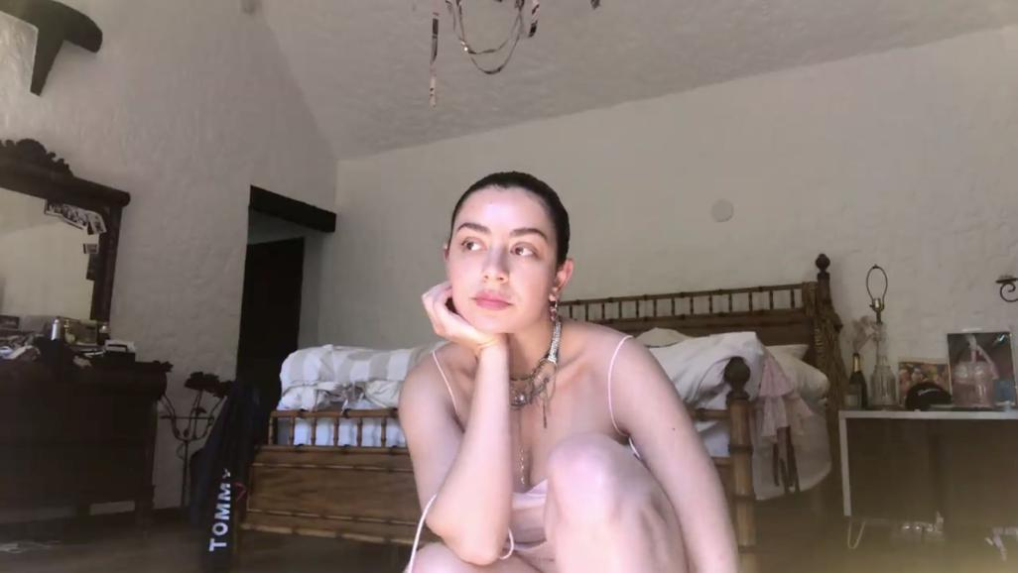

WATCH THE VIDEO​ HERE​

Today Charli XCX releases the video for ‘forever’, the debut track taken from her forthcoming album ‘how i’m feeling now’. Charli announced the visual at the second of her Zoom press conferences last night with fans and special guests such as Nadya Tolokno of Pussy Riot and Shamir Bailey in attendance.

The video is co-directed by Charli and Dan Streit​and​ takes fan collaboration to the next level, with Charli’s fans, known as the Angels, contributing over 5000 clips to be stitched together to create the video. Sending out an open call to her fans, Charli collated Angels’ past memories, as well as tender moments shared directly from their phone camera roll.

‘forever’ was written by Charli XCX and produced by A. G. Cook and BJ Burton. The track was created within two days, with Charli teaming up with Cook and Burton via the internet while all three are in self-isolation. This is a working process that will continue throughout the album, with the entirety of the project being written, recorded, produced and released while in quarantine, with the process being shared with her fans for feedback, contributions and more.

A romantic, hopeful cut of progressive pop, ‘forever’ glows with luminous synths and cascading pixelated textures. Lo-fi in nature before slowly unfurling into something more beautiful, ‘forever’ is a perfect touchpoint for how the upcoming project may sound; patient, forward thinking, and completely unique.

To support those suffering with the effects of COVID-19 if you are in a position to, please consider donating to the following charities:

WORLD HEALTH ORGANIZATION

The World Health Organization (WHO) has launched a special fund designed to raise funds specifically for Covid-19 response. The WHO estimates it needs $675M through April for preparedness and response efforts

The United Nations Foundation and the Swiss Philanthropy Foundation have created a fund to benefit the WHO’s effort. The fund supports the delivery of protective equipment to frontline healthcare workers, laboratory testing and accelerates research into diagnostics, treatments and vaccine development

To donate to the COVID-19 Solidarity Response Fund: click here

LA ALLIANCE

LA Alliance are an organization that fights for the rights and protection of homeless peoples in Los Angeles who are currently campaigning for their protection from COVID-19. More info on what they do here​.​

To donate to the LA Alliance: click here

Hi-res press image​ here​.​
Charli XCX: ​Facebook​ ​| ​Twitter ​​| ​Instagram​

For more information please contact Huxley: anna@huxley.world / mitch@huxley.world / jemma@huxley.world

