CHARLI XCX ANNOUNCES NEW ALBUM
'how i'm feeling now'
ALBUM TO BE WRITTEN, RECORDED AND RELEASED IN SELF-ISOLATION
TO RELEASE 15TH MAY 2020

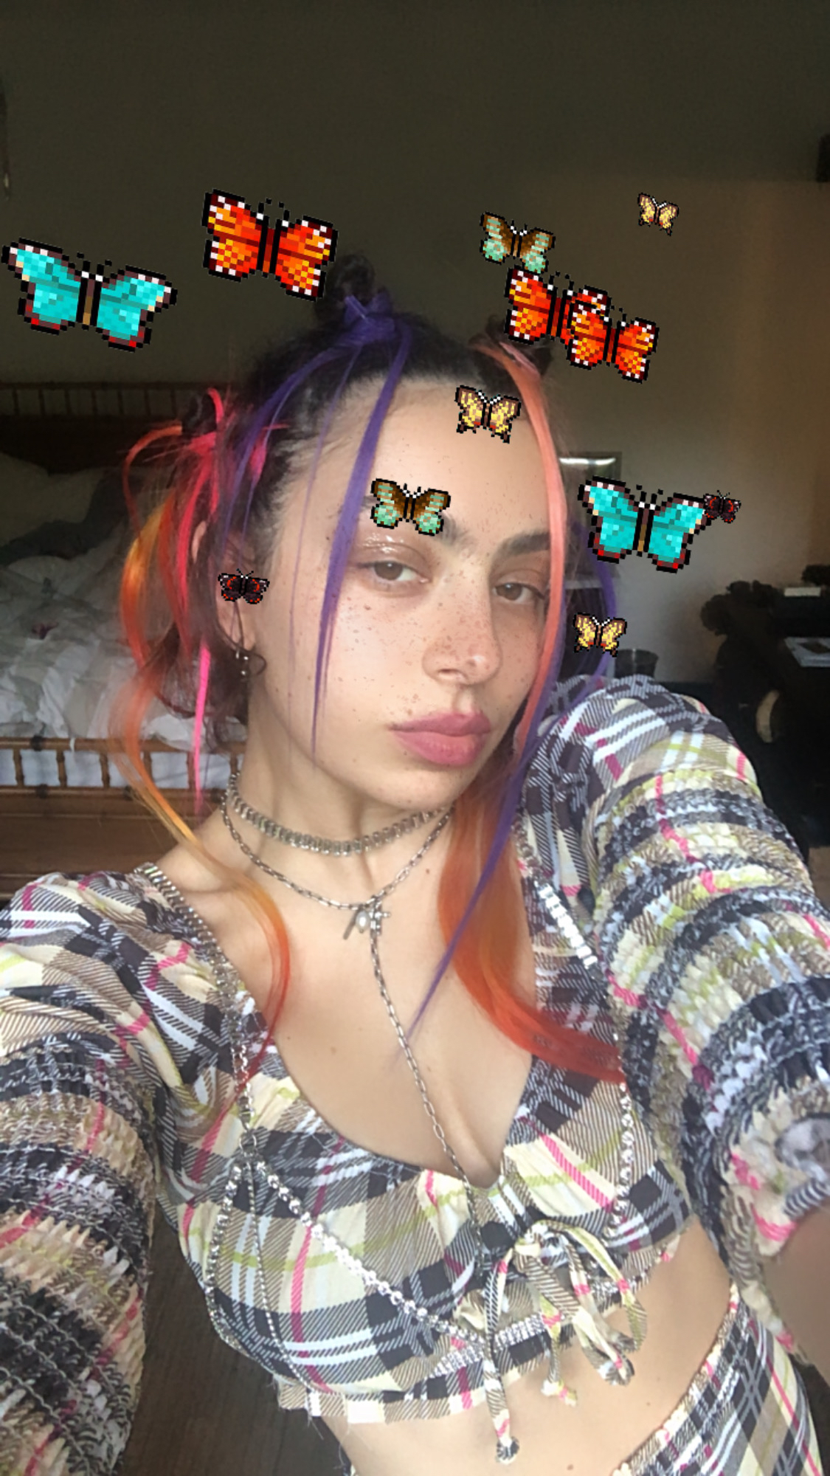

Watch Announcement

Announcement transcript here and hi-res press image here.

Charli XCX announced her new album to 1000 fans live on Zoom at 11:30am PT // 2:30pm ET // 7:30pm BST - watch via the 'how I'm feeling now' YouTube channel here.

To support those suffering with the effects of COVID-19 if you are in a position to, please consider donating to the following charities:

LA Alliance
An organisation that fights for the rights and protection of homeless peoples in Los Angeles who are currently campaigning for their protection from COVID-19. More info on their action here and what they do here.

LA Food Bank
A food bank in LA that is in urgent need of donations as quarantine is affecting their food stock and volunteer time. People in the USA can find their local food banks here, and in the UK here.

Charli XCX: Facebook | Twitter | Instagram

For more information please contact Huxley: anna@huxley.world / mitch@huxley.world / jemma@huxley.world

