FOR IMMEDIATE RELEASE JULY 30, 2020

CHARLIE PUTH SHARES HAYWYRE REMIX OF “GIRLFRIEND”

“GIRLFRIEND” AMASSES OVER 27 MILLION GLOBAL STREAMS

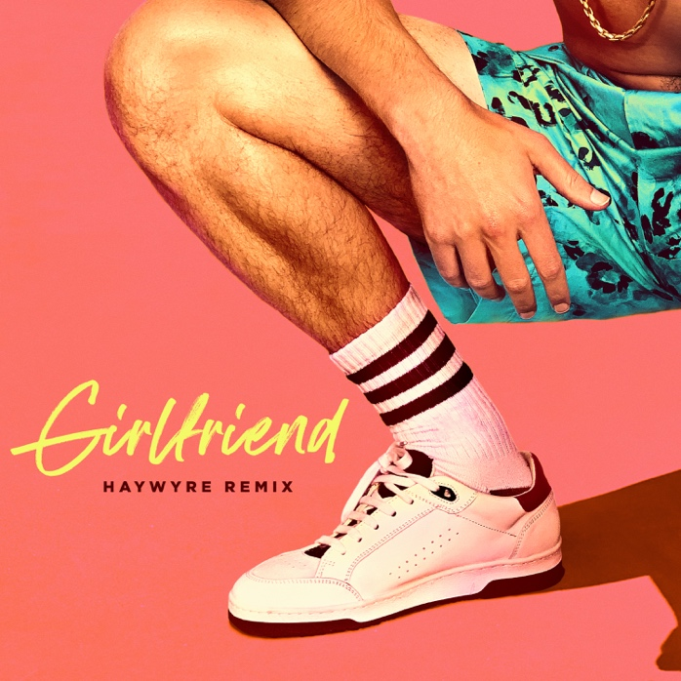
Download Hi-Res Artwork HERE

STREAM/DOWNLOAD “GIRLFRIEND” (HAYWYRE REMIX) HERE

WATCH THE OFFICIAL MUSIC VIDEO FOR “GIRLFRIEND” HERE

Los Angeles, CA – July 30, 2020 – Multi-GRAMMY nominated and multi-platinum singer/songwriter/producer, Charlie Puth, has shared a remix of his new song, “Girlfriend.” With producer and multi-instrumentalist Haywyre at the helm, the remix takes Puth’s funky summer smash and ups the attitude and punch, showcasing his ability to reimagine the music in unique and groundbreaking ways. Renowned for his sophisticated and captivating productions, Haywyre’s music has racked up tens of millions of streams worldwide, and his virtuoso live performances have shared the stage with top dance acts such as Zedd, Gramatik, and GRiZ on tour.

In addition to clocking over 27 million total global streams and over 6.5 million video views, “Girlfriend” has been celebrated in the press, with Vulture calling the song “excellent” and Billboard hailing it a “swoon-worthy summer bop.” The FADER provided further critical acclaim, lauding “Girlfriend” “a finely-tuned pop track…marked with one of his most tenacious hooks to date.” In addition, The FADER went on to praise Puth’s collective body of work, saying “If Charlie Puth is capable of making a bad song, I have yet to hear it.”

Puth debuted the first live performance of “Girlfriend” on The Late Late Show with James Corden, which underscored his superb piano playing skills and signature falsetto. The appearance on the show can viewed HERE, and “Girlfriend (Live From Corden)”, the stripped-down, acoustic rendition of the track, is available to stream/download HERE. Puth also delivered another stellar performance of the song on the Today Show’s Summer Concert Series. Watch it HERE.

Connect with Charlie Puth:
Website | Facebook | Twitter | Instagram | YouTube | Media Assets

Connect with Haywyre:
Website | Facebook | Twitter | Instagram | YouTube

# # #

Press Contacts for Charlie Puth:
ID, Allison Elbl (aelbl@id-pr.com), Rhett Usry (rusry@id-pr.com), Nathalie Rubin (nrubin@id-pr.com)
Atlantic Records, Sheila Richman (sheila.richman@atlanticrecords.com), Ted Sullivan (ted.sullivan@atlanticrecords.com)

Press Contact for Haywyre:
Nate Hurd (nate@nightshift.net)

