CHARLIE PUTH RELEASES acoustic version of HIT NEW SONG
“LIGHT SWITCH”

Track From His Forthcoming Album CHARLIE
Becomes His Most Successful Song Release Ever and Earns Rave Reviews

‘“Light Switch” possesses a dreamy ’80s sheen and a ton of Puth’s personal touches, from lip-smacking ad-libs to hooks nestled into bigger hooks, making for both a breathtaking pop fantasia and welcome return.’ – BILLBOARD

‘Before hitting play on Charlie Puth's new single, 'Light Switch,' know that this funky, upbeat track will likely be stuck in your head for the rest of the day. Maybe even tomorrow, too. Don't say we didn't warn you.’ – IHEARTRADIO

‘…a sun-soaked and upbeat tune which shows off his knack for writing carefree love songs.’- UPROXX

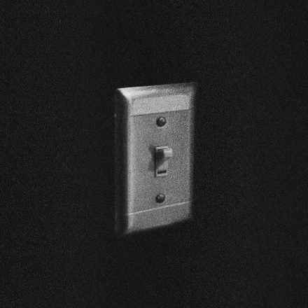
CLICK HERE TO LISTEN TO THE SONG NOW

Los Angeles, CA – February 18, 2022 – GRAMMY nominated and multi-platinum singer/songwriter/producer, Charlie Puth, today released an acoustic version of his hit new song, “Light Switch.” Click HERE to listen.

The striking new acoustic guitar version of the track that features Charlie’s signature falsetto and follows the release of his most successful career debut for a song to date. “Light Switch” hit #1 on the iTunes Pop Chart upon release and is currently exploding up the charts, hitting the Top 40 US chart at #15 this week and #13 at HOT AC as well.

The critics have also raved about the song, with Billboard declaring, ‘“Light Switch” possesses a dreamy ’80s sheen and a ton of Puth’s personal touches, from lip-smacking ad-libs to hooks nestled into bigger hooks, making for both a breathtaking pop fantasia and welcome return.’ iHeart Radio says, “Before hitting play on Charlie Puth's new single, 'Light Switch,' know that this funky, upbeat track will likely be stuck in your head for the rest of the day. Maybe even tomorrow, too. Don't say we didn't warn you.’ Uproxx notes that ‘Light Switch’ is “…a sun-soaked and upbeat tune which shows off his knack for writing carefree love songs.”

After teasing clips of the song for months to his more than 15 million fans on TikTok, the official music video for “Light Switch” has now racked up nearly 30 million views upon its release. “Light Switch” is the first new song to be released from Puth’s upcoming new album, CHARLIE, via Atlantic Records.

Charlie was also recently featured alongside Megan Thee Stallion in FRITO LAY'S new "FLAMIN' HOT" SUPER BOWL spot which sees Megan transformed into a fiery songbird while Puth voices a beatboxing fox. Watch the spot HERE.

At only 30 years old, Puth is a Diamond Certified, 20x Platinum, 4x Grammy-nominated singer, songwriter, producer and multi-instrumentalist, who has garnered three Billboard Music Awards, a Critic’s Choice Award, and a Golden Globe nomination. Puth co-wrote and produced The Kid Laroi and Justin Bieber’s record-breaking single, “Stay,” which quickly become one of the biggest songs of 2021 and holds the title for the longest-reigning No. 1 on the Billboard Global 200 chart and the first to lead it for double-digits - spending a total of eleven weeks at the top of the chart. Puth’s 2020 collaboration with Gabby Barrett on their “I Hope” Remix earned him his fourth top 10 track on the Billboard Hot 100, hit number one on the Billboard “Adult Pop Songs” chart, and won a 2021 Billboard Music Award for “Top Collaboration.” His 2018 GRAMMY-nominated LP, Voicenotes, was RIAA Certified Gold only four days after its release and has logged over 5.6 billion streams worldwide.

Link to Hi-Res Press Images and Single Artwork HERE

Connect with Charlie Puth:
Website | Instagram | Facebook | Twitter | TikTok | YouTube | Spotify | Apple Music

# # #

Press Contacts for Charlie Puth:
ID, Rhett Usry (rusry@id-pr.com)
Atlantic Records, Sheila Richman (sheila.richman@atlanticrecords.com) and Ted Sullivan (ted.sullivan@atlanticrecords.com)

