**CHARLOTTE CARDIN RELEASES “CALIFORNIA”**

**US HEADLINE TOUR KICKS OFF THIS WEEKEND**

**NEW COVER OF “GO FLEX” OUT NOW**

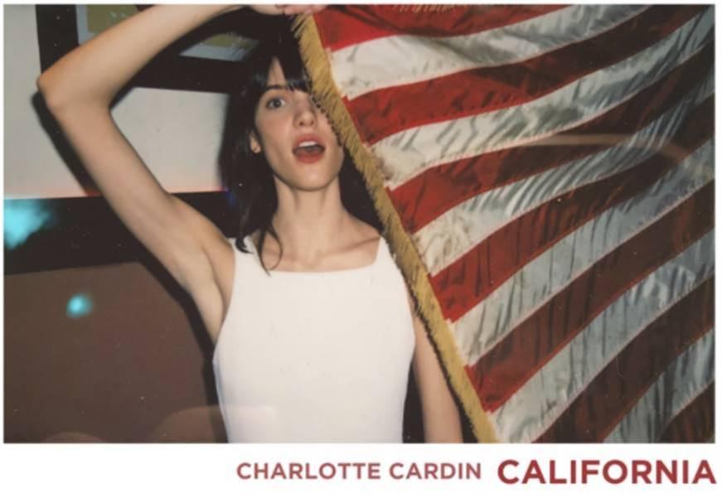

**BUY/STREAM “CALIFORNIA”**: <https://youtu.be/gCFbLq_qqNk>

**BUY/STREAM *MAIN GIRL* EP**: <https://atlantic.lnk.to/MainGirlPR>

(DOWNLOAD ARTWORK – [link](http://press.atlanticrecords.com/wp-content/uploads/2018/04/California.jpg))

Acclaimed Montreal-based singer-songwriter **Charlotte Cardin** has premiered “**California**,” a live-show staple that pairs Cardin’s hypnotic vocals with a bouncing summer-ready instrumental.

Cardin recently released a captivatingly smooth rendition of **Post Malone**’s “**Go Flex**” ([link](https://atlantic.lnk.to/FlexPR)),  just ahead of her first US headline tour. Kicking off this weekend in Philadelphia, PA, shows continue through June including a second night in Brooklyn, NY due to popular demand (full routing below). The shows immediately follow an incredible run of international headline dates, with sold out shows in London, Paris, Toronto & more. Fast becoming known as a uniquely compelling live performer, Cardin has toured nearly non-stop over the past year, including a major US tour alongside **Nick Murphy**, sold out run supporting **BØRNS** and countless Canadian live dates (both as headliner and support). She has also given show-stealing performances at an array of North American festivals including **Bonnaroo**, **Osheaga**, and **Le Festival d’Été de Québec**, the latter of which saw her as special guest to **Sting** and **Peter Gabriel**.

Cardinfirst broke through with her 2016 Canadian EP ***Big Boy***. The release proved a phenomenon with tracks “[**Like It Doesn’t Hurt**](https://youtu.be/OOzetKrKrrA)” (feat. **Husser**) and “[**Dirty Dirty**](https://youtu.be/RZDG3BoNKWY)” quickly gaining critical acclaim the US. **Interview** hailed *“the smoky, jazz-tinged alto's vocal sophistication and adept wordplay”* while **NOISEY** praised her *“remarkable control and maturity”* and **Pigeons & Planes** raved *“she’s got a voice that’ll make you stop whatever you’re doing, and listen.”* Released a year later, Cardin’s major label and US debut EP ***Main Girl*** (Atlantic Records) is highlighted by the breakthrough [single/title track](https://youtu.be/8Xef2NPzGp0), and joined by standouts “[**Paradise Motion**](https://atlanti.cr/paradisemotion)” and “[**The Kids**](https://youtu.be/57PKEK6tjSU).”

**Charlotte Cardin Headline Tour**

w/ Niia & Aliocha

April 14 – Philadelphia, PA @ Boot & Saddle

April 15 – Washington, DC @ Black Cat

April 17 – Brooklyn, NY @ Rough Trade \***SOLD OUT**\*

April 18 – Brooklyn, NY @ Rough Trade \***SOLD OUT**\*

April 20 – Chicago, IL @ Schuba’s

April 21 – St. Louis, MO @ Blueberry Hill Duck Room

April 23 – Denver, CO @ Globe Hall

April 26 – Victoria, BC @ Capital Ballroom

April 27 – Vancouver, BC @ Biltmore Cabaret

April 28 – Seattle, WA @ Crocodile Café \***SOLD OUT**\*

April 29 – Portland, OR @ Doug Fir

May 1 – San Francisco, CA @ The Chapel

May 3 – Los Angeles, CA @ The Echo

May 4 – Santa Ana, CA @ Constellation Room

May 5 – San Diego, CA @ Soda Bar

June 18 – Boston, MA @ Great Scott

**CONNECT**:

[CHARLOTTECARDIN.COM](http://www.charlottecardin.com/) | [FACEBOOK](https://www.facebook.com/charlottecardinofficial/) | [INSTAGRAM](https://www.instagram.com/charlottecardin/?hl=en) | [TWITTER](https://twitter.com/charlottecardin?lang=en) | [YOUTUBE](https://www.youtube.com/user/Charlotte1209)| [ATLANTICRECORDS.COM](http://www.atlanticrecords.com/)

**CONTACT:**

Ted Sullivan | [ted.sullivan@atlanticrecords.com](mailto:ted.sullivan@atlanticrecords.com)