For Immediate Release
FEBRUARY 12, 2021

Charlotte Cardin announces debut album phoenix

Emotional new track “Meaningless” arrives today with Music video

Phoenix arrives april 9th via Atlantic Records,
featuring singles “Passive Aggressive” & “Daddy”

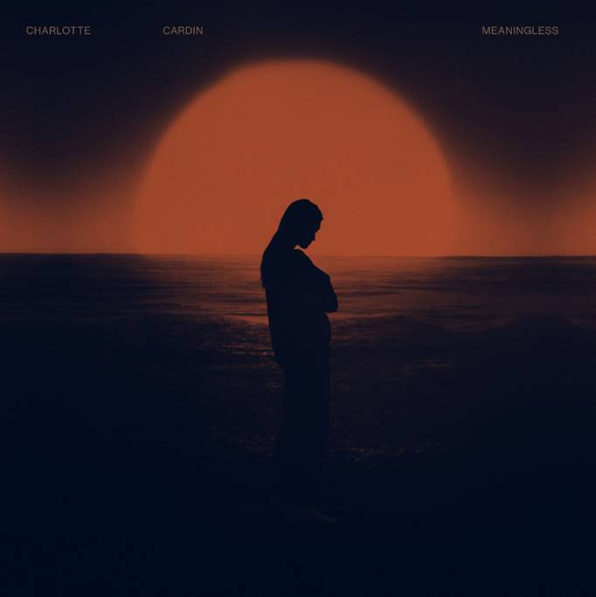
DOWNLOAD HIGH-RES IMAGES

WATCH/STREAM “MEANINGLESS”: https://CharlotteCardin.lnk.to/MeaninglessPR
PRE-SAVE PHOENIX: https://CharlotteCardin.lnk.to/PhoenixPR

Globally-acclaimed singer/songwriter Charlotte Cardin has announced her highly anticipated debut full-length album Phoenix, arriving April 9th via Atlantic Records. The 13-track collection features the emotional new track “Meaningless,” arriving today alongside a captivating Norman Wong-directed (Drake, Halsey) video companion (watch here). Phoenix also features stand-out singles “Passive Aggressive” and “Daddy,” both of which marked the first music in nearly two years from the Montreal-based artist.

“I have always been torn between my true desires and what I chose to present to the world. This conflict of will has gotten me to feel very empty at a young age and is still something I struggle with. Making this album took two years, because I started the writing process trying to keep control over what I wanted to show. It eventually became obvious, though, that I needed to embrace accessing those true impulses for my music (and my life) to make any sense whatsoever. The more I realized certain things about myself in the process, the angrier I got for not understanding them earlier. This conflicting loop of shame versus growth gave birth to ‘Phoenix.’
This was an elemental liberation for me. And if others who, like me, are torn between what is expected from them and who they really are, experience a part of this liberation through my songs, this album will have served its purpose.”
– CHARLOTTE CARDIN

Guided by instinct and gifted with a seismic voice, Cardin pens personal anthems about life and love without filter. Following the success of her Big Boy EP across Canada, she made waves worldwide with her major label and US debut Main Girl EP in 2017 and has amassed over 137 million career streams worldwide. Featuring the standout title track and breakthrough “Dirty Dirty,” Main Girl quickly gained critical acclaim from the likes of The FADER, Harper’s BAZAAR, Interview, NYLON, PAPER, W Magazine & more. The release simultaneously sparked a whirlwind two-year journey around the globe that saw Cardin support the likes of Nick Murphy and BØRNS, in addition to selling out headline shows on multiple continents and gracing the stages of festivals such as Bonnaroo, Osheaga & Festival d’Été de Québec (as a special guest of Sting and Peter Gabriel).

Having spent the majority of the past two years locked in the Cult Nation studio, Cardin is primed for a rise back into the spotlight with Phoenix. With 2020 having seen her grace the cover of ELLE Québec for a third time and continue to serve as house ambassador for CHANEL, the celebrated chanteuse has only just begun to take flight.

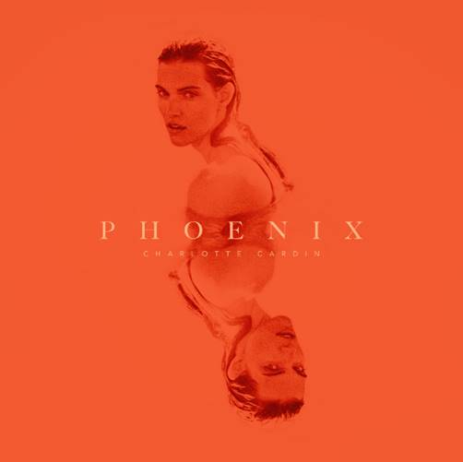
Charlotte Cardin – Phoenix
(out April 9th via Atlantic Records)

1. Phoenix
2. Passive Aggressive
3. Anyone Who Loves Me
4. Meaningless
5. Daddy
6. Sex To Me
7. Good Girl
8. Sad Girl
9. XOXO
10. Oceans
11. Sun Goes Down (Buddy)
12. Romeo
13. Je Quitte

DOWNLOAD HIGH-RES PHOTOS

CONNECT:
CHARLOTTECARDIN.COM | FACEBOOK | INSTAGRAM | TWITTER | YOUTUBE| PRESS ASSETS

CONTACT:
Ted Sullivan | ted.sullivan@atlanticrecords.com

