For Immediate Release
September 18, 2020

Charlotte Cardin returns with “Passive Aggressive”
New single & music video out now!

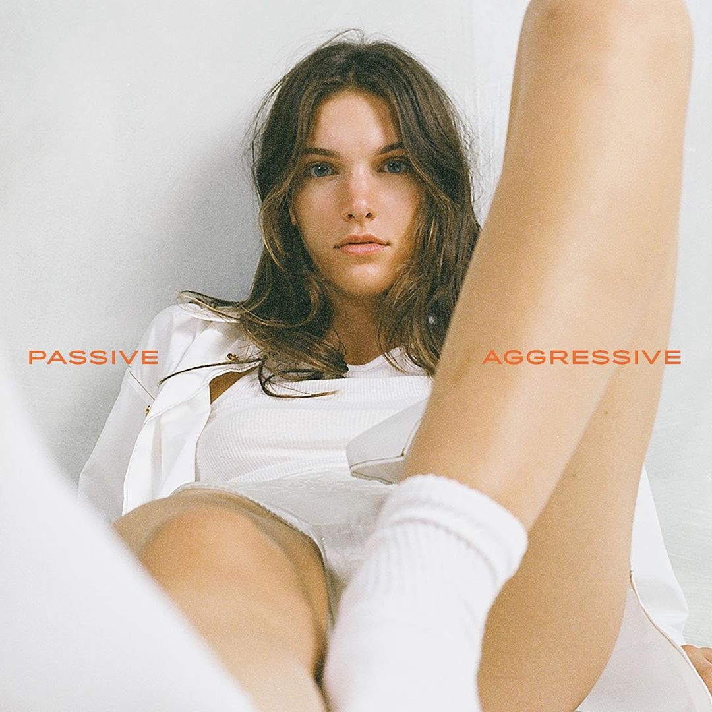

Watch/Stream “Passive Aggressive”: https://CharlotteCardin.lnk.to/PassiveAggressive

Globally-acclaimed singer/songwriter Charlotte Cardin has returned with new single “Passive Aggressive” – available now via Atlantic Records. Co-penned by Cardin & Jason Brando and produced by Brando, Marc-André Gilbert (MAG) & Connor Seidel, the track arrives alongside a captivating music video (also directed by Cardin & Brando) showcasing the beautiful yet twisted aftermath of a relationship gone awry. “Passive Aggressive” marks the first release in nearly two years from the Montreal-based artist, having already amassed over 117 million career streams worldwide.

Curling around a danceable bass line, “Passive Aggressive” glows with eighties gloss as Cardin’s vocal acrobatics enchant. “It’s basically a song about the relief, celebration, and liberation you feel once you get rid of a toxic relationship,” she explains. “It’s about a very passive aggressive ex and just those toxic vibes. It’s being happy to be on your own and embrace your inner strength.”

Guided by instinct and gifted with a seismic voice, Cardin pens personal anthems about life and love without filter. Following the success of her Big Boy EP across Canada, she made waves worldwide with her major label and US debut Main Girl EP in 2017. Featuring the standout title track and breakthrough “Dirty Dirty,” Main Girl quickly gained critical acclaim from the likes of The FADER, Harper’s BAZAAR, Interview, NYLON, PAPER, W Magazine & more. The release simultaneously sparked a whirlwind two-year journey around the globe that saw Cardin support the likes of Nick Murphy and BØRNS, in addition to selling out headline shows on multiple continents and gracing the stages of festivals such as Bonnaroo, Osheaga & Festival d’Été de Québec (as a special guest of Sting and Peter Gabriel).

Having spent the majority of 2019 locked in the Cult Nation studio, Cardin is primed for a rise back into the spotlight with her forthcoming full-length debut. With 2020 already having seen her grace the cover of ELLE Québec for a third time and continue to serve as house ambassador for CHANEL, the celebrated chanteuse has only just begun to take flight.

CONNECT:
CHARLOTTECARDIN.COM | FACEBOOK | INSTAGRAM | TWITTER | YOUTUBE| PRESS ASSETS

CONTACT:
Ted Sullivan | ted.sullivan@atlanticrecords.com

