CHARLOTTE LAWRENCE’S NEW EP
CHARLOTTE OUT MARCH 5TH!
PRE-ORDER IT HERE!
WATCH TRAILER HERE!

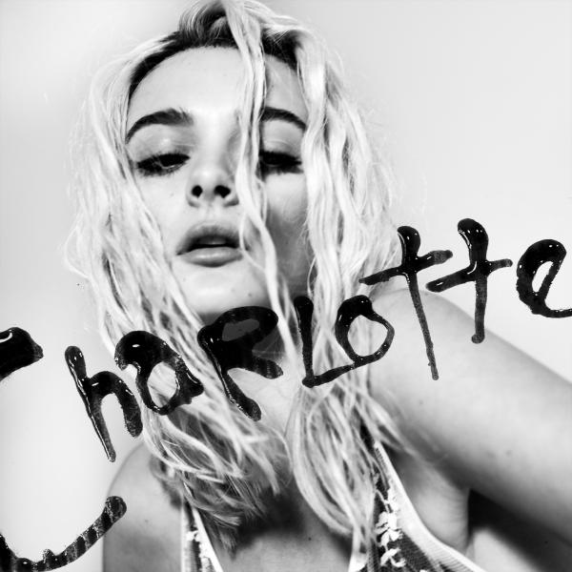
Download Hi-Res Photos Here!
OFFICIAL VIDEO FOR “TALK YOU DOWN” OUT NOW
WATCH IT HERE!
January 28, 2021—Breakout singer/songwriter Charlotte Lawrence’s upcoming EP, Charlotte, out March 5th, is now available for pre-order here! Charlotte announced the EP on her Instagram last week, exciting fans by dropping a trailer for the upcoming project—watch it here!

The six song EP is led by single 'Talk You Down', which Charlotte dropped at the start of 2021. ‘Talk You Down’ is an addictive percussion-driven electronic pop number about her anxiety, which she's remarkably open about. Charlotte released the official music video, directed by Trey Lyons for the track today—check it out here!

On Charlotte, she explores fear and struggle through a relationship on 'Sin x Secret', a sense of feeling lost on 'Cowboys', aching heartbreak on 'Slow Motion', the perils of love on 'You', and addiction and dependence on 'RX'.

Charlotte Track List
- Talk You Down
- You
- Sin x Secret
- Slow Motion
- Cowboys
- RX

ABOUT CHARLOTTE LAWRENCE:
Hailed by Billboard for her “haunting take on pop rock,” Atlantic recording artist Charlotte Lawrence has quickly proven a milestone artist, fusing deeply personal lyrics with larger-than-life melodies and epic choruses to create a remarkable, multi-faceted musical vision all her own. The Los Angeles-based singer-songwriter first earned critical acclaim – and millions of worldwide streams – for such breakthrough hits as “Just The Same“ and “Sleep Talking,” prompting applause from outlets spanning W, i-D, V Magazine, CLASH, Ones To Watch, The Line of Best Fit and many more. A wide of array of original music followed, including 2017’s breakthrough debut EP, YOUNG, and an extraordinary string of releases like “Why Do You Love Me,” “Navy Blue,” “God Must Be Doing Cocaine,” and “Joke’s On You,“ the latter featured on BIRDS OF PREY: THE ALBUM, Atlantic’s star-studded musical companion to Warner Bros. Pictures’ blockbuster Birds Of Prey (And The Fantabulous Emancipation Of One Harley Quinn). Having firmly established herself as a definitive force in the realm of pop, Lawrence has spent recent months hard at work in the studio on her forthcoming EP, CHARLOTTE, which is led by single 'Talk You Down', an addictive percussion-driven electronic pop number. With the new EP, Lawrence pushes her innovative blend of dark pop aesthetics with alternative rock energy even further into the extraordinary unknown.

CONNECT:
OFFICIAL | FACEBOOK | TWITTER | INSTAGRAM

CONTACT:
Kelly.McWilliam@altanticrecords.com

