FOR IMMEDIATE RELEASE
FEBRUARY 25, 2020

COLDPLAY RELEASE “CHAMPION OF THE WORLD” VIDEO
PLUS NEW ACOUSTIC EP AVAILABLE VIA APPLE MUSIC

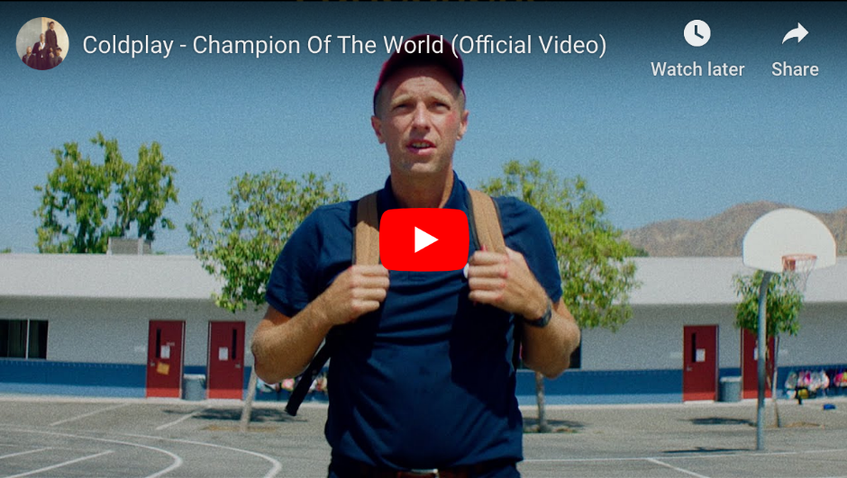

Coldplay have today premiered the video for “Champion Of The World,” from their critically-lauded new album Everyday Life.

The video was filmed in Los Angeles by French director Cloé Bailly. You can watch it at https://youtu.be/kayI9QB1-IA now.

Says Cloé: “The video is about this magic power that kids have to switch off from reality and jump into their own world.”

The video comes hot on the heels of the video for “Cry Cry Cry,” which was directed by Dakota Johnson and Cory Bailey and is available to watch at https://youtu.be/lA9-TQE3lTM.

The band’s new Coldplay Reimagined acoustic EP / short film is also out this week on Apple Music. It features Chris Martin & Jonny Buckland’s stripped-back performances of “Cry Cry Cry,” “BrokEn” and “Champion Of The World” from Everyday Life, and is available at https://apple.co/coldplay.

Click here to download hi-res album artwork and band photo.

For more information please visit Coldplay.com or contact:
Sheila Richman (Atlantic Records) – sheila.richman@atlanticrecords.com
Ted Sullivan (Atlantic Records) – ted.sullivan@atlanticrecords.com

