FOR IMMEDIATE RELEASE

DECEMBER 9, 2019



**COLDPLAY PREMIERE VIDEO FOR EVERYDAY LIFE ON SOWETO TV**

VIDEO AVAILABLE ONLINE NOW FOLLOWING DEBUT

PLAY ON SOUTH AFRICAN COMMUNITY TV STATION

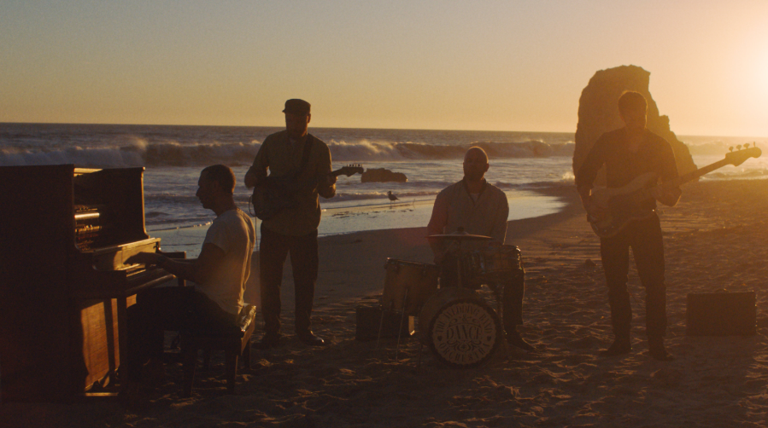

**Coldplay** have today released the video for their latest single, “**Everyday Life**,” from their critically-lauded new album of the same name.

The expansive video was filmed in multiple locations across the world - including **South Africa**, **Morocco** and the **Ukraine**.  Earlier today, it was given a worldwide premiere on South African community TV station, **Soweto TV**, and is now available online at <https://youtu.be/7HmiFxqdgq4>.

The video was directed by **Karena Evans**, the 23-year-old Toronto native responsible for many of Drake’s recent videos (such as “**God’s Plan**” and "**In My Feelings**”).

The song is the closing track of Coldplay’s acclaimed new album, ***Everyday Life***.

On the day of its release, the album was launched with two stunning performances in **Amman, Jordan** - viewed by a global YouTube audience of more than 20 million. The band performed the two halves of the double-album - **Sunrise** and **Sunset** - live and in full. Click to watch them now: [Sunrise](https://www.youtube.com/watch?reload=9&v=NFf2VFREkZo) / [Sunset](https://www.youtube.com/watch?v=0wysCoAm2Yo).

[Click here](https://press.atlanticrecords.com/coldplay/) to download hi-res album artwork and band photo.

For more information please visit [**Coldplay.com**](https://www.coldplay.com/) or contact:

Sheila Richman (Atlantic Records) – [sheila.richman@atlanticrecords.com](mailto:sheila.richman@atlanticrecords.com)

Ted Sullivan (Atlantic Records) – [ted.sullivan@atlanticrecords.com](mailto:ted.sullivan@atlanticrecords.com)