COLDPLAY AND SELENA GOMEZ
PREMIERE LET SOMEBODY GO VIDEO
WATCH THE STUNNING DAVE MEYERS-DIRECTED CLIP

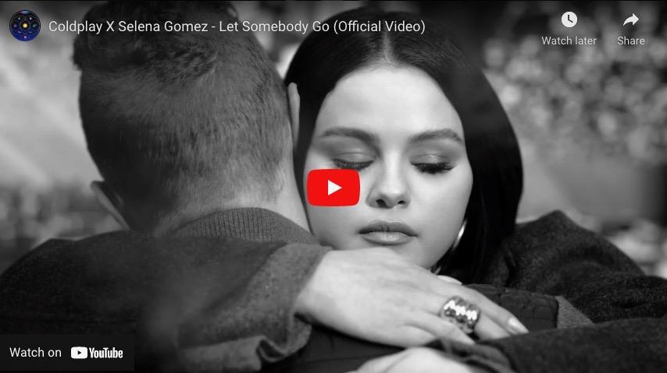

Coldplay have today premiered the video for Let Somebody Go, their heart-wrenching new single with Grammy-nominated singer Selena Gomez. The video is available to watch at youtu.be/CWCMGIG1Y54 now.

The stunning, Escher-inspired video was directed by Dave Meyers and co-conceived / choreographed by Yoann Bourgeois.

Let Somebody Go is taken from Coldplay’s hit album Music Of The Spheres, which has already surpassed more than a billion total streams.

The single is the follow-up to My Universe, which made history as the first Billboard Hot 100 #1 by two co-billed lead groups, Coldplay also became the first British band ever to debut at #1 on the Hot 100 with the collaboration.

Next month, the band begins their massive 2022 global stadium tour in Costa Rica. The full list of Music Of The Spheres World Tour shows is available at coldplay.com/tour. The tour is accompanied by a comprehensive set of sustainability initiatives which can be seen at coldplay.com/sustainability.

Download video clips / stills for media use: here

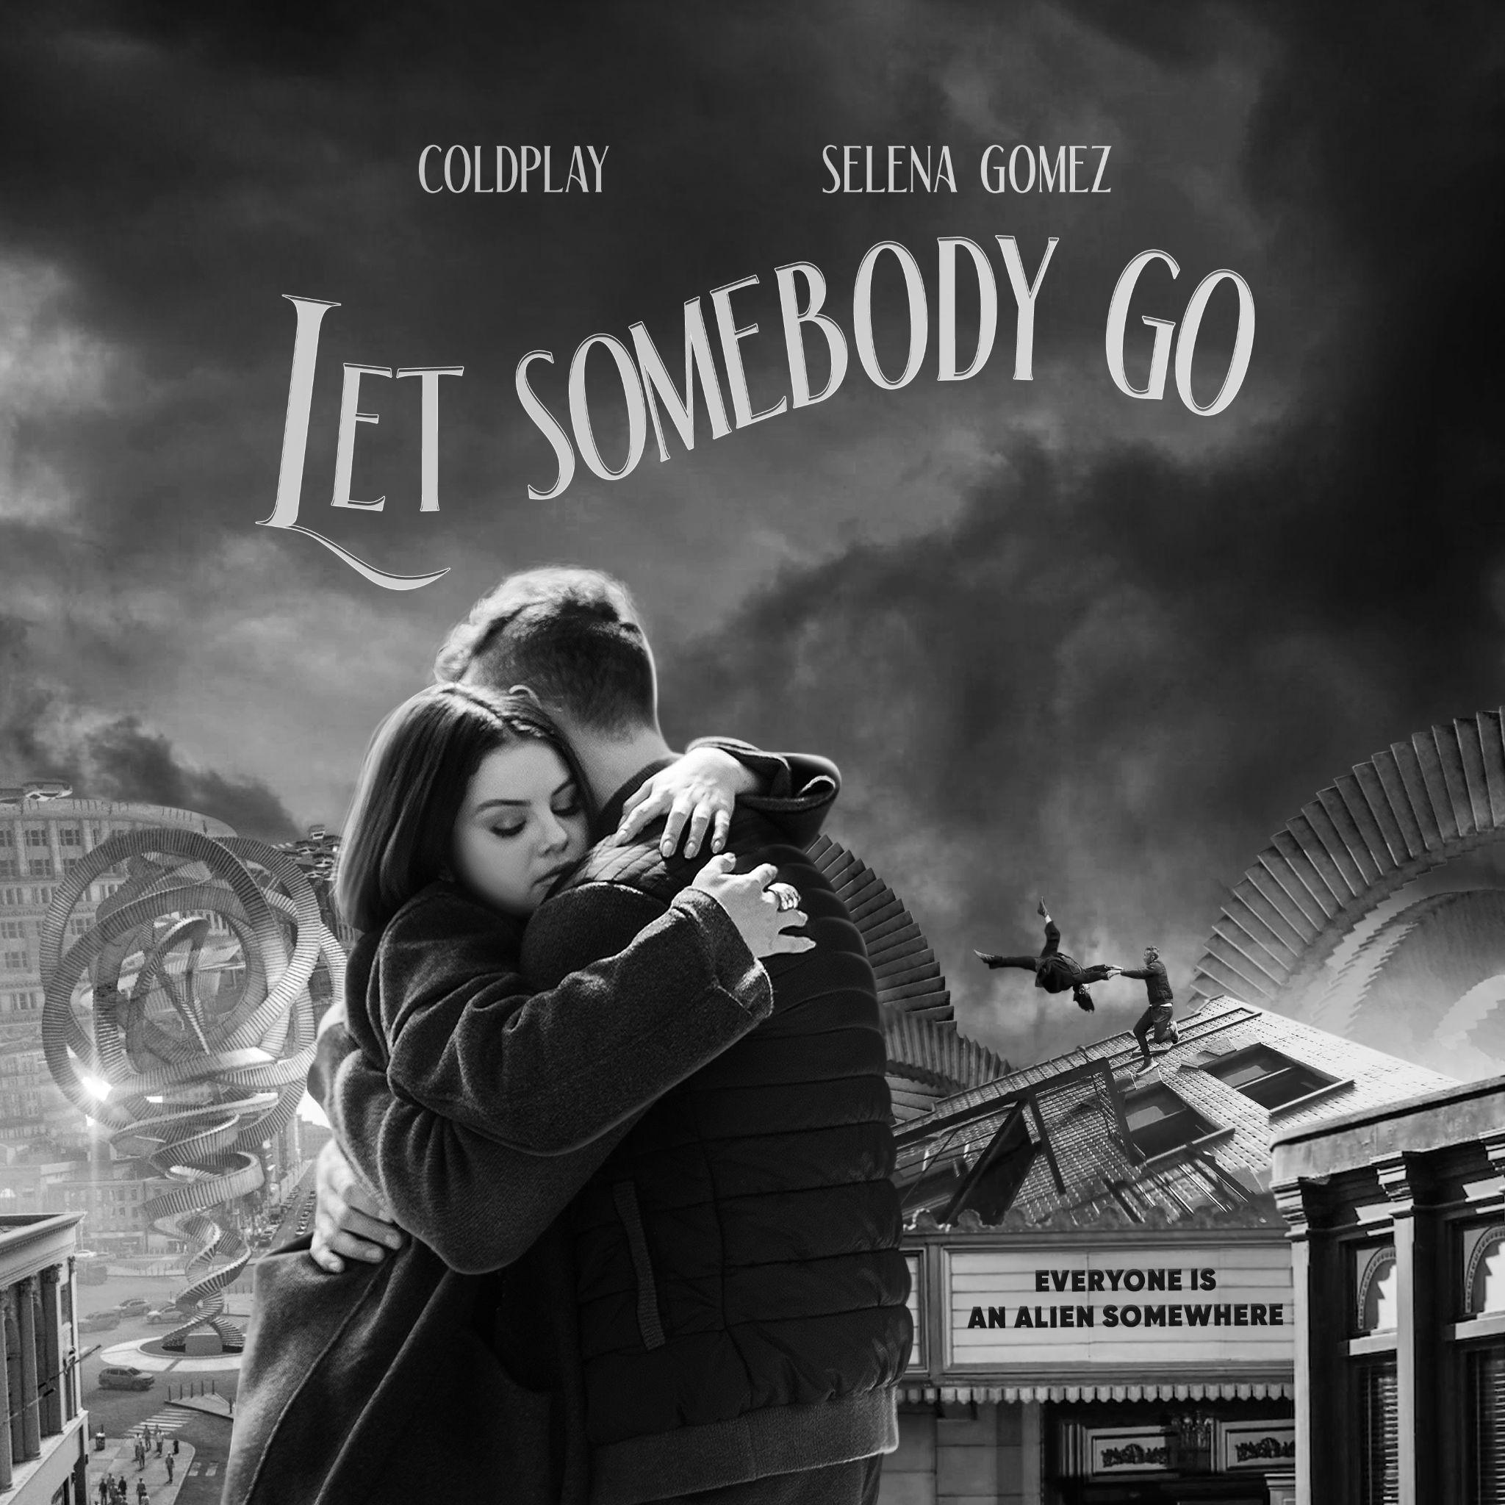
Download / stream Let Somebody Go at coldplay.lnk.to/LetSomebodyGo

For more information please visit Coldplay.com or contact:
Sheila Richman (Atlantic Records) – sheila.richman@atlanticrecords.com
Ted Sullivan (Atlantic Records) – ted.sullivan@atlanticrecords.com

