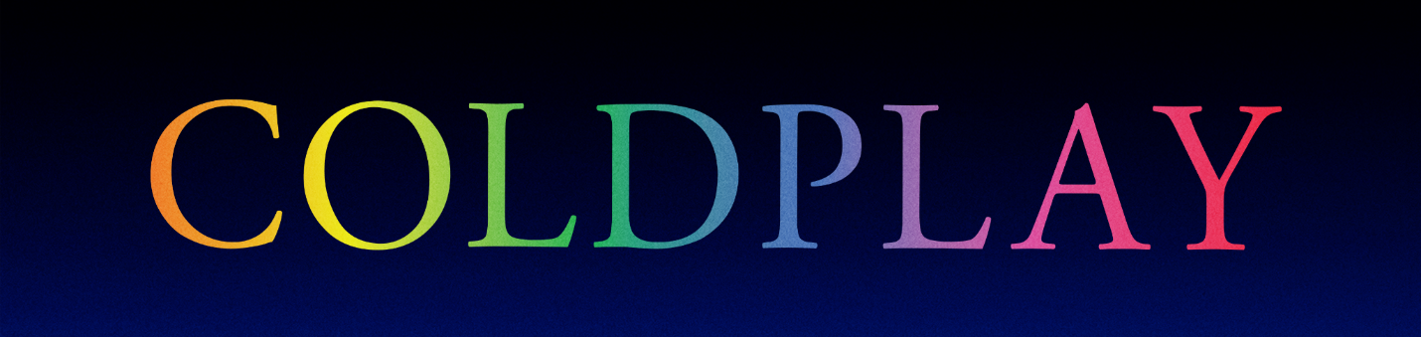

COLDPLAY & BTS MY UNIVERSE SINGLE OUT TODAY
COLLABORATION AVAILABLE WORLDWIDE NOW

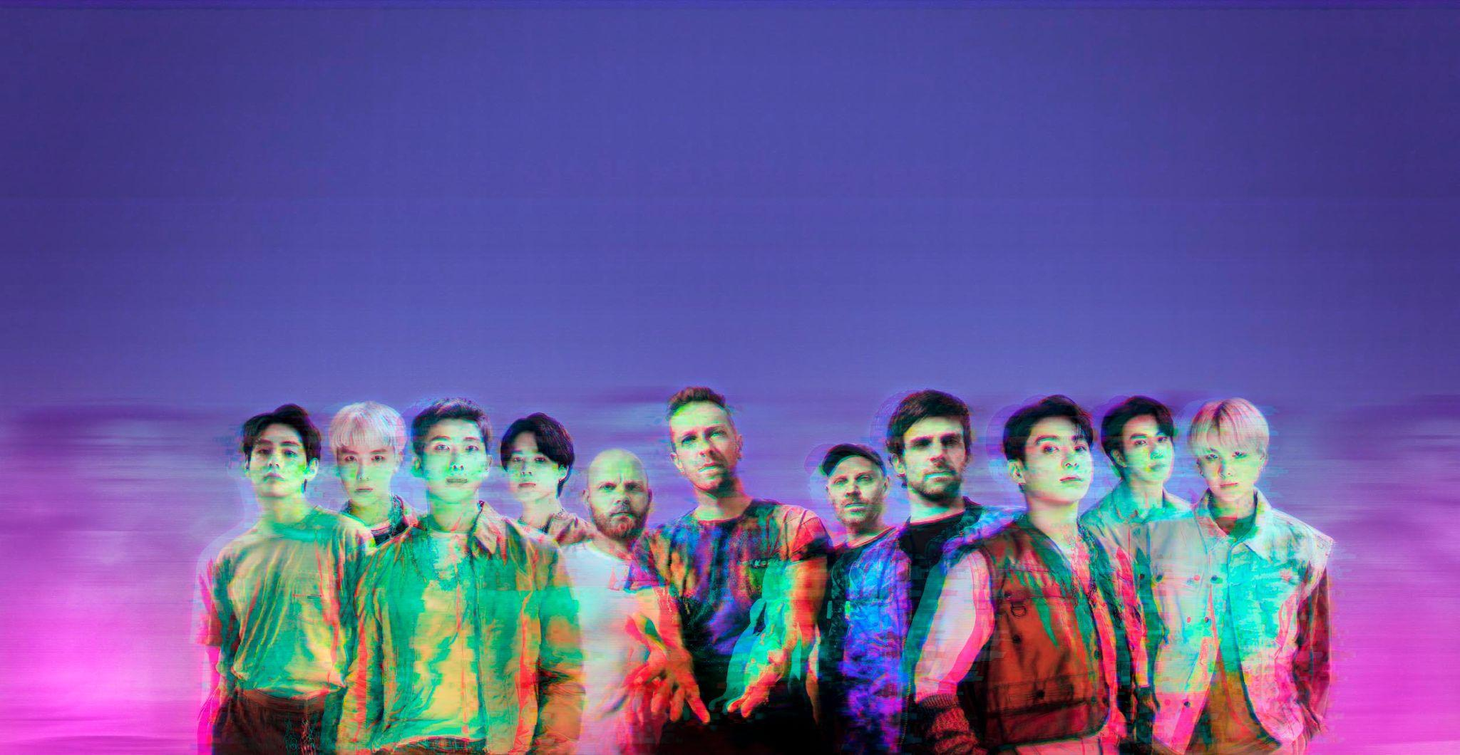
Credit: James Marcus Haney x Heo Jae Young x Kim So Jung

Coldplay have today released their much-anticipated collaboration with BTS. My Universe, which was written by Coldplay and BTS and produced by Max Martin, is available to stream / download worldwide now.

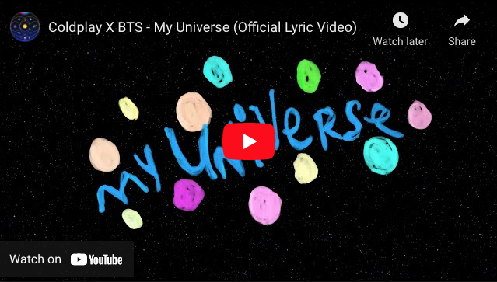

The song’s official lyric video - which is available now - features handwritten lyrics from both groups, in both English and Korean.

Coldplay have also teased the song’s Dave Meyers-directed official music video, as “coming very soon”.

My Universe follows Coldplay’s worldwide hit Higher Power as the second single to be taken from the band’s forthcoming album Music Of The Spheres (out October 15th).

Download images / artwork for media use: cldp.ly/MU-media

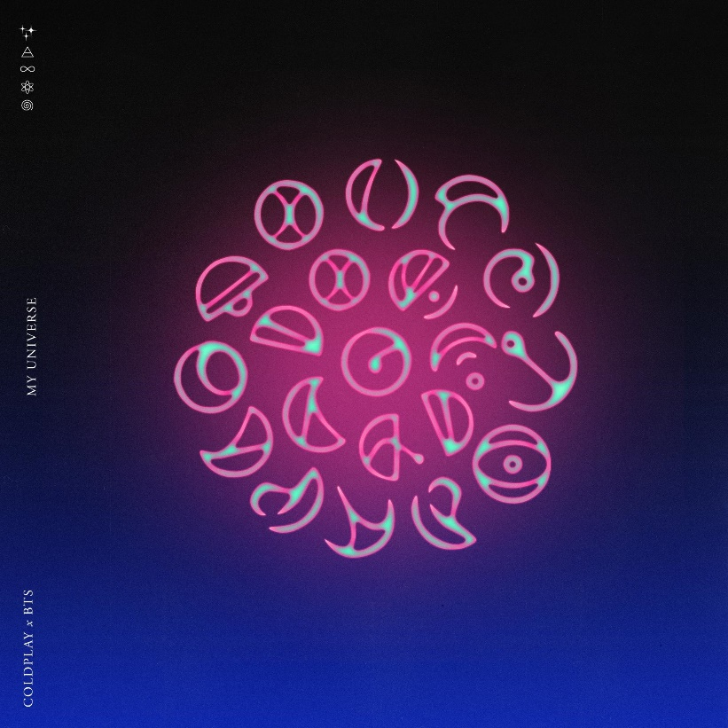

For more information please visit Coldplay.com or contact:
Sheila Richman (Atlantic Records) – sheila.richman@atlanticrecords.com
Ted Sullivan (Atlantic Records) – ted.sullivan@atlanticrecords.com

