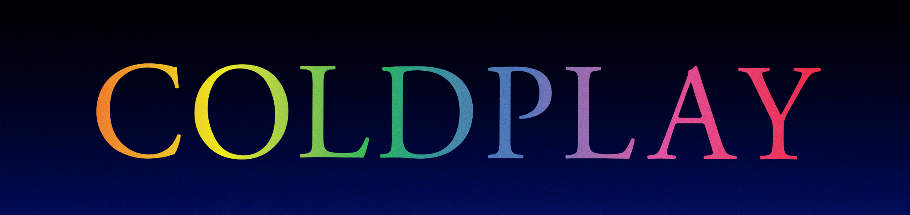

COLDPLAY & BTS ANNOUNCE MY UNIVERSE SINGLE
NEW COLLABORATION OUT ON SEPTEMBER 24TH

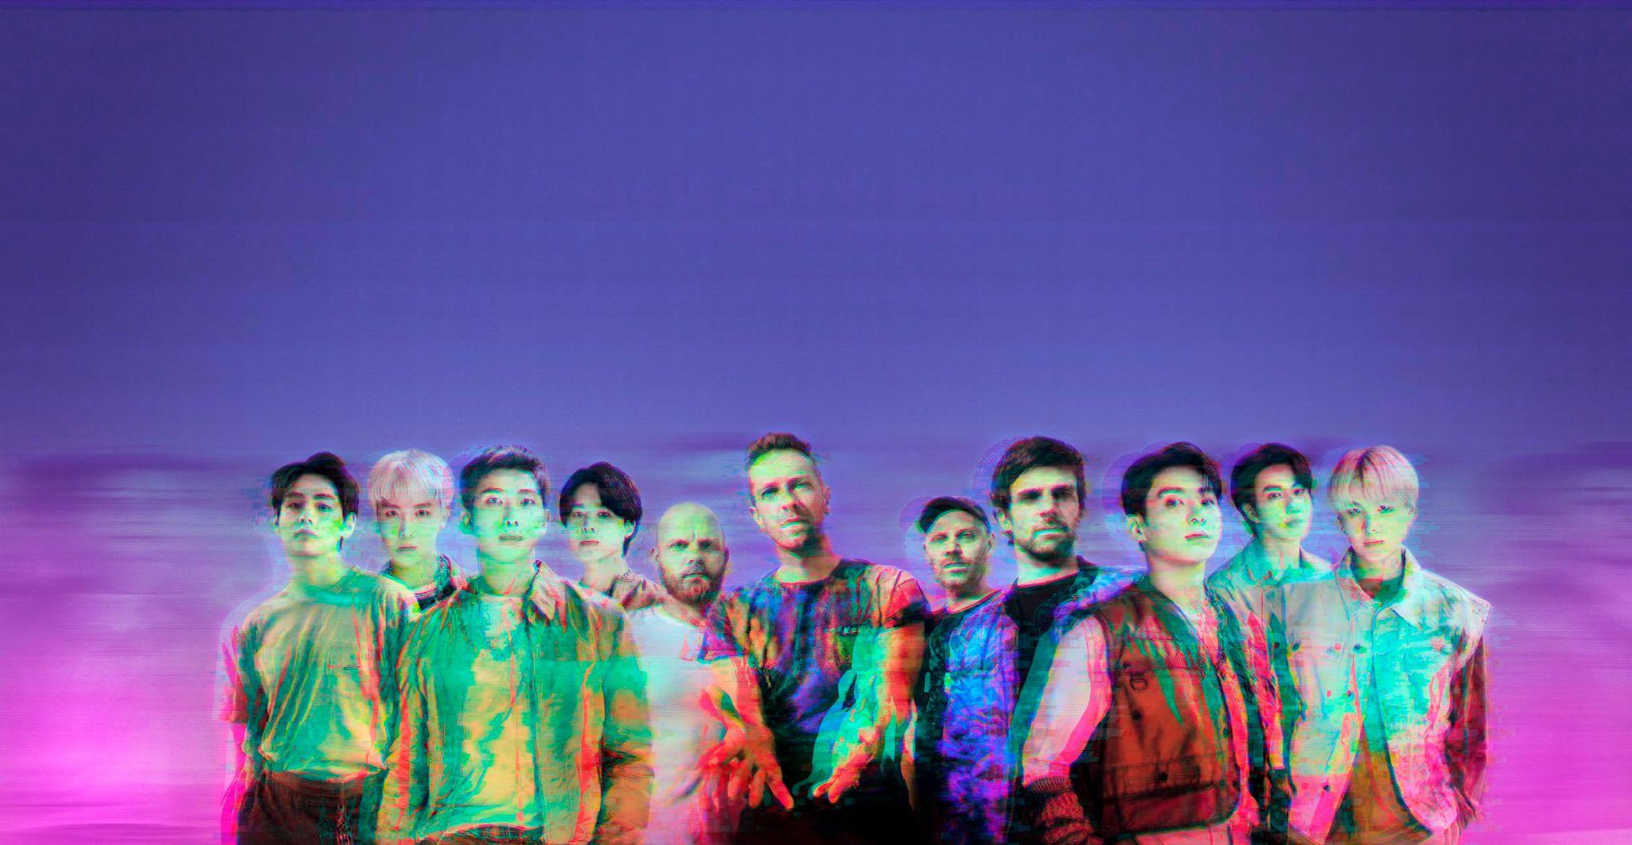
Credit: James Marcus Haney x Heo Jae Young x Kim So Jung

Coldplay have today announced their much-anticipated collaboration with BTS. My Universe will be released on September 24th.

The track, sung in both English and Korean, was written by Coldplay and BTS and produced by Max Martin. It is available to pre-order / pre-save now, with a CD single also available to order, at myuniverse.coldplay.com.

My Universe follows Coldplay’s worldwide hit Higher Power as the second single to be taken from the band’s forthcoming album Music Of The Spheres (out October 15th).

Download images / artwork for media use: cldp.ly/MU-media

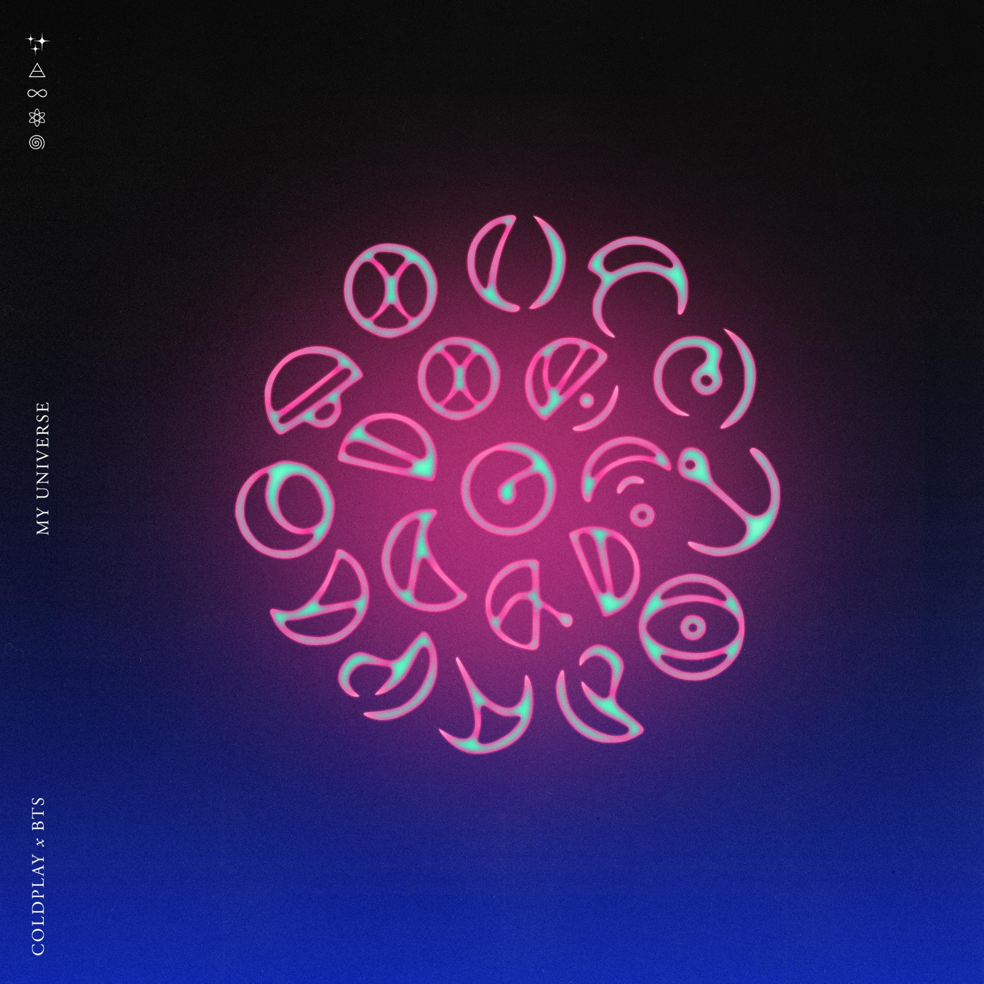

For more information please visit Coldplay.com or contact:
Sheila Richman | Sheila.Richman@Atlanticrecords.com
Ted Sullivan | Ted.Sullivan@Atlanticrecords.com

