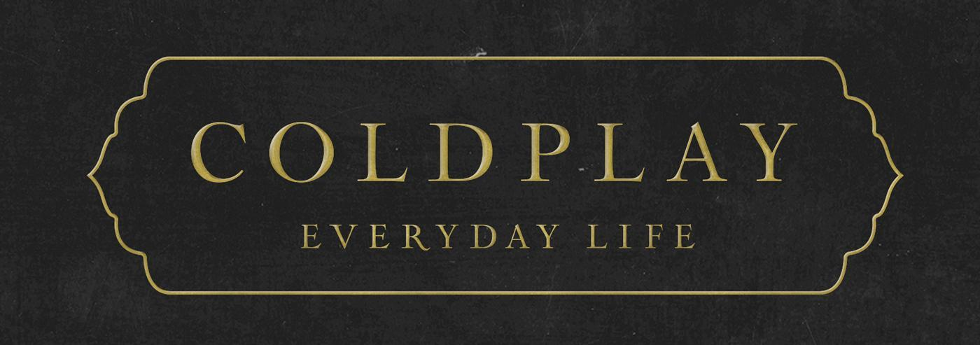
COLDPLAY ANNOUNCE HOLLYWOOD PALLADIUM
SHOW IN SUPPORT OF REFORM LA JAILS

To celebrate the release of their acclaimed new album, Everyday Life, Coldplay have announced a special, intimate show at the Hollywood Palladium on Monday, January 20.

The MLK Day concert will support Reform LA Jails, which campaigns for prison reform and advocates alternatives to incarceration.

The event will also feature performances by Compton hip hop artist Boogie and upcoming rapper Bobby Gonz. The guest speakers will be Patrisse Cullors, founder of Reform LA Jails and co-founder of Black Lives Matter Global Network, and actress America Ferrera, co-founder of Harness, which activates artists and activists to advance social justice.

To ensure tickets get into the hands of fans, not scalpers or bots, the band have partnered with Ticketmaster’s Verified Fan® platform. Fans can register for the onsale now through Wednesday, January 15 at 10pm PT by signing up HERE. Registered fans who receive an invitation code will have access to purchase tickets on Friday, January 17 at 10am PT.

The show is in addition to the previously-announced, sold out #CitiSoundVault show at The Hollywood Palladium on January 21, in support of A New Way of Life, which provides housing and support to women rebuilding their lives after prison. The guest speakers that night will be A New Way Of Life founder Susan Burton, and the actress and activist Natalie Portman.

On Wednesday (Jan 15), Coldplay will give an exclusive acoustic performance for SiriusXM & Pandora at SiriusXM Hollywood. That afternoon, the band will also be guests on The Ellen DeGeneres Show.

Then, on Friday (Jan 17), KROQ will host the band for an intimate show to celebrate the grand reopening of their HD Radio Soundspace. The following day (Jan 18), Coldplay will perform at iHeartRadio’s ALTer EGO at the LA Forum.

Everyday Life is Coldplay’s eighth studio album, described by Rolling Stone as “Coldplay’s rangiest and deepest release by orders of magnitude, maybe even their best,” with Stereogum calling it “a truly great album”.

The album’s lead single, Orphans, topped both Billboard’s Rock Airplay and Adult Alternative Songs charts, equalling the record for most Number Ones on the latter chart (with 13 across the band’s career).

Click here to download hi-res album artwork and band photo.

For more information please visit Coldplay.com or contact:
Sheila Richman (Atlantic Records) – sheila.richman@atlanticrecords.com
Ted Sullivan (Atlantic Records) – ted.sullivan@atlanticrecords.com

