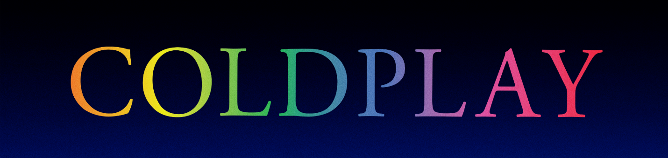

COLDPLAY REVEAL SELENA GOMEZ COLLABORATION
PLUS JAMES CORDEN RESIDENCY ANNOUNCED

Selena Gomez today confirmed her guest appearance on Coldplay’s forthcoming Music Of The Spheres album, arriving October 15th. The multi-platinum recording artist teased a preview video on her Twitter account, for a song called Let Somebody Go.

The band have now revealed the full list of guests for the album, which also features appearances from BTS, We Are KING and Jacob Collier. The record’s tracklisting is below.

🪐
Higher Power
Humankind
✨
Let Somebody Go (with Selena Gomez)
❤️ (with We Are KING and Jacob Collier)
People Of The Pride
Biutyful
🌎
My Universe (with BTS)
♾️

Coloratura

Meanwhile, the band have confirmed a week-long music residency on CBS’s THE LATE LATE SHOW with JAMES CORDEN from Monday, October 18th to Thursday, October 21st to celebrate the release of Music Of The Spheres. The residency will include the television debut of Let Somebody Go with Selena Gomez as well as a special performance of ❤️ (pronounced Human Heart) with We Are KING and Jacob Collier.

For more information please visit coldplay.com or contact:
Sheila Richman | Sheila.Richman@Atlanticrecords.com
Ted Sullivan | Ted.Sullivan@Atlanticrecords.com

